QA



UBS Financial Services

Wealth Management Americas

**WMAP – EISL Notification Hub**

**Document Version : 2.5 (Draft)**

|  |  |
| --- | --- |
| **Document Owner** | **WMA EISL Team** |
| **Date** | **7th May 2019** |

1. Glossary 3

2. Introduction 4

3. Overview 5

4. Technology Components 8

5. Architecture 10

5.1 Design Considerations 11

5.2 Non-Functional Requirements 12

6. Use Case Depictions 13

7. EISL High Level Process Flow 14

7.1 Near-Real Time and Batch Data Flow (e.g. Positions Data) 16

7.2 Real Time Streaming Data Flow (e.g. Orders) 16

7.3 Data Request Flow (e.g. Security Master) 17

8. Initialization and Registration Code Interfaces 19

8.1 Initialization Epic 19

8.2 Initialization Technical Story Design 20

8.1 Registration Story Epic 20

8.2 Registration Technical Story Design 21

9. Appendix 24

9.1 Event-Driven Architecture 24

9.2 Event Driven Process - High Level Flow 24

9.2.1 Inter-Business Request Flow 24

9.2.2 North Bound Flow 25

9.2.3 South Bound Flow 28

9.2.4 Data Streaming Flow 30

9.2.5 Start/Resume/Terminate 31

9.2.6 Master Events 36

9.3 Design Details 37

9.3.1 Data Ingestion Sequence Diagram 38

9.3.2 Data Cache Access Sequence Diagram 39

9.3.3 Data Request Sequence Diagram 39

9.3.4 File Transfer Sequence Diagram 40

9.3.5 REST Call Sequence Diagram 41

9.3.6 Data Stream Sequence Diagram 42

9.3.7 Transform Cache Data Sequence Diagram 43

9.3.8 Notification Hub Data 44

9.3.9 Master Sequence Diagrams 47

9.3.9.1 End of Day 47

9.3.9.2 Start of Day 47

9.3.10 Core Sequence Diagrams 48

9.3.10.1 Initialization Sequence 48

9.3.10.1.1 Security Sequence 50

9.3.10.1.2 Entitlement Sequence 51

9.3.10.2 Static Information Management 52

9.3.10.3 Registration Information Management 56

9.3.10.1 Broadridge Mapping and Correlation 60

9.3.10.2 Scheduling Sequence 64

9.3.10.3 Notification Access Sequences 65

9.3.10.3.1 Event Hub Sequence 65

9.3.10.3.2 Data Hub Sequences 68

9.3.10.3.2.1 Data Streaming Access Sequence 69

9.3.10.3.2.2 Data Topic Access Sequence 71

9.3.10.3.2.3 Cached Data Access Sequence 72

9.3.10.3.2.4 Data Blob Access Sequence 72

9.3.10.4 Logging 73

9.3.10.4.1 Logging Service 74

9.3.10.4.2 Log Access Service 75

9.3.10.5 Exceptions 76

9.3.10.5.1 Exception Service 77

9.3.10.5.2 Exception Access Service Sequence 78

9.3.10.5.3 NFR Exception Service Sequence 79

# Glossary

|  |  |  |
| --- | --- | --- |
| Notifications | There are 2 distinct types of notifications | 1. Event messages 2. Data messages |
| Event Categories | There are 3 types of events | 1. Operation events 2. System events 3. Business events |
| Event Types and Sub Types | These define the domain and sub domains | e.g. Orders and … |
| Data Messages | There are only 2 data message types | 1. Streaming data (publish/subscribe) 2. Reference Data for BR to EISL communication |
| Registration | Dynamic information management | This is used to identify relationships between producers and consumers based around the Triad of categories, event types and sub types. |
| Event Registry | Static information management | This stores all pre-defined event information with corresponding topics |
| Data Registry | Static information management | This stores all associated data information for pre-defined events and corresponding data protocols. |
| Exception Registry | Static information management | This stores all exception work item definitions associated to pre-defined events. |

# Introduction

In the US, we are creating our state-of-the art Wealth Management Americas Platform, which will help to deliver our organic growth strategy objectives. WMA is partnering with Broadridge to achieve our platform vision to support our strategic growth objectives. We will implement this platform leveraging Broadridge market service capabilities along with strategic UBS applications and services, to create new front-to-back offering.

The objective of the WMA project is to create a centralized core communication (Digital Fabric) layer that allows UBS to co-operate using a highly federated set of data sources. These data sources are split across multiple domains (physical) that support both these data sources and any external interactions (publish or consumption) associated to them.

# Overview

A high-level view of the EISL – external systems interaction, with emphasis around the notification hub is shown below:

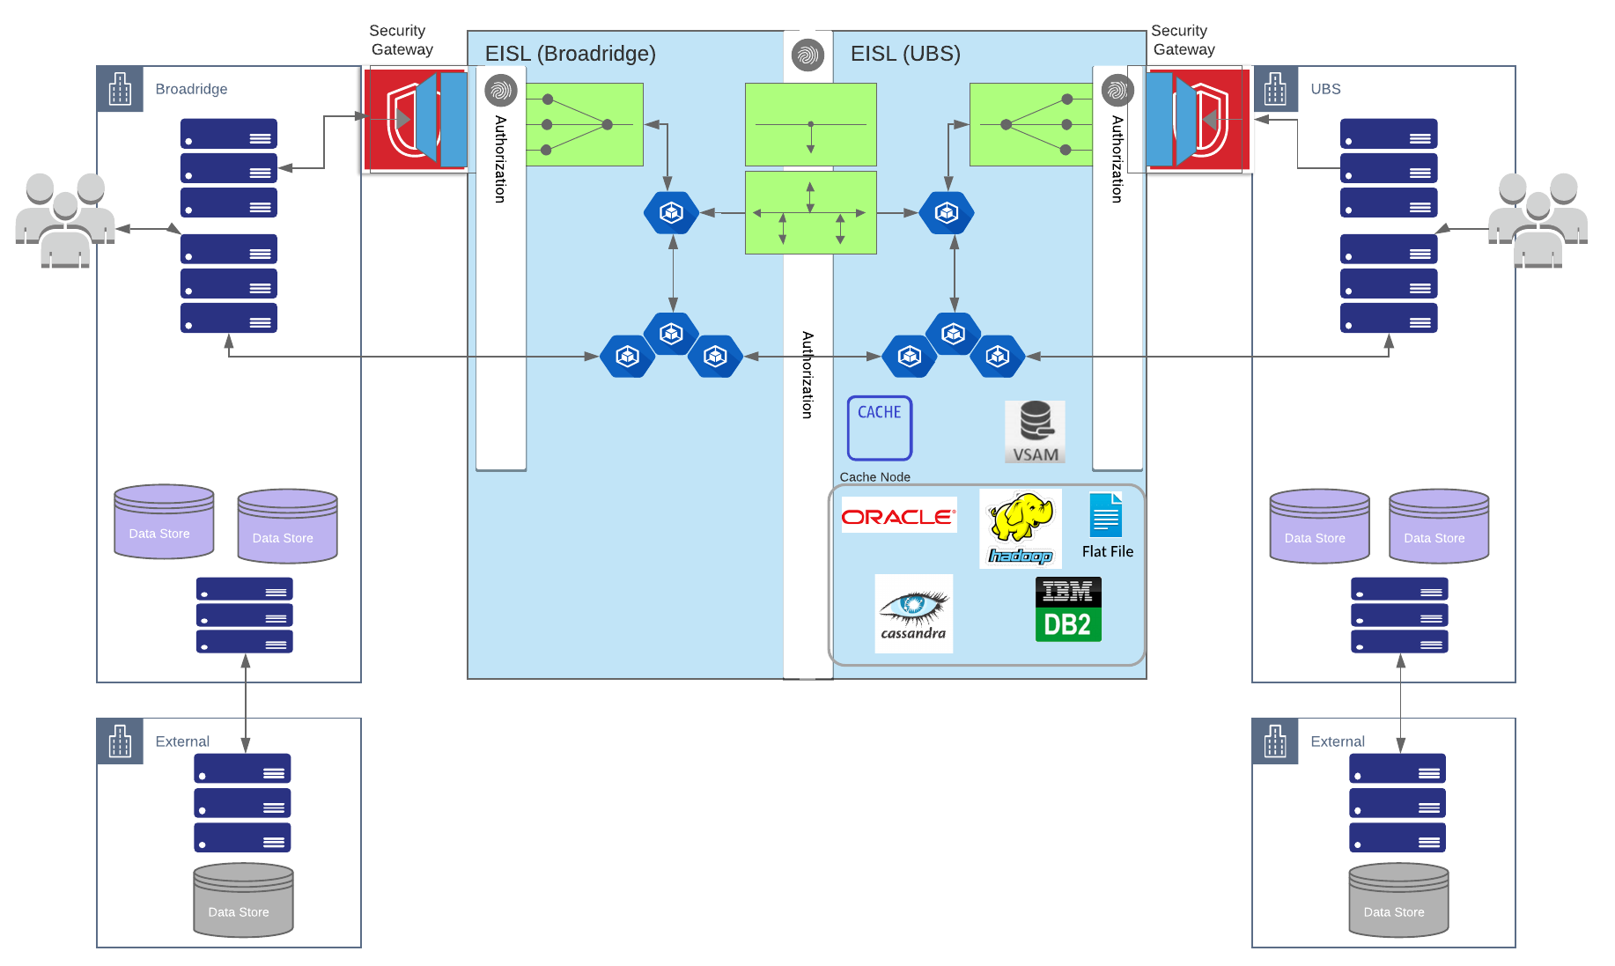

As shown above the digital fabric required the handle this communication is called EISL. THE EISL layer is divided into 2 layers:

1. EISL – UBS
2. EISL – Broadridge

Each EISL component is responsible for the following fundamental areas of integration:

1. Registration
2. Notification Hub
   1. System Event Hub – caters to all the system notification/event messages
   2. EISL Event Hub – caters for all in-bound requests that require interaction with EISL (process execution).
   3. Data Hub – caters to the ingestion of data into EISL and for data streaming between external parties.
3. Data Management. Data is served through a variety of protocols that includes:
   1. Data Streaming using the Data Hub.
   2. Data Input to EISL using the Data Hub.
   3. Data Blob Storage used to preserve input data.
   4. Data Cache for External Entity consumption.
   5. Data REST services for direct data access.
   6. Data File for transporting large data components.

Key to this was the selection of technologies that enable the Notification Hub.

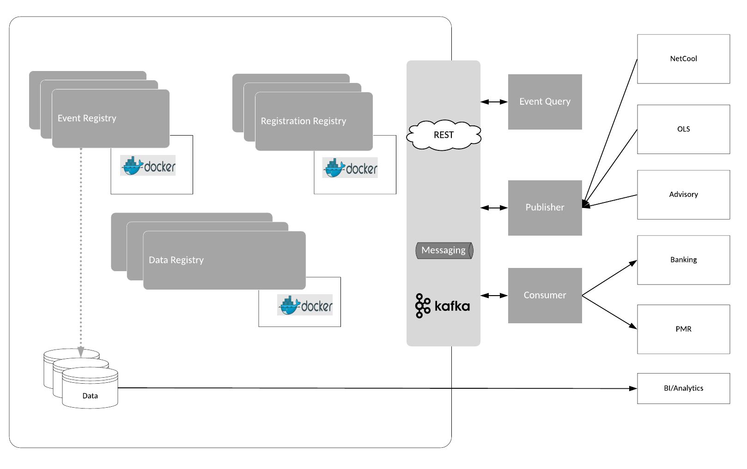

The Notification Hub is designed around an underlying set of Registries, which are broadly categories into the 3 sections below

1. Event Registry (static data)
   * 1. The Event Registry is the parent component associated to all interactions. This is the core element that manages static events, including references to data components and exceptions associated to each event. Included in the static data are:
        1. ServiceId that defines a unique reference for an event and is used by external entities to publish or subscribe to events
        2. The topic in the Event Hub that is used for access to these messages.
2. Data Registry (static data)
   * 1. This consists of data information that is associated to a specific event ServiceId. As such it manages all static data information. As any event can include multiple data representations the static data registry supports the following types of data:
        1. Cache Data
        2. Files
        3. REST access Data
        4. Streaming Data
3. Registration Registry (dynamic data)
   * 1. External entities register with EISL for events (business) which allows these entities to be notified of any operation related to a specific ServiceId. In addition to this these entities define the role (publisher or consumer) associated to the registration.
     2. There is no direct registration for data, instead this is a real time verification performed by EISL for any data request associated to a business event. This abstraction provides two key components:
        1. Allows EISL to check entitlements only when required – at the time of data access.
        2. Ensures that changes to external systems that manage entitlements continue to preserve that role.
     3. External entities do not directly interact with each other but submit requests (which may include data references) to EISL, which in turn processes any associated data and then creates relevant business events to notify other external entities.
     4. The registration service, in conjunction with the Data Registry, is used to manage data access. There are 2 distinct modes of Data Management:
        1. Data Streaming. In this scenario EISL provides both the publisher and consumers the data topic to use for the data stream.
        2. Data Access. All other forms of data are through data references whether that is a REST URL, File URL or Cache. In this case EISL, based on the external entity’s entitlements, provides either the data (as a JSON model) or a reference to retrieve the data. The model is designed that in all cases data retrieved can be filtered in EISL as part of these requests, with the exception of REST.

# Technology Components

The following diagram shows the overall technology components associated to the EISL digital fabric:

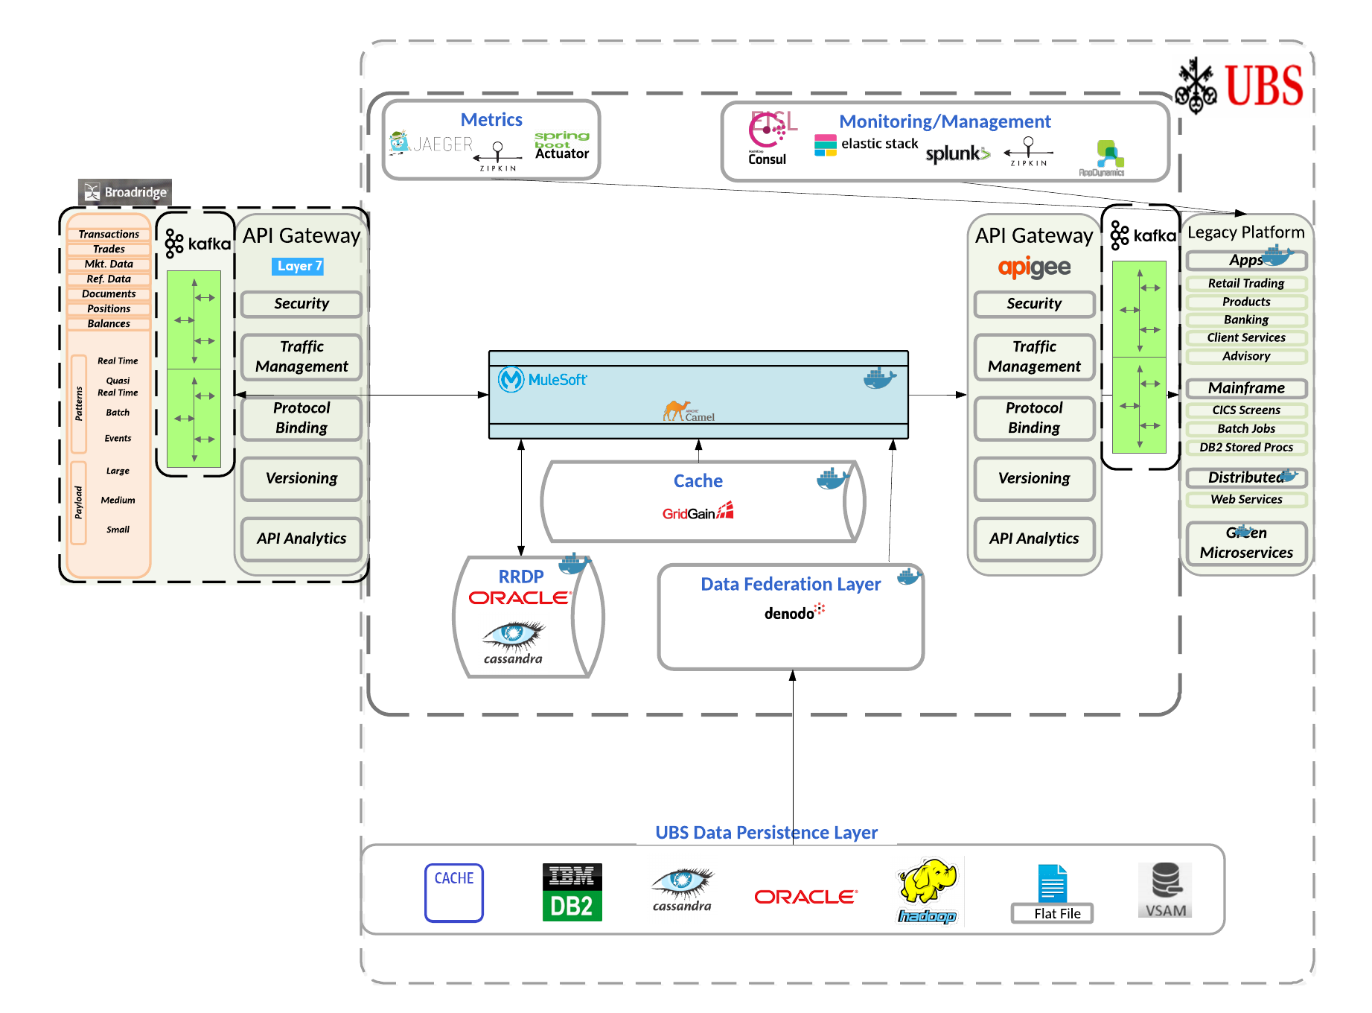

|  |  |
| --- | --- |
| **Area** | **Technologies / Tools / Frameworks** |
| API Gateway | APIGee |
| Virtual Abstraction Layer | Denodo |
| Container | Docker / Kubernetes (Container management) |
| ESB | MuleSoft Anypoint Platform (?) |
| Development Framework | SpringBoot |
| Messaging | JMS |
| Streaming | Confluent KAFKA |
| Cloud | Microsoft Azure |
| Metrics / Logging | slf4j (CTO Logger), Zipkin, JAEGER, SpringBoot Actuator, Logstash |
| Monitoring & Analytics | Splunk, AppDynamics, Consul, Elastic Stack |
| Data Caching | GridGain |
| Data Persistence | Azure Blob Store, Azure NoSQL Store, Cassandra, MS-SQL |
| Version Control | GitHub |
| Test Automation | Selenium, Cucumber, JUnit, Mockito, Jmock |
| BigData Processing | Spark |
| Deployment (CI / CD) | GitHub, TeamCity, Nexus, RLC, Maven |
| Data Access | Spring-JDBC, JPA, Hibernate, myBatis |
| Security | MAC, JWT, SAML, OAUTH2 |
| User Interface | Web Interfaces |

# Architecture

The following shows the physical architecture and the roll of each of these technologies within that physical architecture:

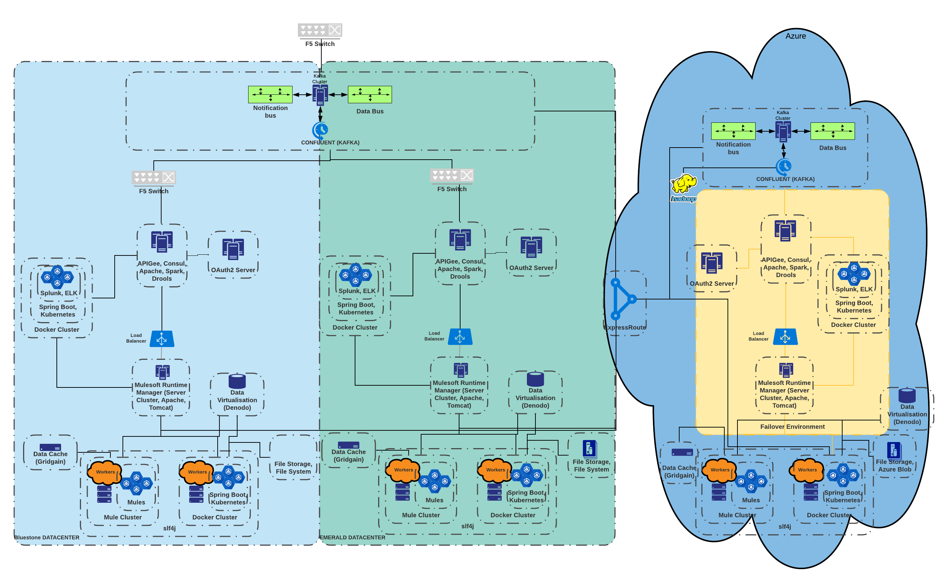

Figure 1- Physical Model & Technologies

Based on this set of technologies, the expected multiple data centers and the requirement of being cloud-enabled led the group to put together the following logical architecture:

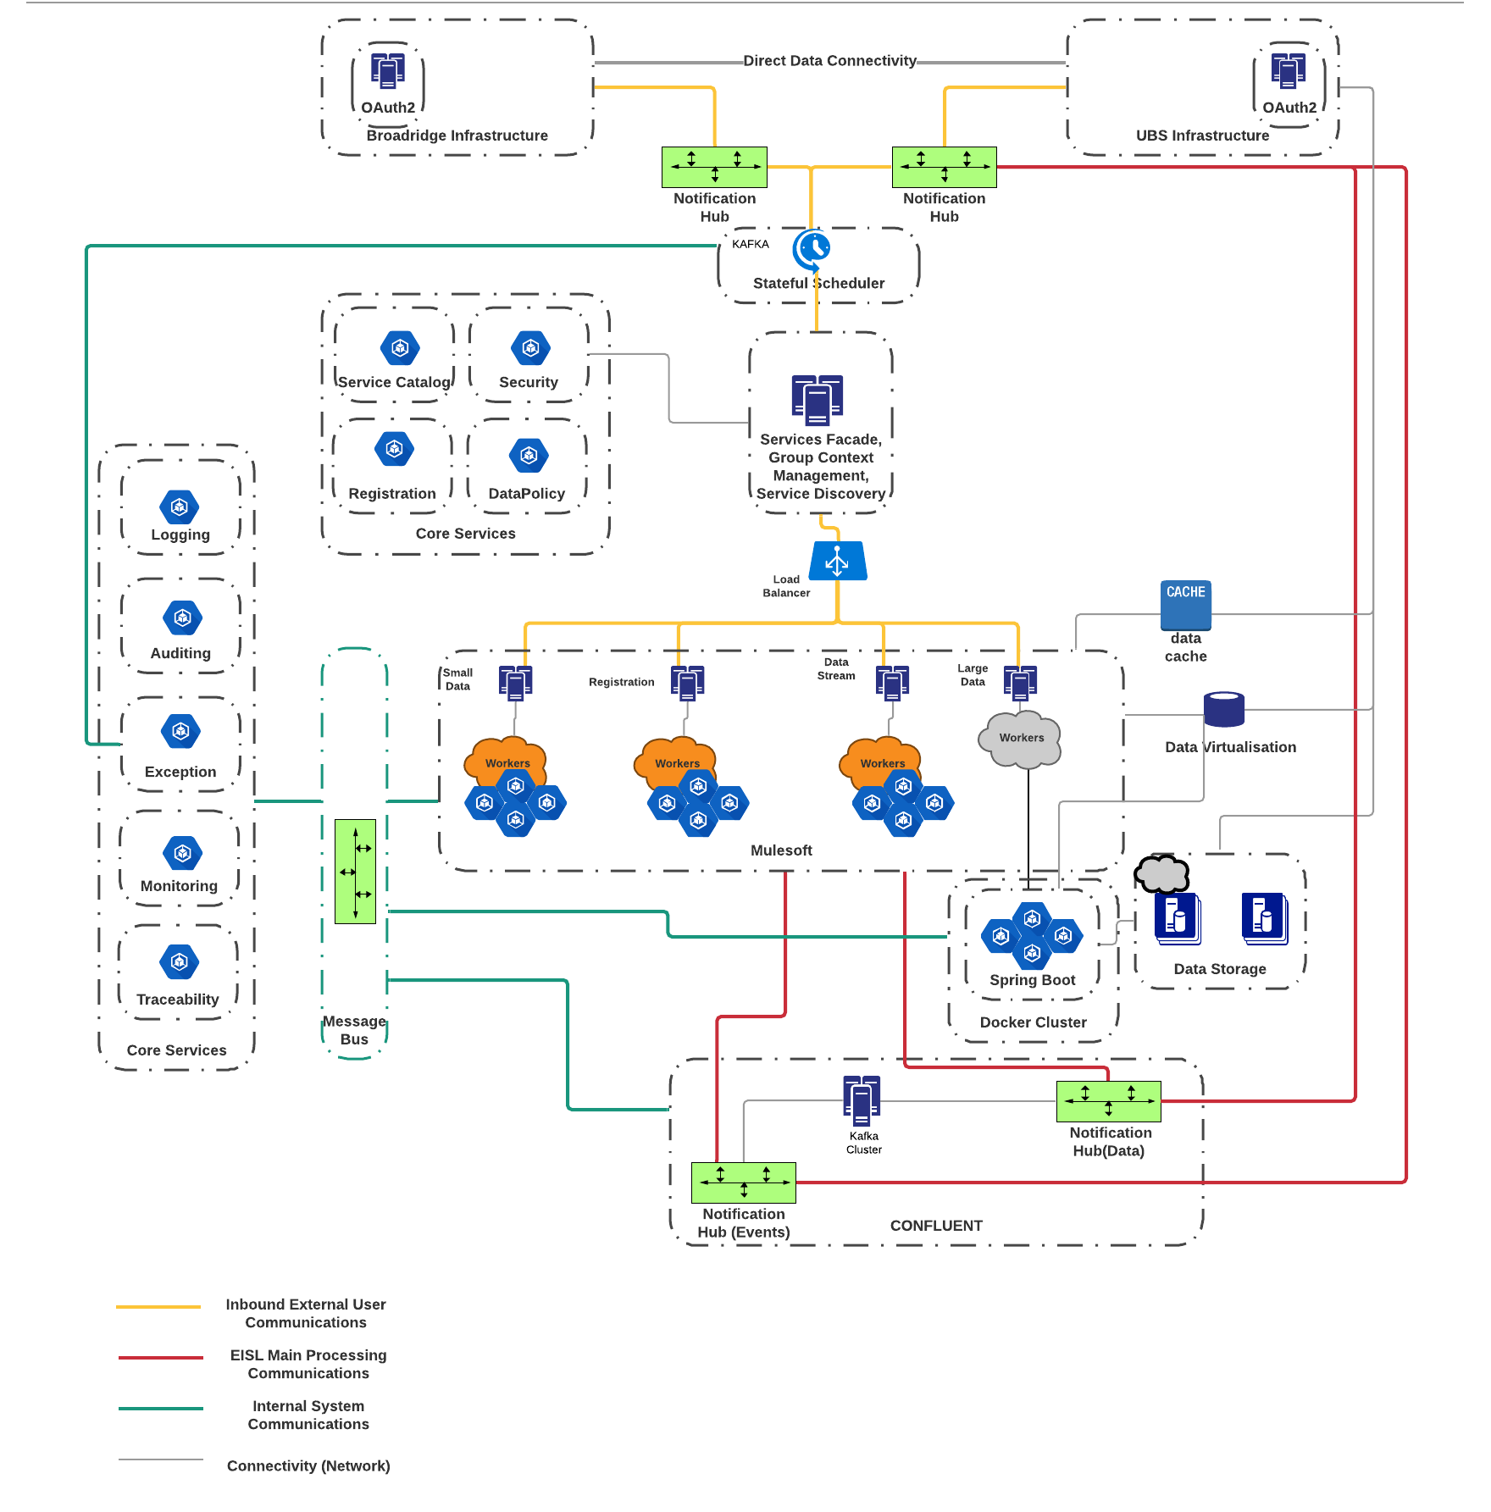

Figure 2 - Logical View

## Design Considerations

The logical architecture is designed around the following key drivers (Design Considerations):

1. Logging
2. Exception management/error handling
3. Ontology management through Data federation layer
4. **Notification management**
5. Traceability and Lineage
6. Security
7. Monitoring
8. Dependency Tracking
9. Registration
10. Non Functional Requirements

## Non-Functional Requirements

EISL should also provide for the following non-functional requirements:

| **#** | **Non-functional requirement** | **Description** |
| --- | --- | --- |
| 1 | Performance | EISL’s performance will be measured based on complete adherence to service level agreements set forth by business needs. For example, during the batch process, there could be an expectation of data ingestion, transformation and supply to Legacy application and back to an application on Broadridge platform |
| 2 | Scalability | EISL should be scalable to address any future growing needs of the business and consequent data exchange. |
| 3 | Reliability | EISL should offer reliability while offering Monitoring capabilities as well as Graceful degradation capabilities |
| 4 | Maintainability | EISL should offer easy maintainability. Custom services and workflows will be designed to be quickly and easily maintainable to preserve agility. SDLC for EISL layer must support quicker time to market for any changes. |
| 5 | Agility | EISL should offer faster time to market for current development and any future enhancements |
| 6 | Compliance | Actions/changes that are communicated through EISL should be auditable and traceable. EISL should facilitate regulatory compliance and cost allocation based on use |
| 7 | Vendor abstraction | EISL should offer vendor abstraction from UBS internal systems. |
| 8 | Resiliency | Resiliency has two components, one is high availability, and other is disaster recovery. We will provide multiple geographically distributed instances for EISL layer applications to satisfy both disaster recovery and high availability requirements. Possibly, cloud will be leveraged to provide HA/DR. |
| 9 | Business Continuity | EISL should be designed to offer business continuity for UBS applications. Intent is to make it transparent for downstream applications staying at UBS that the source applications for those systems are now running outside of UBS. We will also provide data to Broadridge for moving applications. E.g. feeding custom UBS security identifiers to Broadridge. |

# Use Case Depictions

WMA requires the ability to generate and share across domains a series of event notifications these range from ‘master’ events such as:

* Start of Day
* End of Day

To business events such as:

* Data available
* Data change
* Data update
* Data cancel

These notification events can be grouped under the following categories:

* Operation events
* System events
* Business events

The following shows a typical business flow for Positions Data:

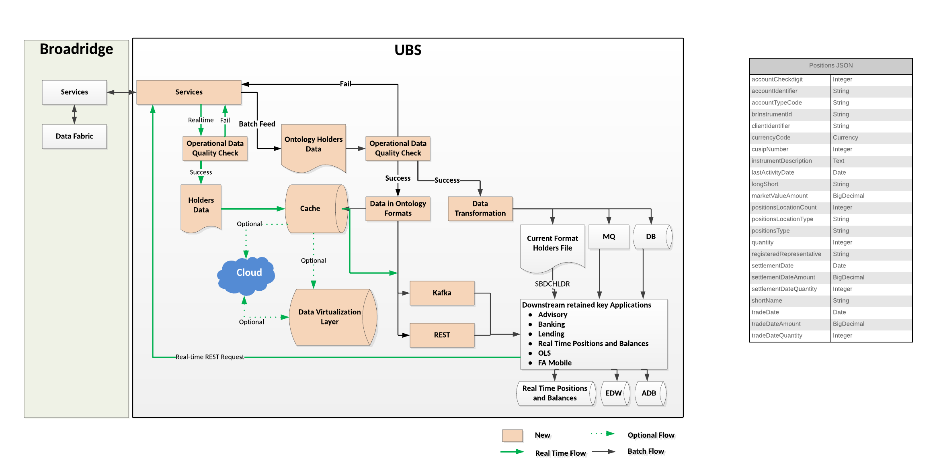

Figure 3 - Business Overview of WMAP Process

# EISL High Level Process Flow

EISL is designed around an “Event-based” model where external entities do not directly communicate with each other, but rather communicate via EISL. This model provides the ability to achieve the following.

* Increase reliability.
  + As events and data are not handled as a single entity it is crucial that both operations have been completed before publishing business notifications.
  + Using EISL’s orchestration allows the platform to pre and post process incoming and outgoing data, ensuring validity of data.
* Extensibility
  + As external entities ONLY interact with EISL then the number and location of these entities are solely the responsibility of EISL. The result is that EISL is designed to support current service providers (Broadridge) and UBS advisors, but can be extended to include multiple service providers.

The model adopted in EISL is that events themselves are classified into the following categories:

1. Operation. These events are notifications to EISL requested it perform (execute) a service, usually this means that EISL will need to process, in some way, data associated to this request. These operations would include:
   1. Request Data
   2. Upload Data
   3. Grant Access to Data
   4. Transform Data
   5. Enrich Data
   6. Filter Data
2. System. These events are system level events that instruct EISL to perform (execute) services associated to platform management and include operations such as:
   1. Start of Day. This will result in re-initialization external entity configurations and registrations.
   2. End of Day. Triggers services that perform cleanup of registrations, events and data.
3. Business. These events, primarily issued by EISL, are communications to external entities that notify these entities of events. These events are associated to the data level for business requirements.

EISL achieves this by requiring the following high-level steps:

1. An external entity must register with EISL; this is done through the Initialization Sequence and performs two functions:
2. Authorization and Entitlement. Persisted for that service within a JWToken.
3. Registration with the EISL underlying persistent data model.
4. Post data, if any required by the event, to the data hub.
5. EISL will automatically pull these data messages off the hub and store them.
6. Post an “operation” event to the event hub for EISL to process.
7. EISL then processes that “operation” through specialized listener services.
8. Once the process completes, including all transformations, filters, enrichments, etc. the special listener service posts a system event that corresponds to the initial request.

When external entities register for “system” events then the listener is triggered once EISL has completed a specific request. The message context provided to the listener provides sufficient information to allow that external entity to:

1.     Retrieve the cache saved data (using EISL).

2.     Connect to a stream of data on the data hub.

3.     Find the file copied from the external provider.

4.     Retrieve the REST Uri endpoint for getting data directly from an external entity.

In order to fully understand the above it is critical to establish that we have 3 fundamental requirements.

1. Near real time communication.

This model is associated to data that is indirectly accessed through EISL based off Business Notifications sent by EISL. Each Business Notification will identify the change associated to the data update and includes the following data types:

* 1. Data pushed to EISL and saved in a cache.
  2. Data that is referenced through a REST call.
  3. Data that is stored in a File.

1. Real time communication.

This is defined by data streaming and is triggered by a single Business Notification ‘domain’.start and is culminated with another Business Notification ‘domain’.end. Outside of these business notifications ALL communication is done through data streaming on the domain specific topic. This infers that any addition data metadata must be included in the data stream.

1. Request communications.

This allows external entities to request data such as Files from another external entity. This has the optional requirement to provide associated attributes that are needed in order to complete this request. Unlike the previous 2 options this is primarily an event communication as opposed to a data one.

## Near-Real Time and Batch Data Flow (e.g. Positions Data)

The following shows a typical model where data is published to EISL, where the data can be a data model (JSON), reference to REST service or data is a File. In all these scenarios the data gets saved within EISL and consumers request the data (or data reference) from EISL.

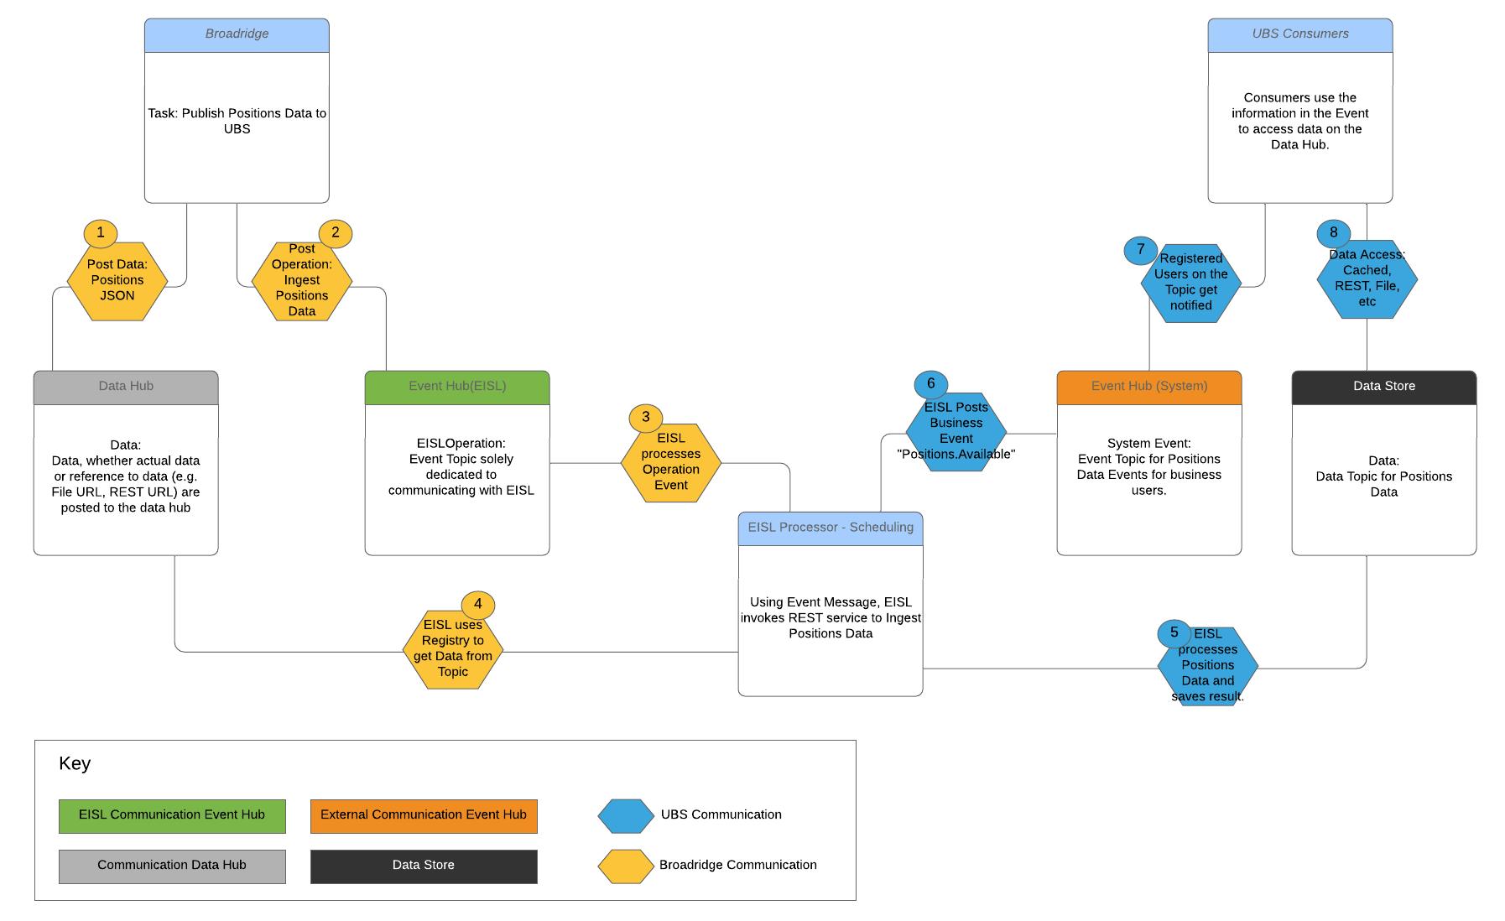

Figure 4 - Event Model (Near Real-Time or Batch)

## Real Time Streaming Data Flow (e.g. Orders)

The model for data streaming is slightly different than the EISL Data model. In this scenario there is a pre-requisite to setup the data communication channel. This is achieved by triggering a business event (e.g. orders.start) and will be shut down by triggering another business event (e.g. orders.end). Within these notifications ALL communications are simple data hub streams associated to this domain. While these business events are triggered from EISL, the method of creating these is the same as with EISL Data where an external event tells EISL to generate this event. This allows EISL to configure and validate applications (users) registered for this.

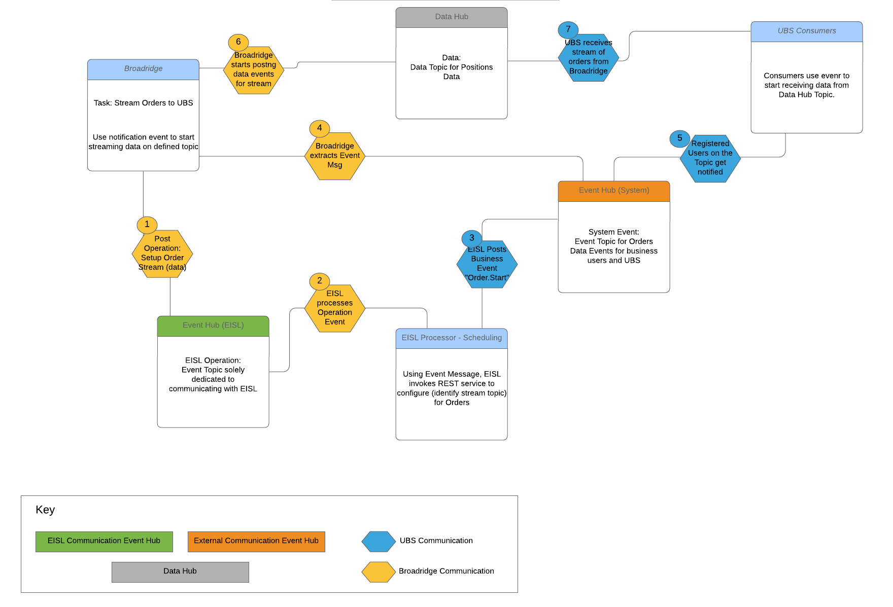

Figure 5 - Event Model (Streaming)

## Data Request Flow (e.g. Security Master)

There must also be the ability for external entities to indirectly trigger data flow operations. This has been defined through a ‘request’ flow. Primarily this is an event flow, but also supports the ability to provide additional data attributes associated to these requests. These requests follow the standard pattern of communication through EISL and the triggering of an EISL flow that acts as the intermediary before creating a business event. This allows EISL to accomplish the following:

1. Authorization
2. Fault Tolerance
3. Traceability
4. Continuity

The following shows the associated high-level flow for a UBS consumer requesting the Security Master and defining additional UBS attributes associated to the data.

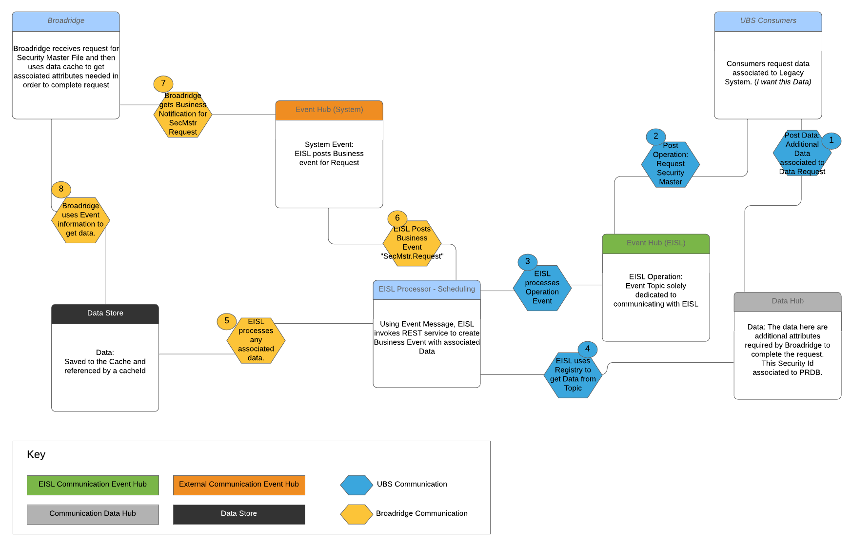

Figure 6 - Event Model (Request for Data)

# Initialization and Registration Code Interfaces

The implementation approach is based around Agile which means that the sequence diagrams are used to define Story Epics. Once the Epic is defined detailed design is added to each Epic and then used to create Technical Stories for Sprint delivery. Any issues identified in the above process or changes to architecture are then added to the sequence diagram and design and additional stories are added to the backlog.

The following shows the code snippets that implement Initialization for communication with EISL:

## Initialization Epic

Defined by the following Sequence Diagram:

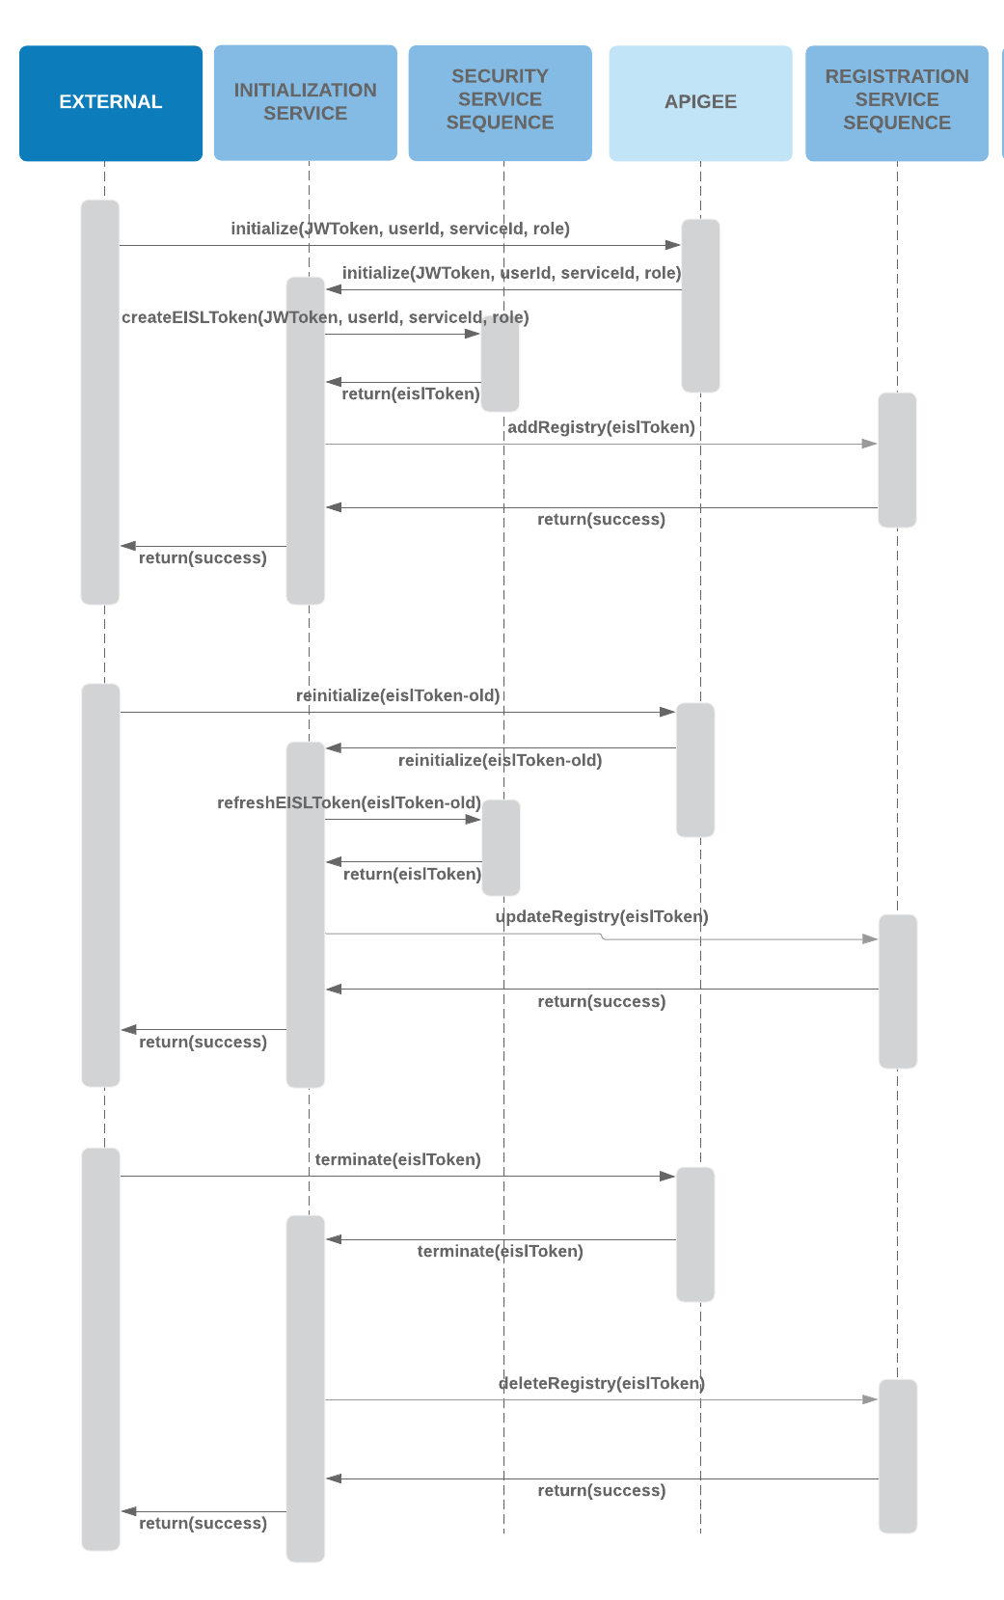

## Initialization Technical Story Design

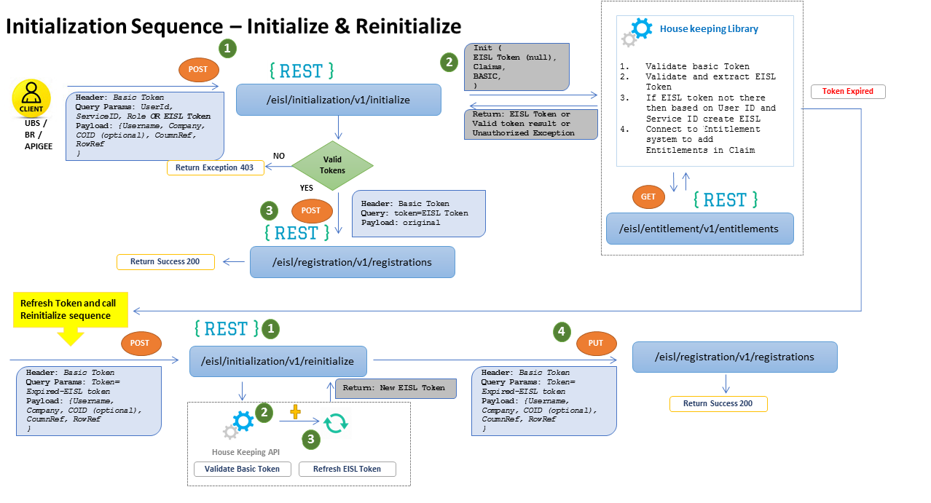

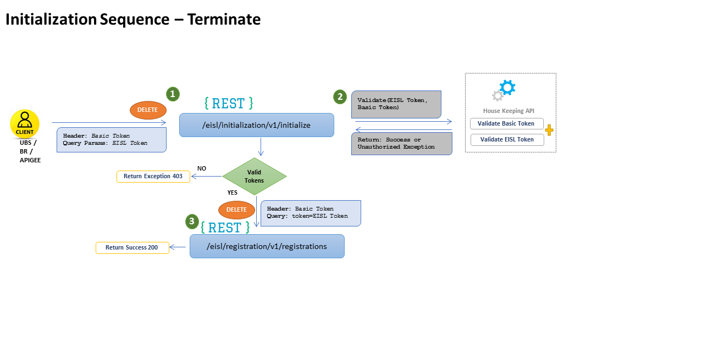

## Registration Story Epic

This is defined by the following sequence diagram:

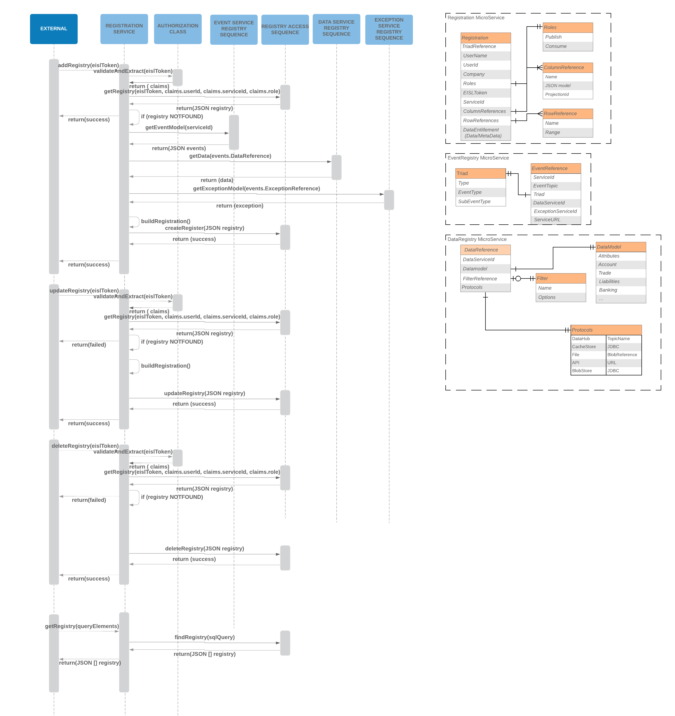

## Registration Technical Story Design

Once applications (users) have initialized their interaction with EISL they must register. The following shows the code snippets for these operations:

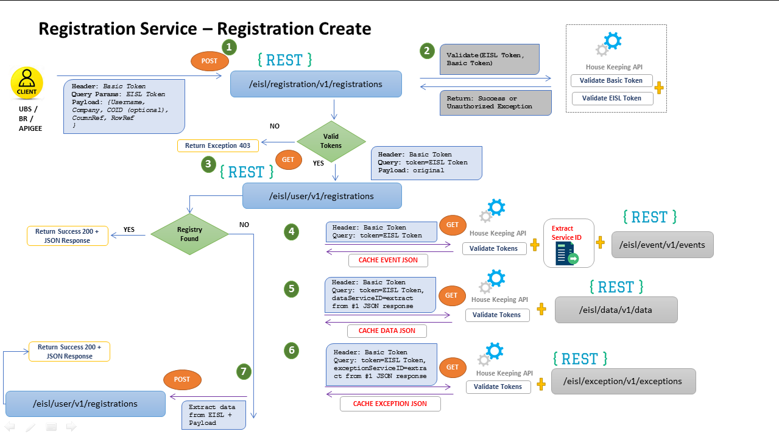

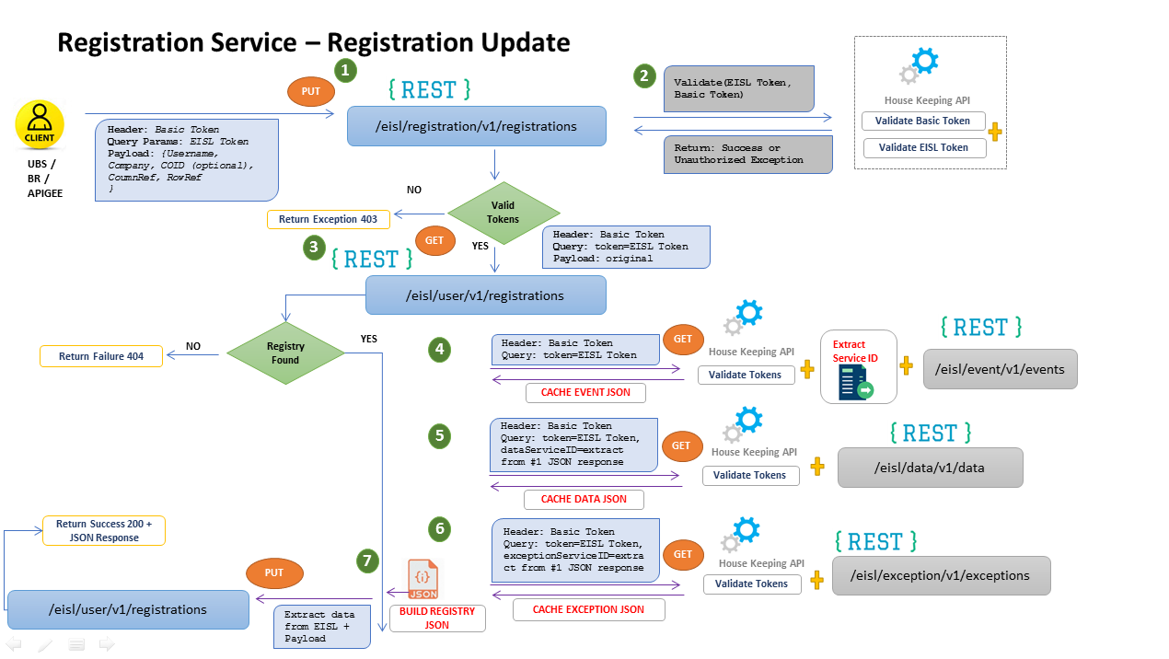

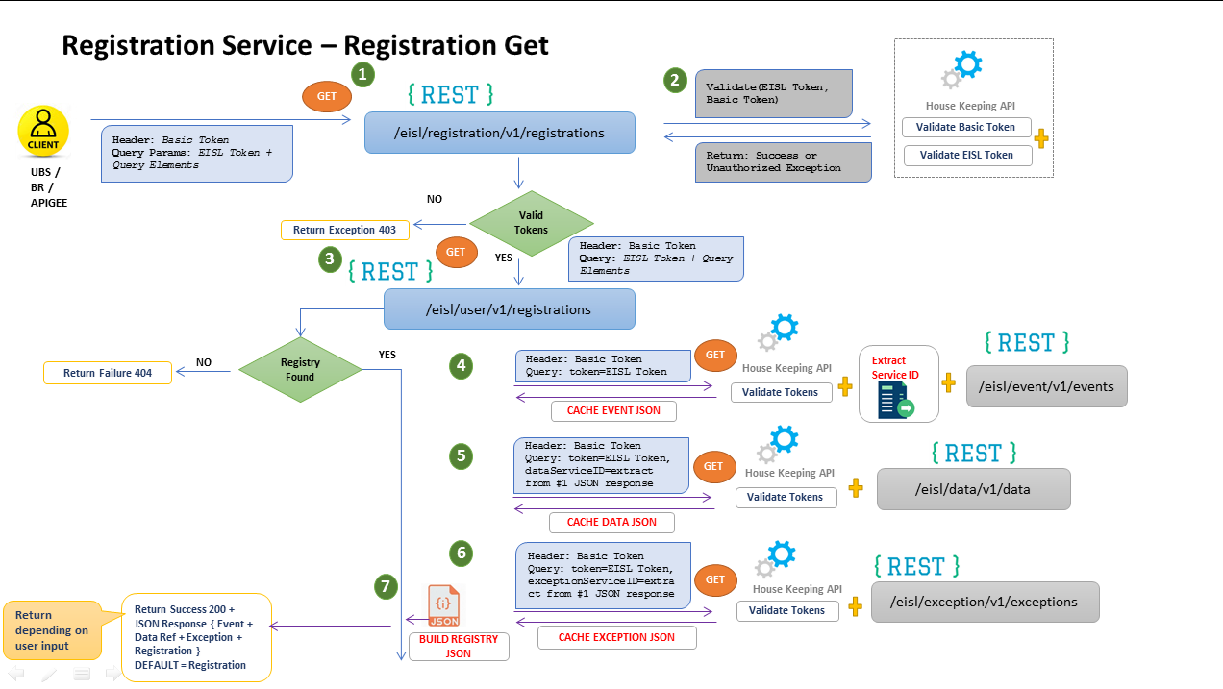

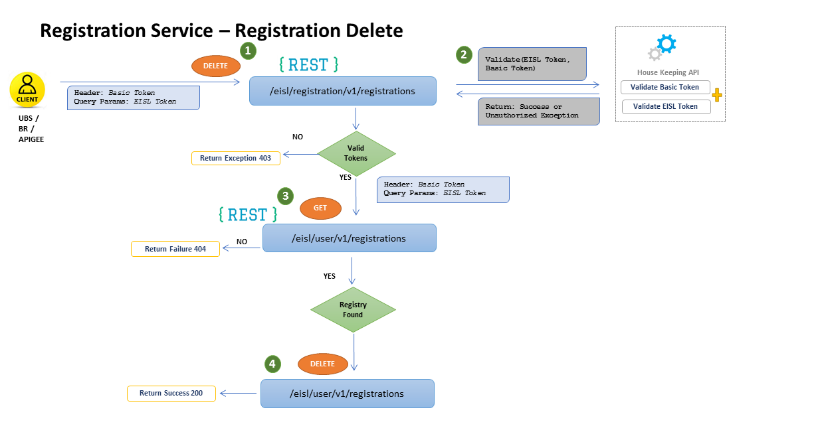

# Appendix

## Event-Driven Architecture

Kafka (Confluent) was selected as the Notification Hub technology for the following reasons:

1. High performance capabilities associated to data streaming.
2. Ability to handle large numbers of event messages with guaranteed deliver and ordering.

The event driven architecture is designed to initiate all interactions through events. The implication being that all external entities register for events from EISL. Any event received from EISL allows an external entity to then process associated to data, where the data could be a REST Service to access the data or the topic used to stream data.

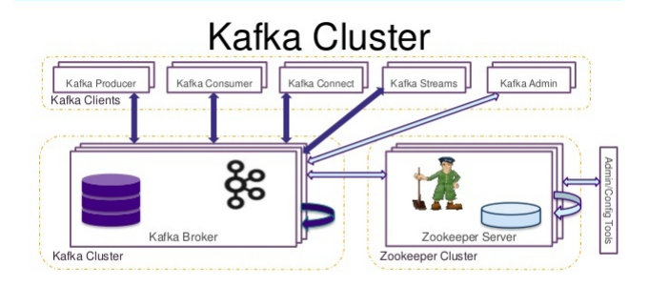

## Event Driven Process - High Level Flow

Event driven architecture that allows the processing of both events and data can be explained from publishers' perspective and consumers' perspective separately as given below.

### Inter-Business Request Flow

As an underlying fundamental component within the EISL platform is the ability for external users (applications) to request data from each other. This allows UBS to tailor and enrich ‘standard’ data from an external service provider and additionally ensures that external providers can deliver data ‘just-in-time’. The following flow shows how EISL participates and enhances this capability.

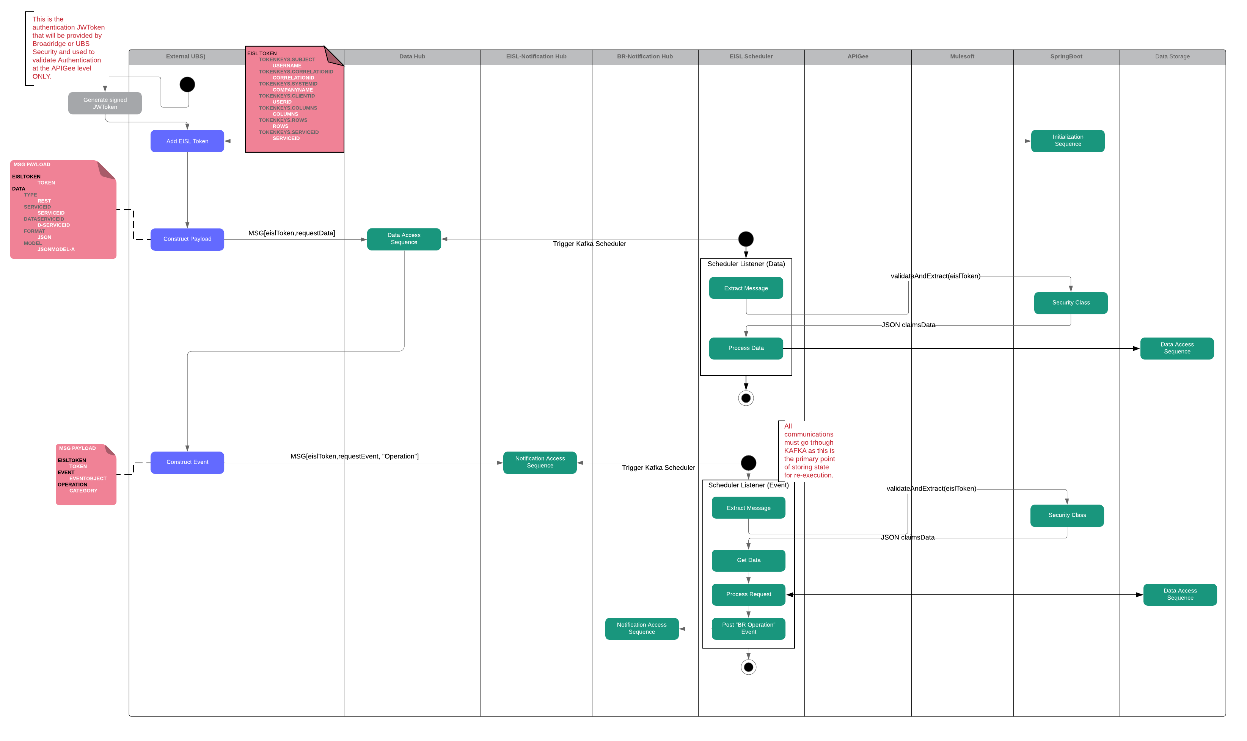

Figure 7 - Swimlane Flow (Request for Data)

### North Bound Flow

Northbound flow depicts how the events and data are processed from the publisher/producer's perspective. This flow starts with Client (UBS/Broadridge) generating the EISL token including 4 key attributes "userid, serviceid, role, eventOnly). The role attribute decides whether if request actor is a consumer or a producer **(Producer, in case of north bound)**, whereas eventOnly determine if you are registering for an event or for event and data.

With the EISL token the first entry point is Registration, the registration service will check

* If a user is already registered then registration endpoint will return the "Event" details,
* If a user is not registered, then will have to register the user and will return the "Event and Registration " details.
* In case "EventOnly" attribute in initial request is false then the Registration service will return the "Event + Data Reference and Registration" details

There are 2 subsequent notifications, both related through a single transaction id. These notifications are:

1. Data Message that defines the payload associated to the EISL Event.
2. Event Message that specifies what EISL should do with the data.

For the data message there is a Kafka listener that pulls the data off the topic and saves it to the blob storage, referenced by the transaction id.

The event message is processed through a similar listener within EISL and process the event message in order call the appropriate APIGee endpoint. Based on Service discovery logic the appropriate REST call is made which will either call a Mule flow.

Mule will execute the flow and retrieve the data (blob storage) using the transaction id, process/transform the data and will save it to the specified location (Cache). MuleSoft will pass back to the scheduler all information about the result including references to the final data location (in this case cache Id) and the original transaction id.

The scheduler event listener will then post the “System” event to the notification hub. This message will contain all the metadata associated to the data, including the cache Id needed to retrieve the data.

Below is the high-level view of north bound - events and data processing from the publishing perspective

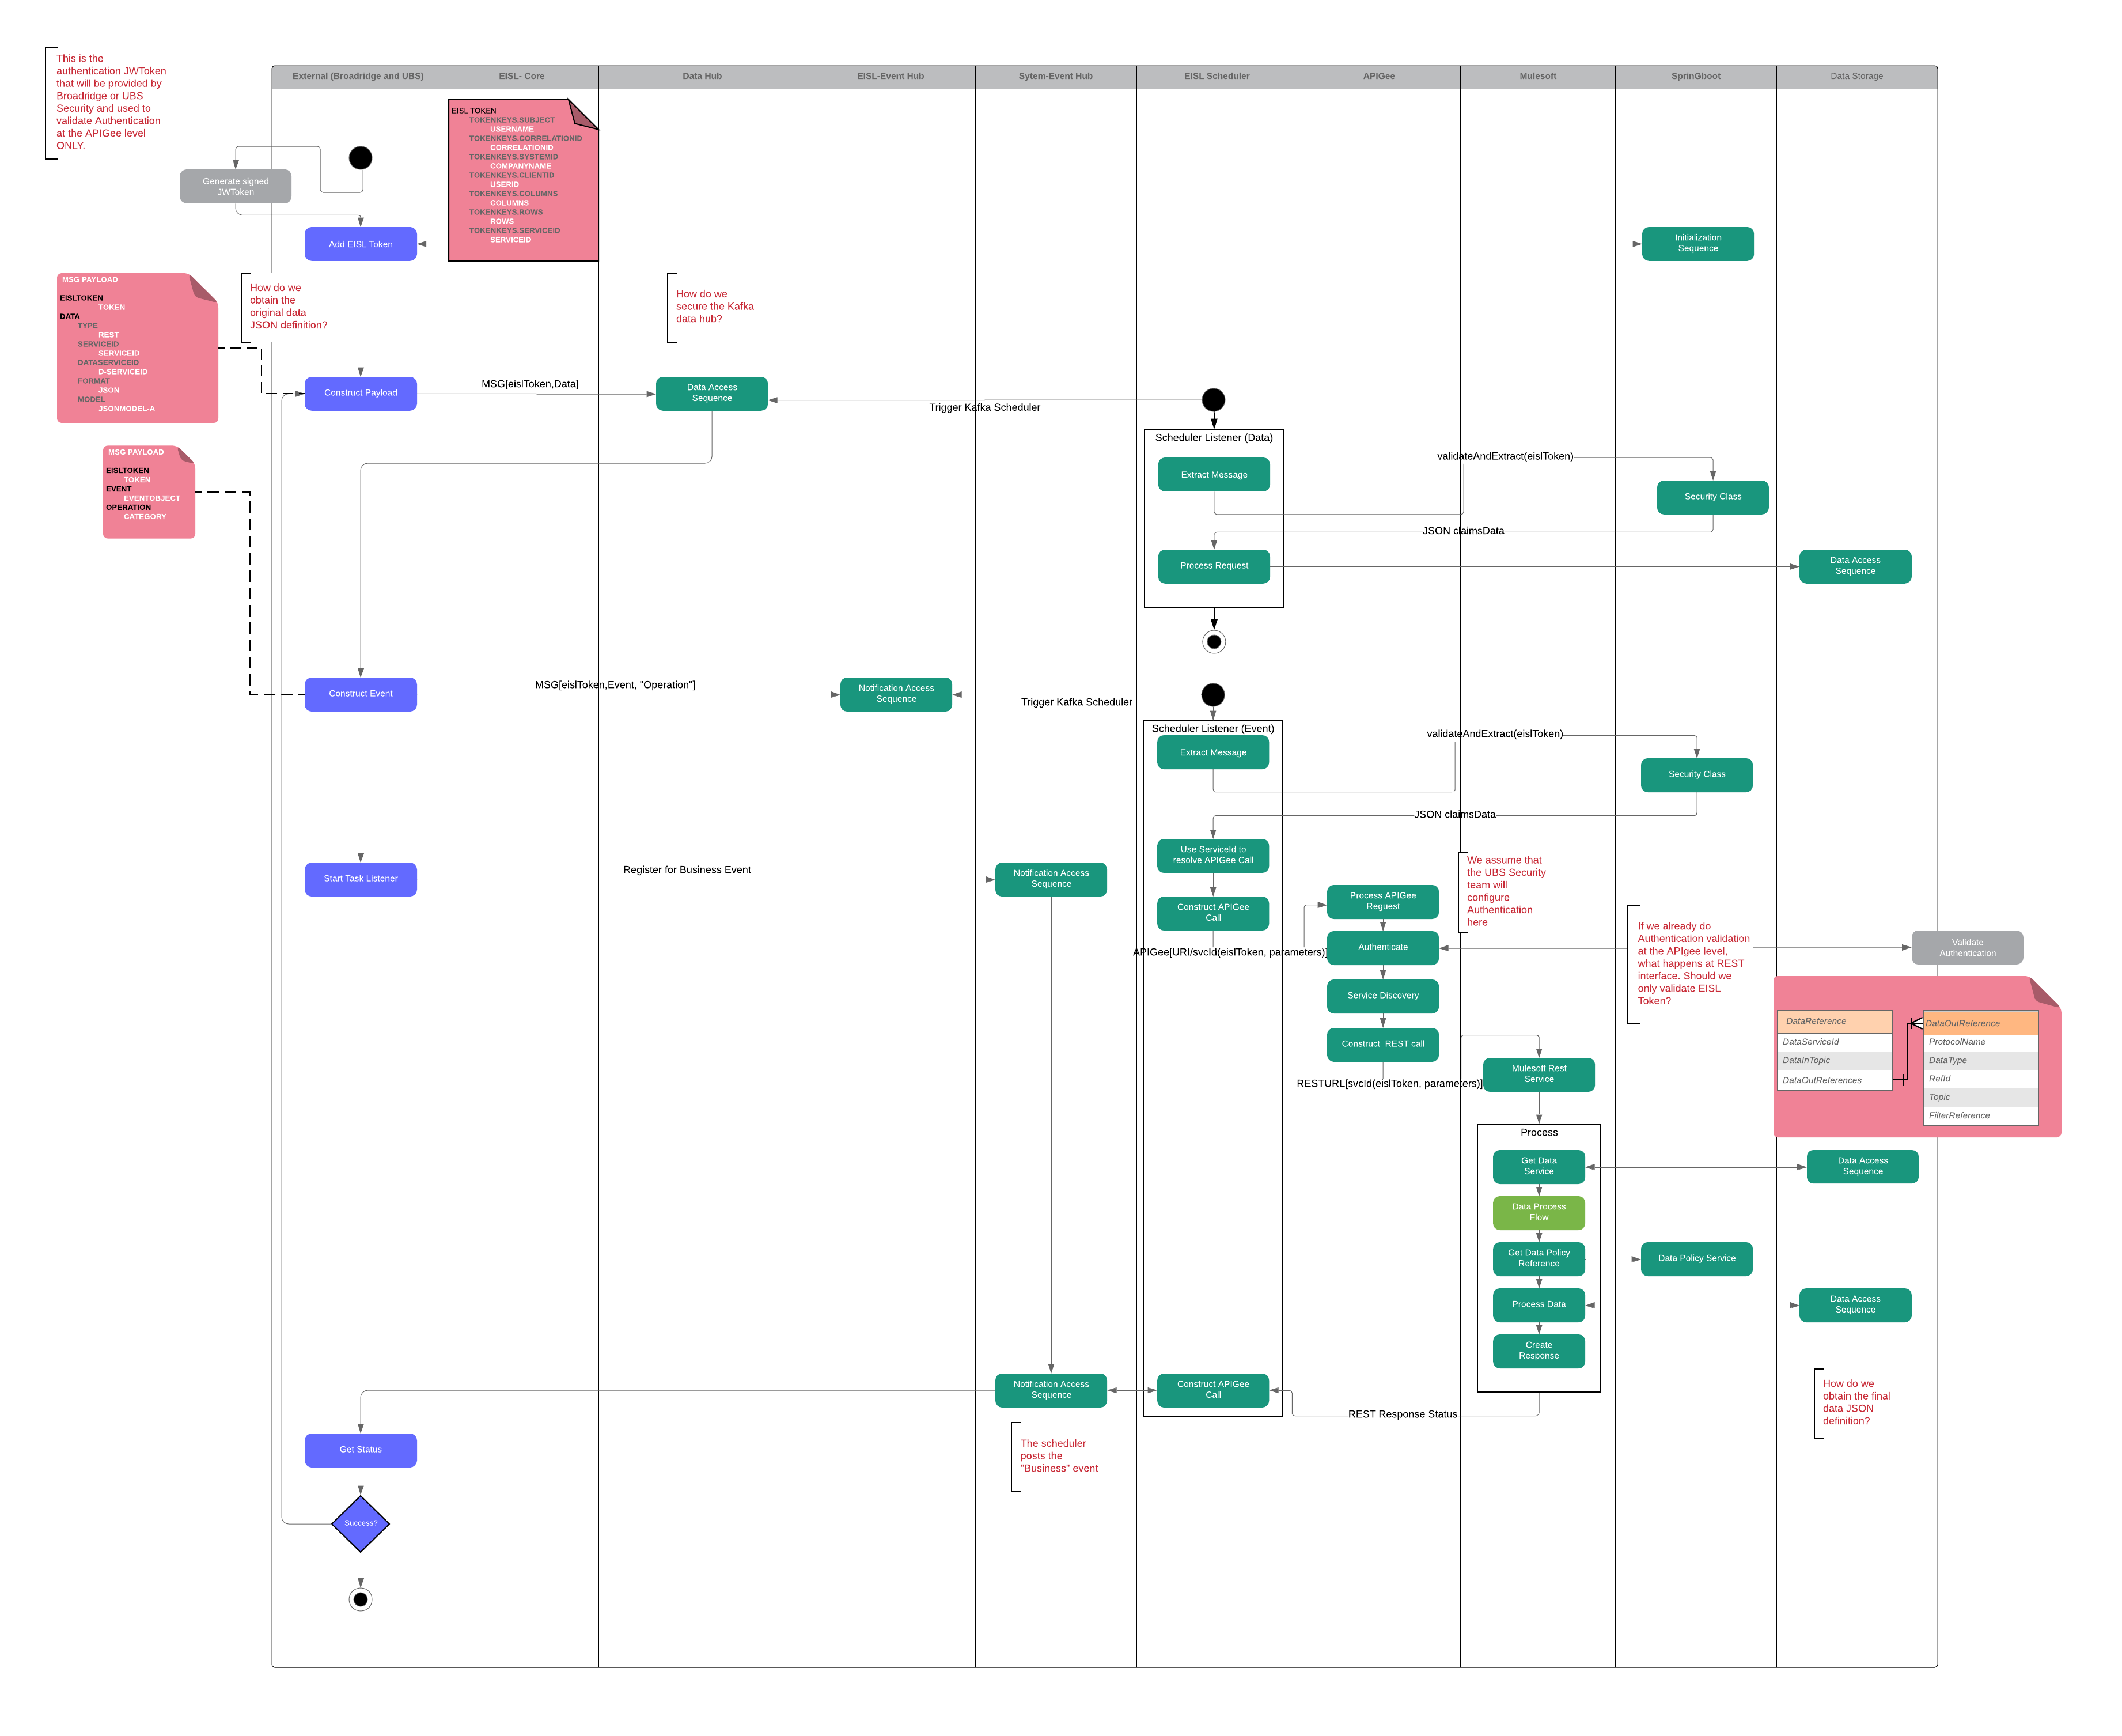

Figure 8 - Swimlane Flow (Data Publishing)

### South Bound Flow

This sequence starts with Client (UBS/Broadridge) generating the EISL token derived from 4 key attributes (userid, serviceid, role, eventOnly). The role attribute decides whether if request actor is a consumer or a producer **(Consumer, in case of South bound),** whereas “eventOnly” determine if you are registering for an event or for event and data.

With EISL token the first entry point is Registration, the registration service will check

* If a user is already registered then registration endpoint will return the "Event" details,
* If a user is not registered, then will have to register the user and will return the "Event and Registration " details.
* In case "eventOnly" attribute in initial request is false then the Registration service will return the "Event + Data Reference and Registration" details.

A system event will trigger the request that an event has occurred. The event message will include all the information necessary to achieve one or both of the following:

1. Identify the metadata associated to the event. This could be that a file containing x number of rows has been transferred to a location or that an order over a certain price has been processed.
2. Retrieve the explicit data associated to this event, this will enable the external entity to retrieve the following:
   1. Identify the cache data using the cache id.
   2. Identify a REST URL from the metadata in the event.
   3. Identify a File location from the metadata in the event.
   4. Identify a data streaming topic for a new stream of data.

In addition to this the event will also contain the original transaction id associated to the initial data processing ensuring that EISL maintains complete traceability at the transaction level.

Below is the southbound aspect of the same event driven process flow:

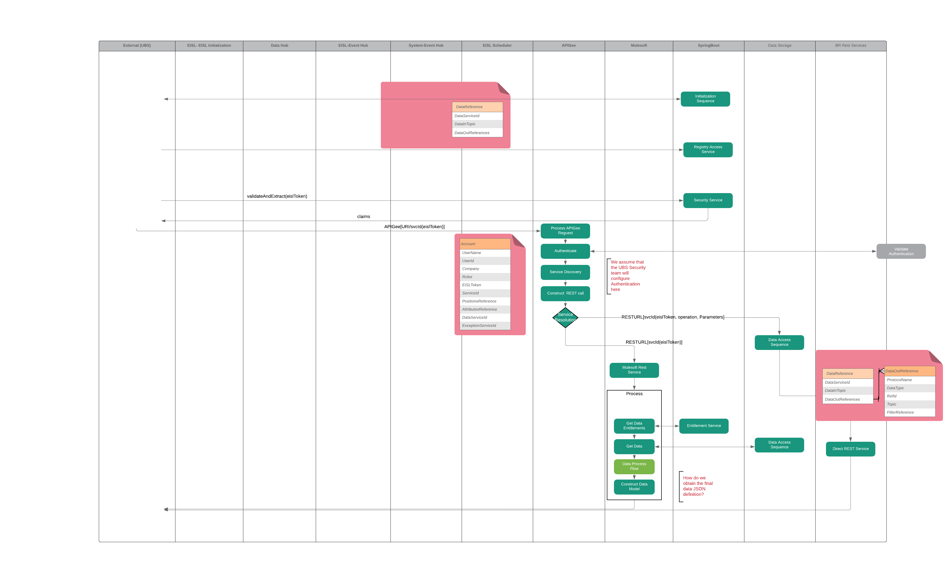

Figure 9 - Swimlane Flow (Data Consumption)

In order to support the above two flows (North/South), producers and consumers will need to register and continue to support that both within a transaction and across ongoing operations (day-to-day). The most logical way to accomplish this is to integrate the following:

1. Authorization
2. Entitlements
3. Service Access

This is accomplished using the initialization sequence, which can be automatically re-initialized and/or terminated by EISL as part of ‘master’ events.

### Data Streaming Flow

While the Northbound and Southbound flows depict near real-time and batch interactions, there is also a combination model associated to real-time data streaming. This model is triggered, like everything in EISL, through an event (domain.start) and will continue until another event (domain.end) is sent. The domain.start event will contain the data topic that both publisher and consumers will use for data streaming and access to the data stream will occur through the SDK layer (Data Access). The following flow shows how the two sides initiate and consumer data streams.

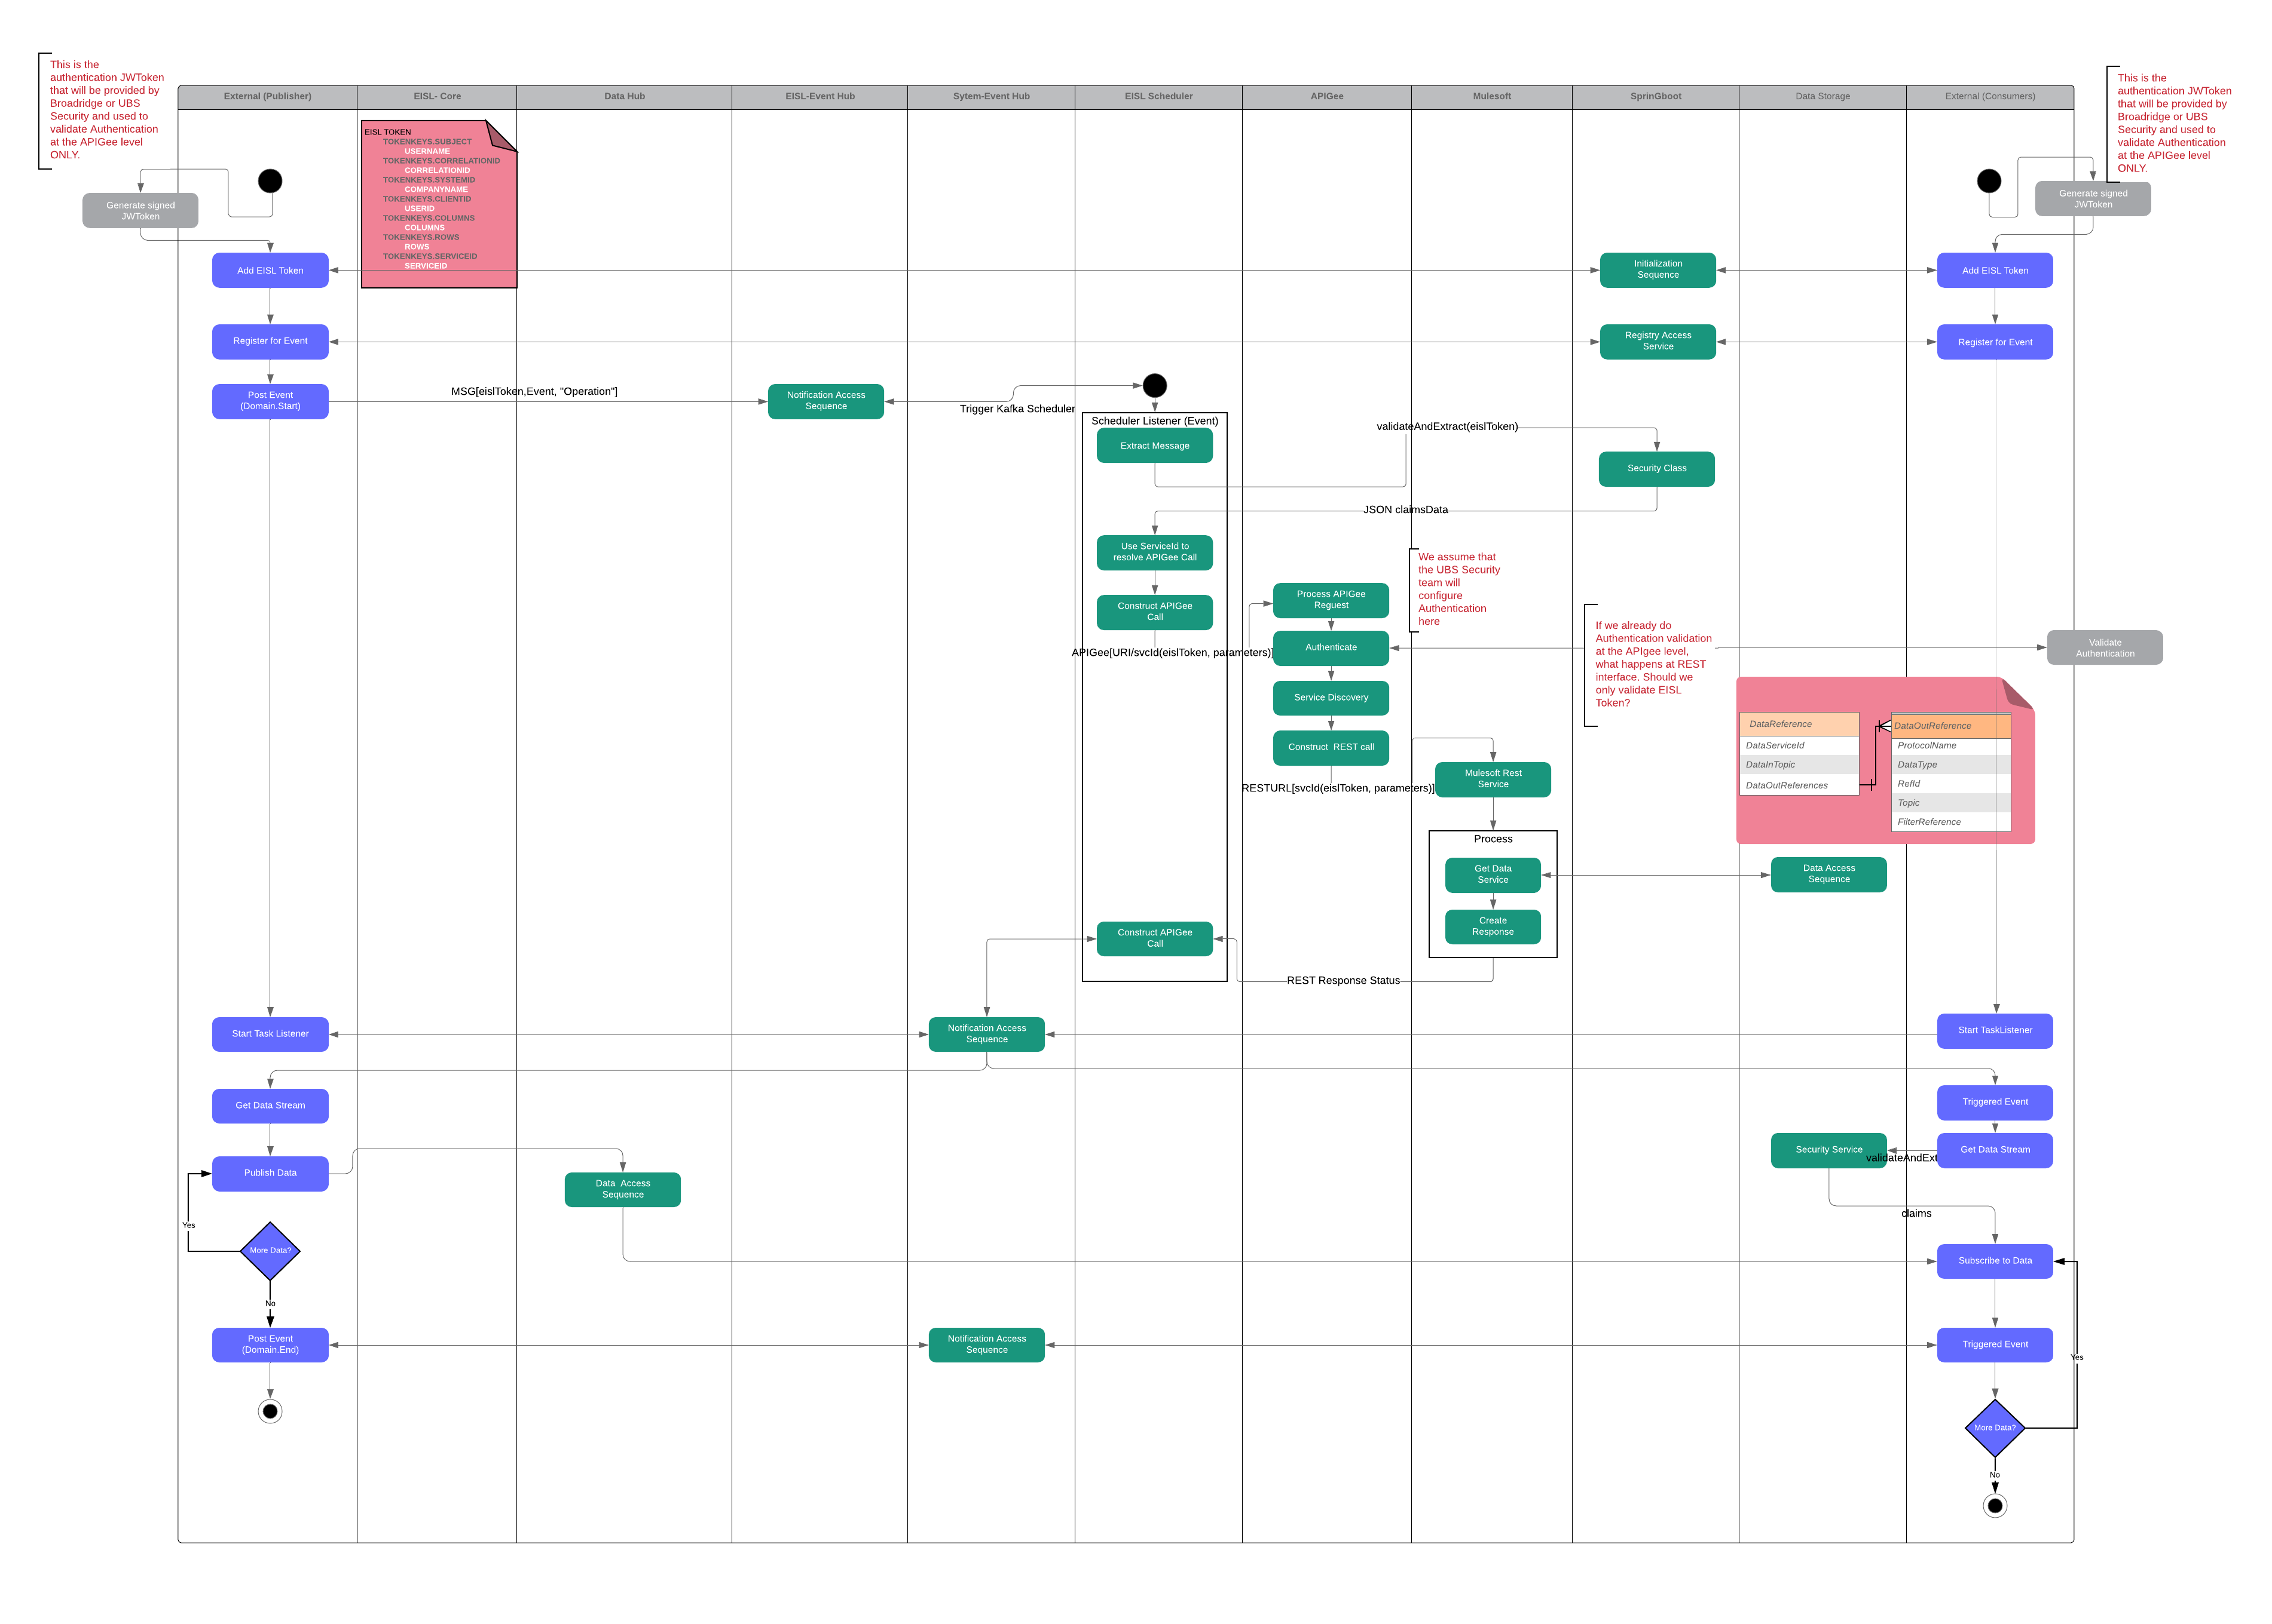

Figure 10 - Swimlane Flow (Data Streaming)

### Start/Resume/Terminate

Start/Resume/Terminate flow depicts how the external systems [Broadridge/UBS systems] is authorized and entitled by EISL using EISL token creation and registration, upon successful completion, the external system will be able to publish/consume events and data through EISL.

* External system will send basic token along with other claims data like user ID, service ID to APIGee
* APIGee will perform initialization method that will in turn, interact with security service for creating the EISL JW token
* Security Service will create the EISL token using the claims and would call the Entitlement Service by passing that EISL Token, User DI and Service ID to get the entitlements for the user and get the final EISL token from Entitlement service
* Initialization methods will also call registration service for both the event notifications and data access at service level for the given service id, user id and receive the registration completion status as response

Below is the process flow diagram that that explains the Start/Resume/Terminate sequence flow.

**Initialization Flow:**

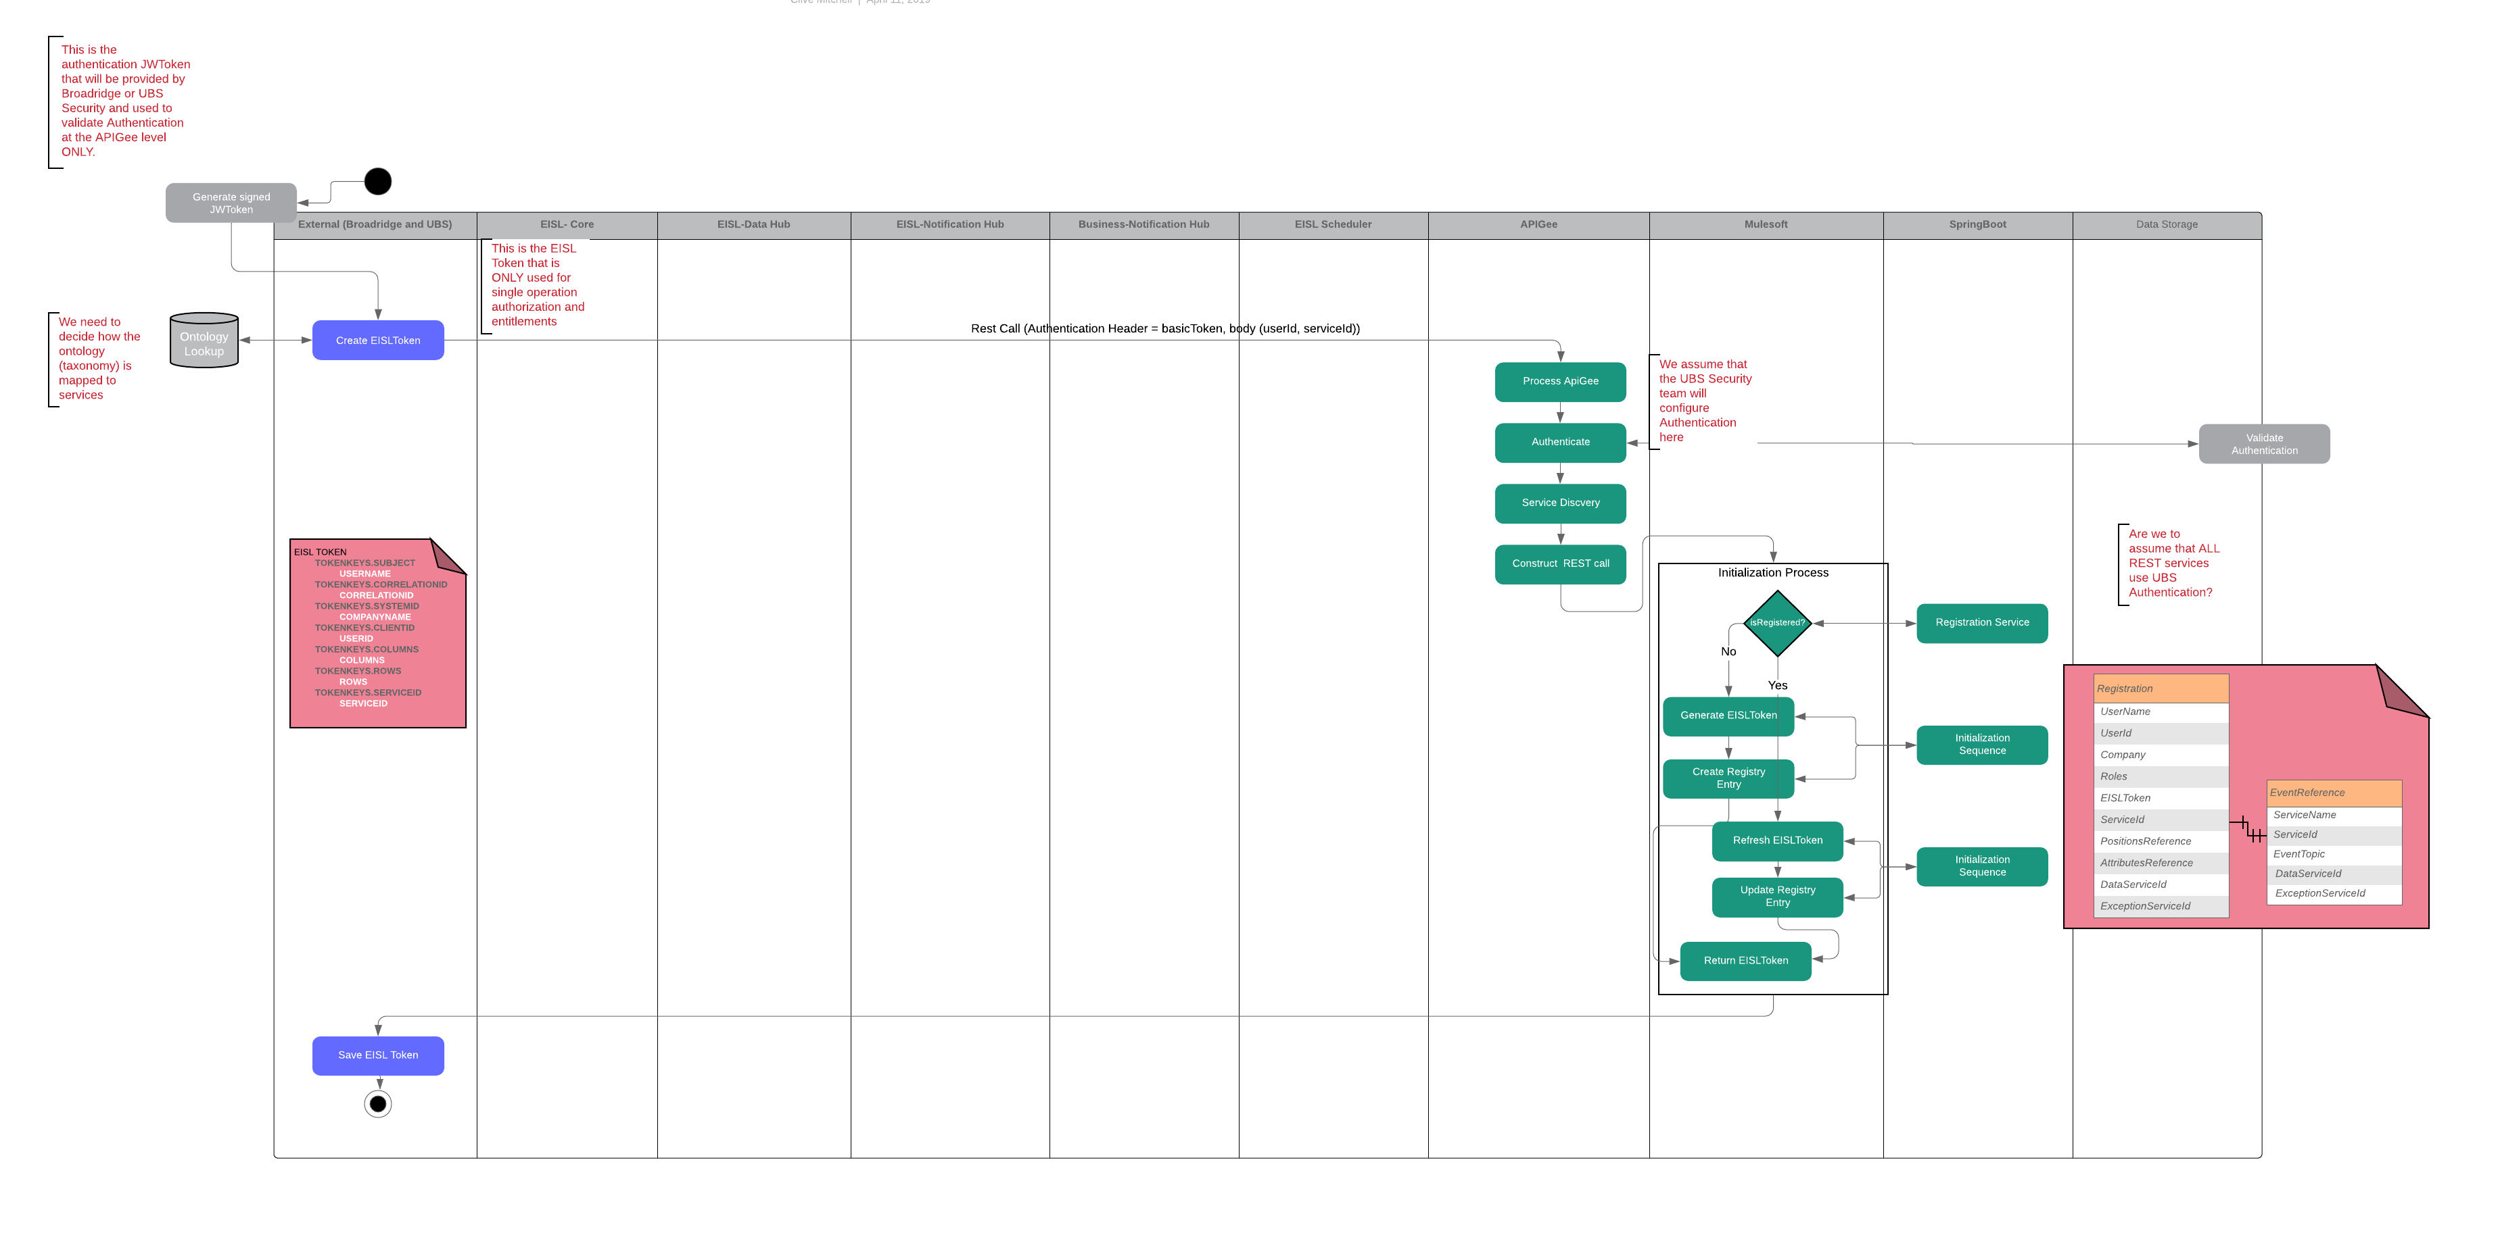

Figure 11 - Swimlane Flow (One Time User Authorization & Registration)

**Re-Initialization (Resume) Flow:**

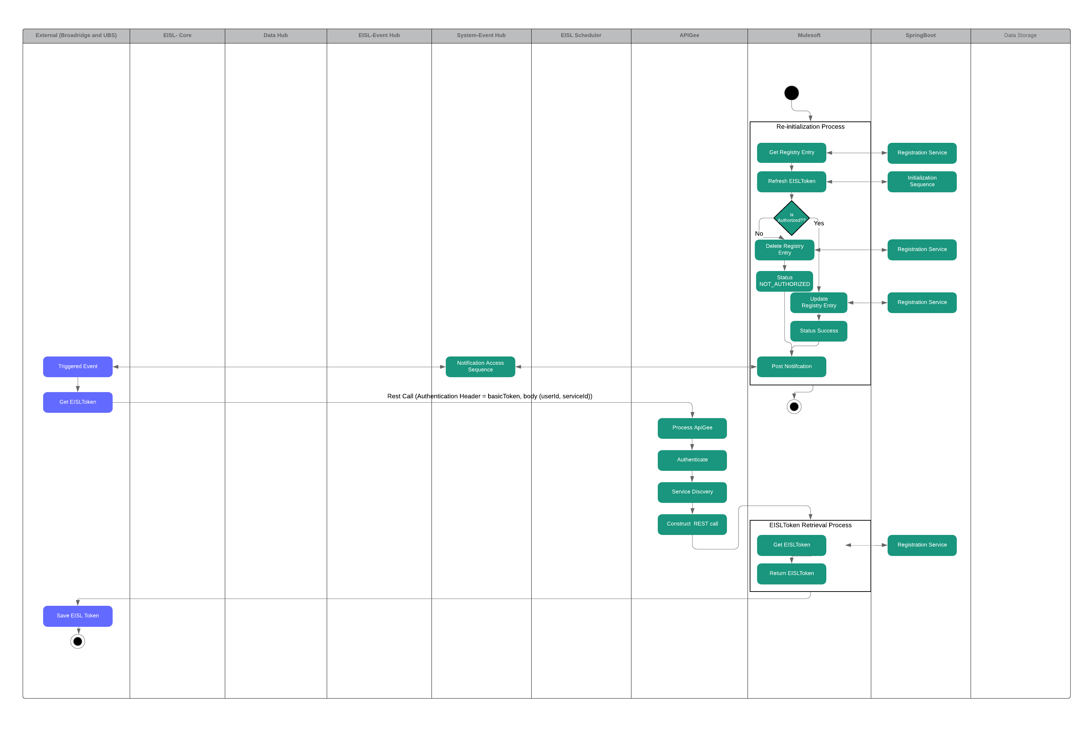

Figure 12 - Swimlane Flow (Automated Refresh of Authorization)

**Termination Flow:**

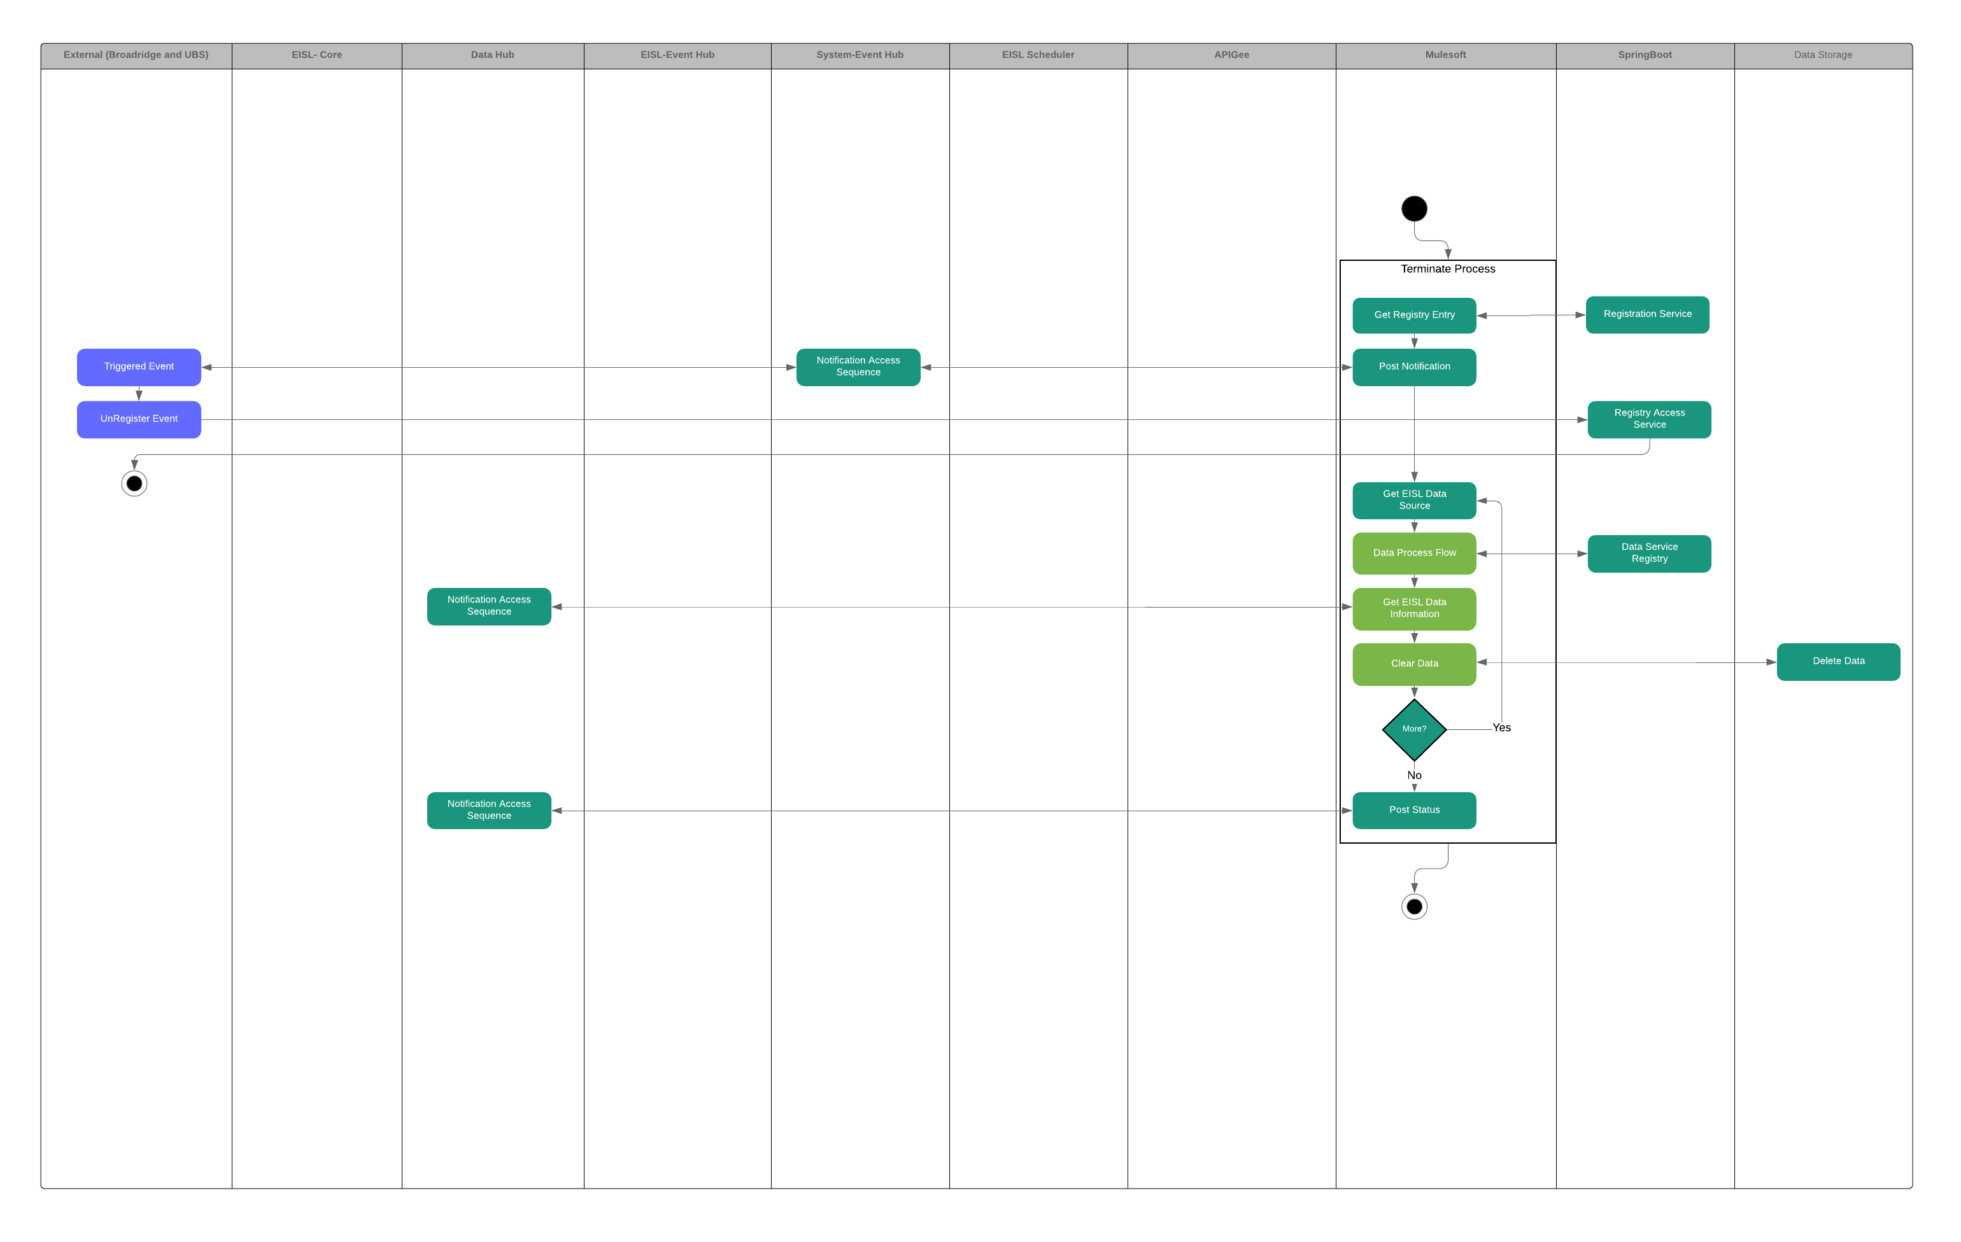

Figure 13 - Swimlane Flow (User Registration Cleanup)

### Master Events

This category includes system informational events such as End of Day, Start of Day and will trigger operations such as re-initialization and termination of current system flows and in addition will execute cleanup of cached and saved data. The following flow shows the process associated to the two previously mentioned master events:

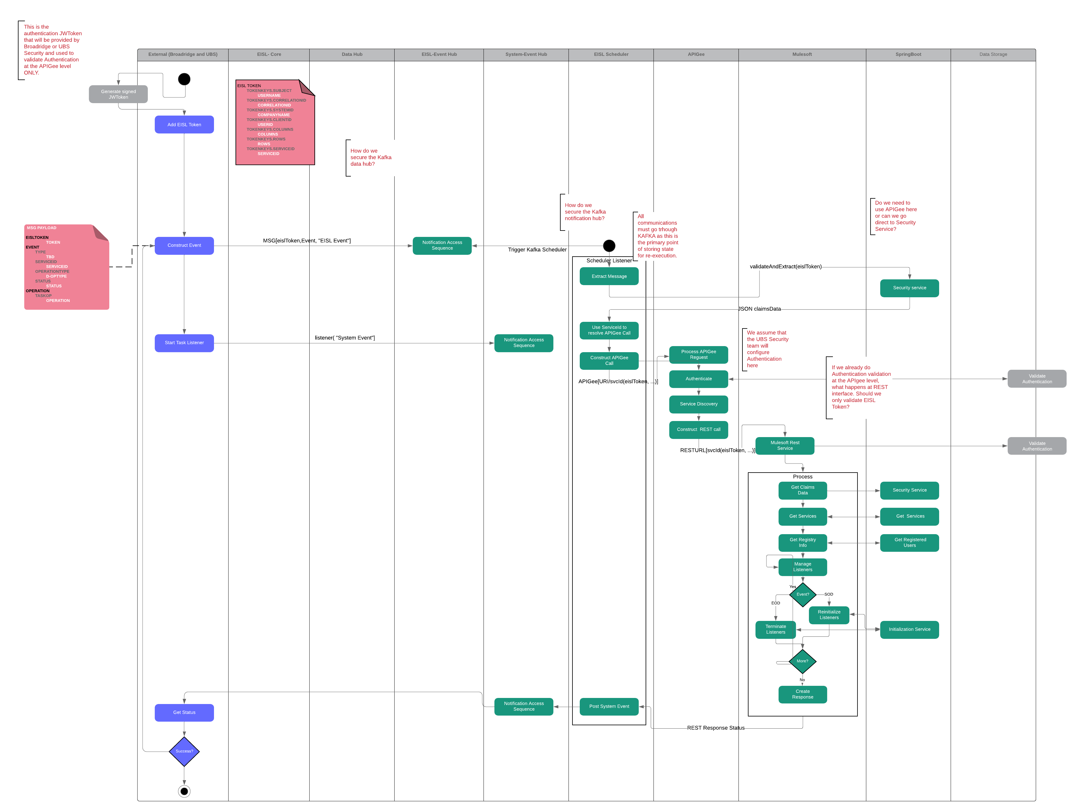

Figure 14 - Swimlane Flow (Grouped Operations)

## Design Details

The following sequence diagrams show how the Notification Hub handles the data transfer of positions data from Broadridge to UBS. The high-level use case looks like:

EISL notification hub design details can be grouped under Data Ingestion and Data cache.

This flow has the following key components associated to it:

**Data Ingestion**

1. The data, as JSON model, is posted to the Data Hub.
2. EISL scheduler will automatically pull the data from these pre-defined topics and store the data, including reference data, to the blob storage.
3. The producer (Broadridge) posts an event to EISL that executes the associated process to ingest the data.
4. The EISL scheduler automatically processes these events and identifies the transaction id (to get the data), the type of final data type of the ingestion (in this case Cache) and the REST service to invoke.
5. MuleSoft then uses the transaction id to access the associated data from the blob storage
6. MuleSoft continues to process this data, including any enrichment needed.
7. MuleSoft finally posts the output data to the pre-defined data type (in this case Cache) storage.
8. An event notification is then posted to the Notification Hub informing them that the Positions Data is now available, along with metadata identifying how to access the data (cache id).

**Data Cache Access**

1. Any UBS application that is registered for this event will now be triggered.
2. The UBS application will then extract the event message, obtaining the metadata, service URL and the data location (cache id)
3. The application service will then invoke the service URL, which will resolve to a MuleSoft flow, that then processes the request and retrieves the data.

### Data Ingestion Sequence Diagram

The following sequence diagram shows how data is ingested; in addition, there are similar sequences to handle:

* Data Streaming
* File Upload
* Direct Rest Calls

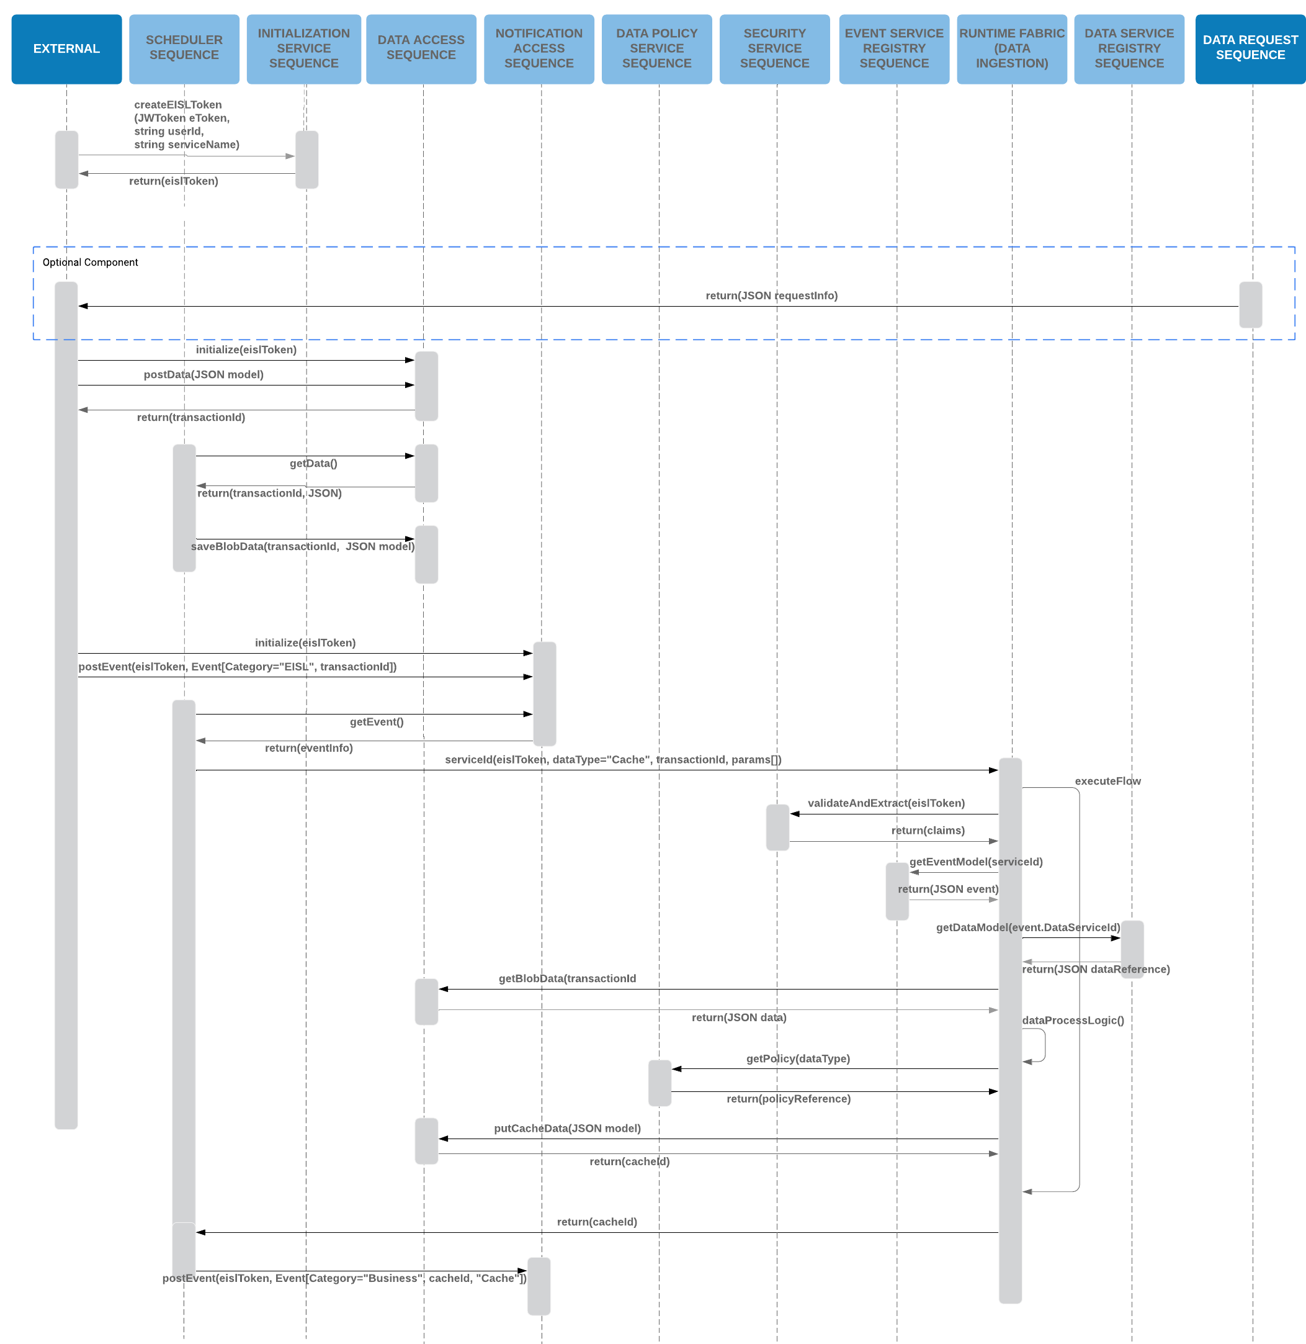

### Data Cache Access Sequence Diagram

This sequence identifies the flow associated to retrieving data from cache after being triggered by a business event notification.

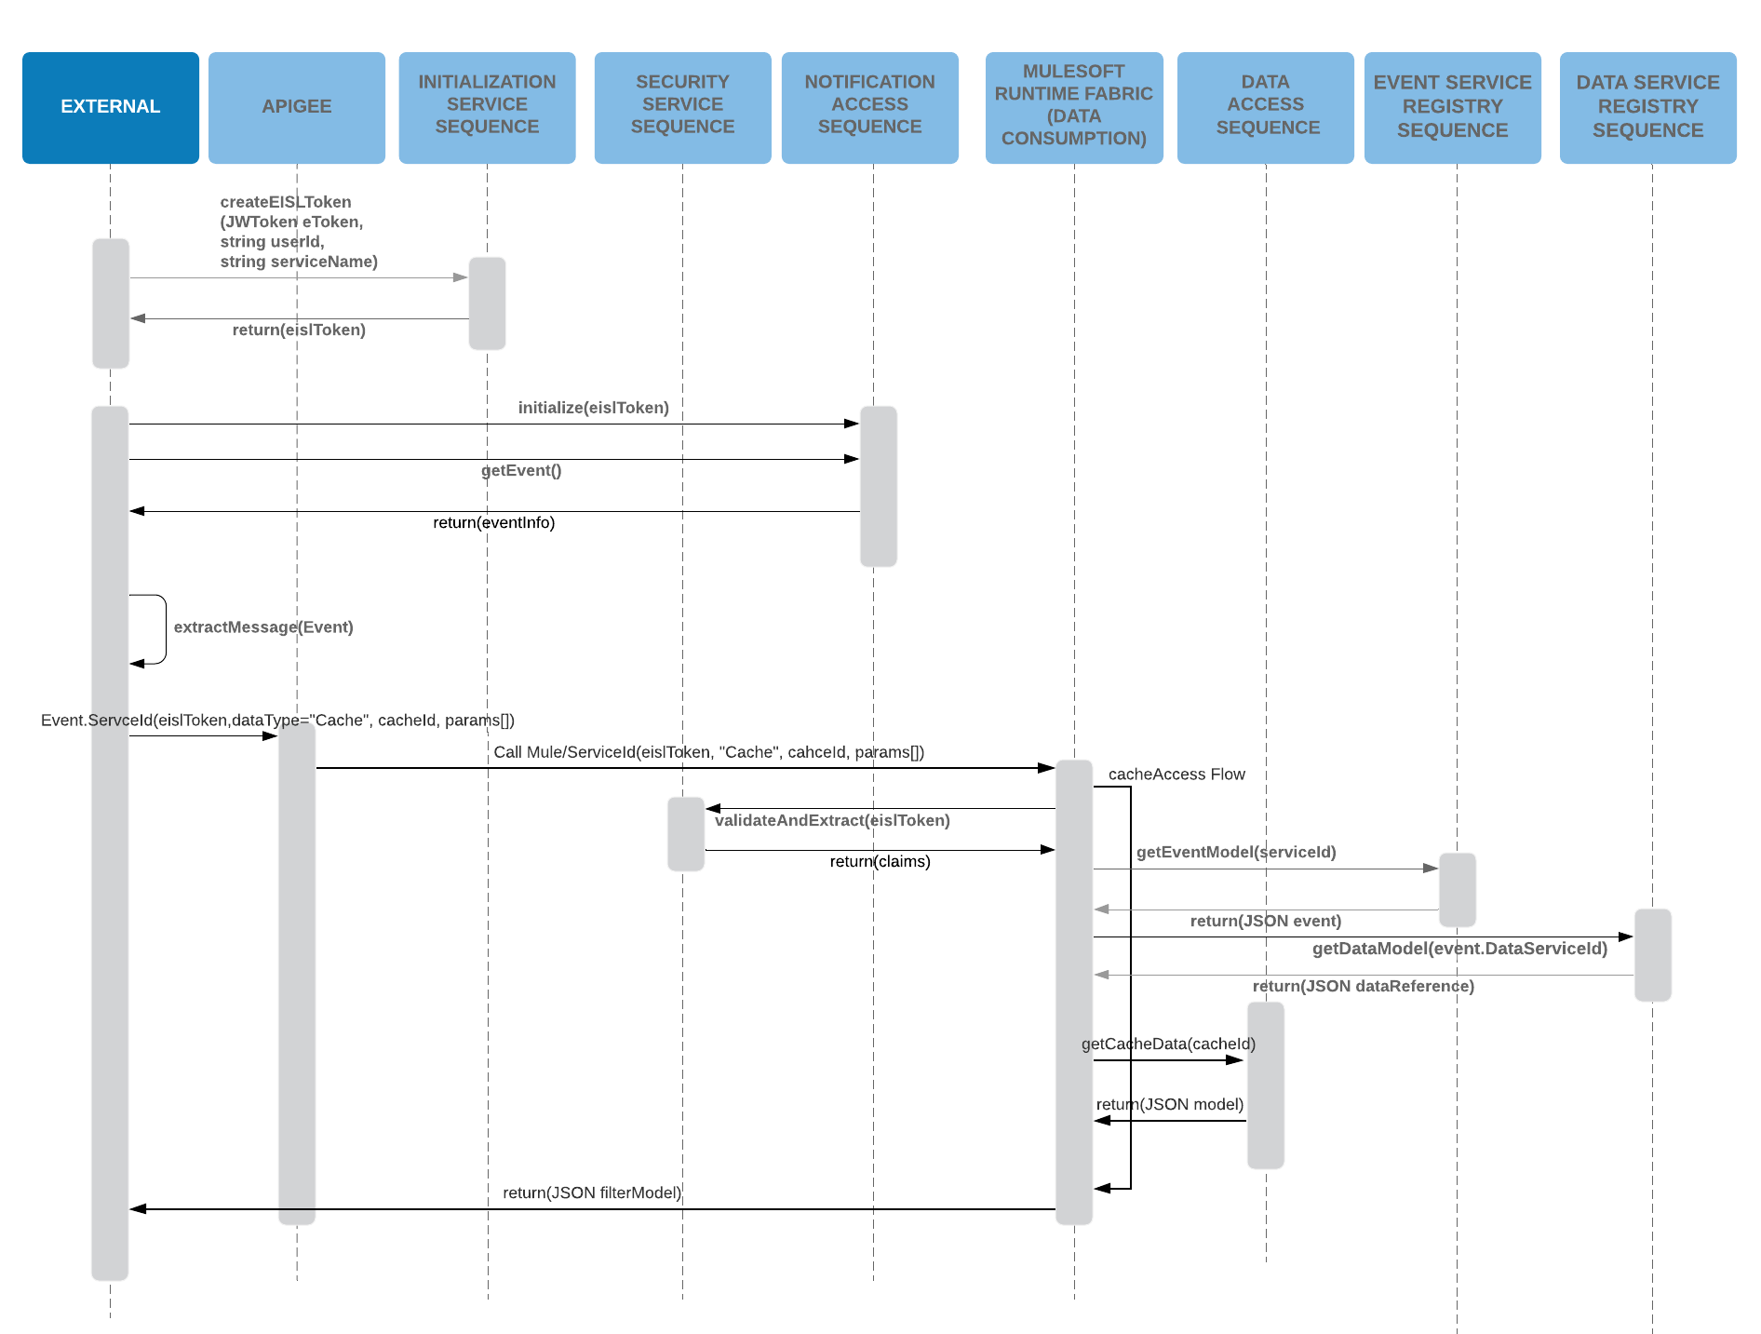

### Data Request Sequence Diagram

The following sequence diagram shows how external entities can request data and how that would be processed within EISL:

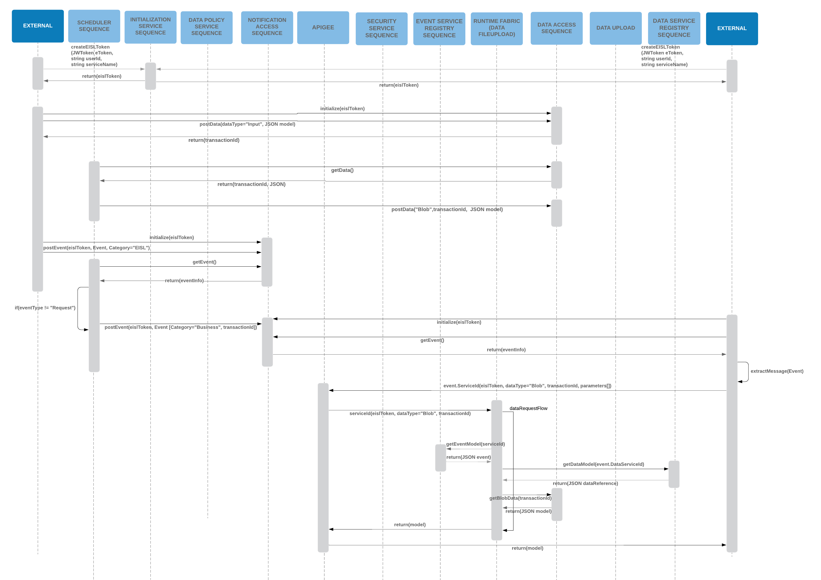

### File Transfer Sequence Diagram

The following shows the high-level sequence for file transfer, which would have been indirectly triggered from the request sequence. This would allow the receiving party to specify the destination location.

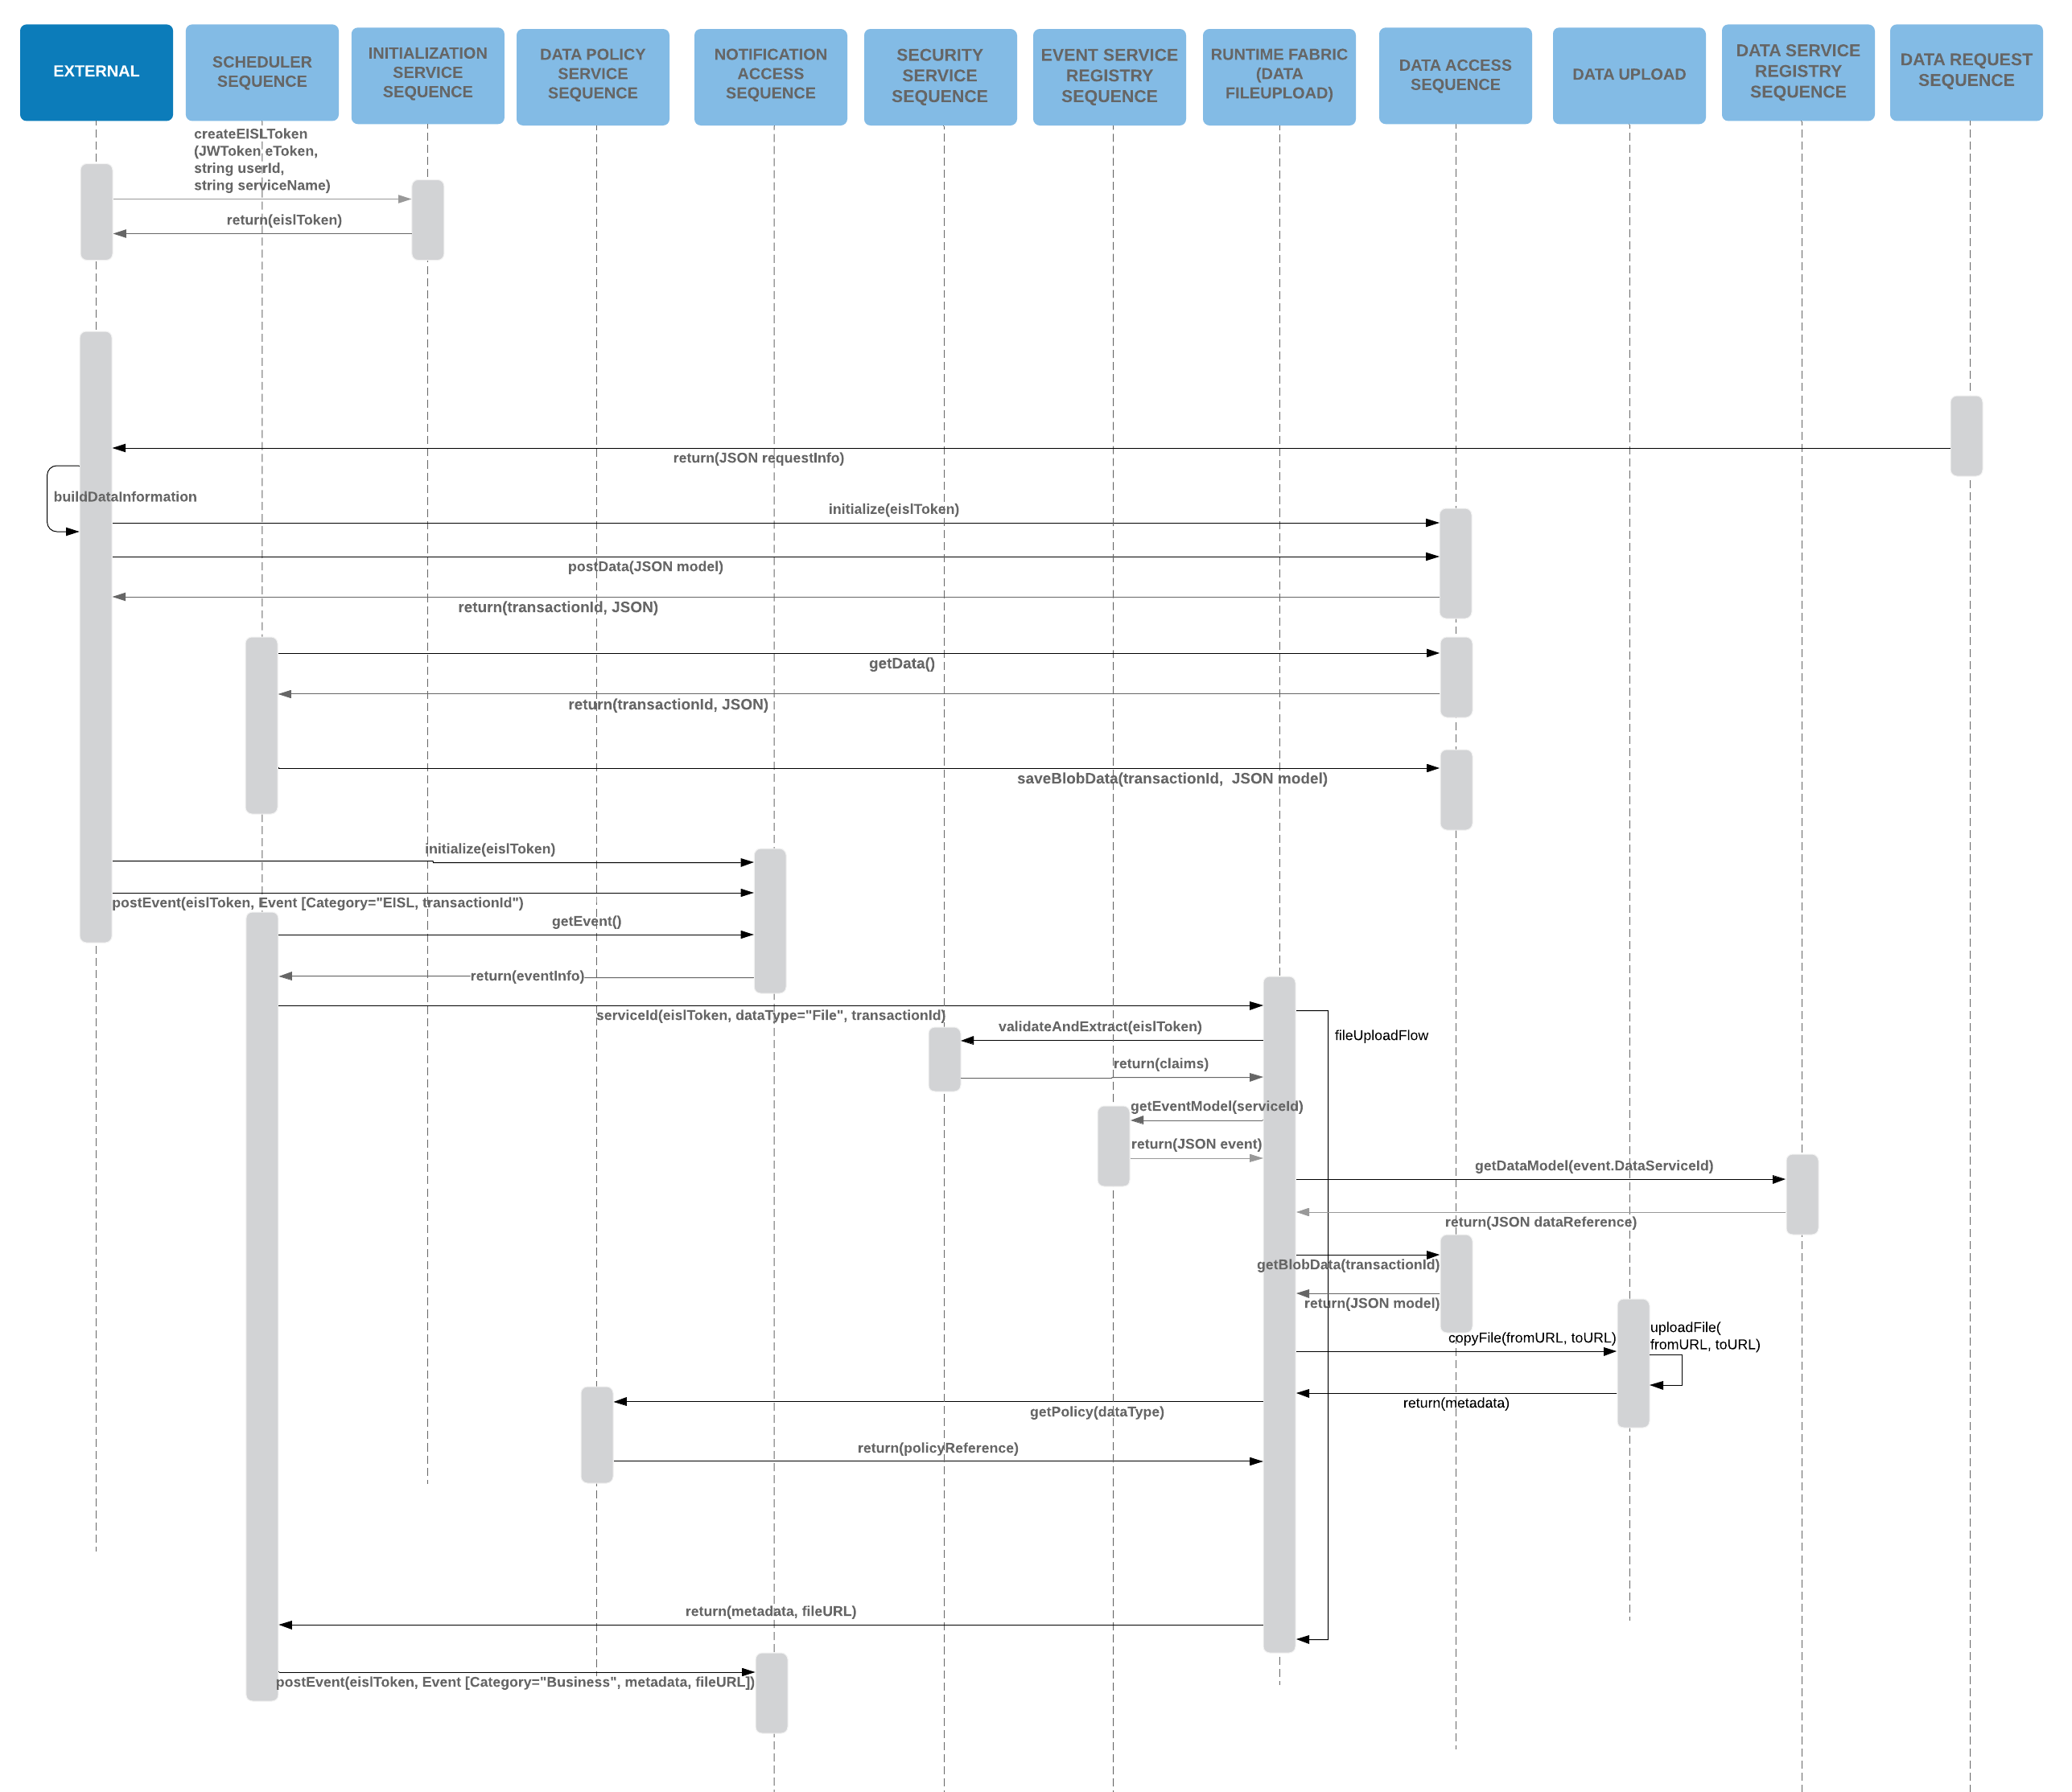

### REST Call Sequence Diagram

This sequence diagram expresses the communication events necessary to identify and retrieve remote data through a REST call. EISL plays the role of communication manager processing the request and identifying the REST URL endpoint to proceed.

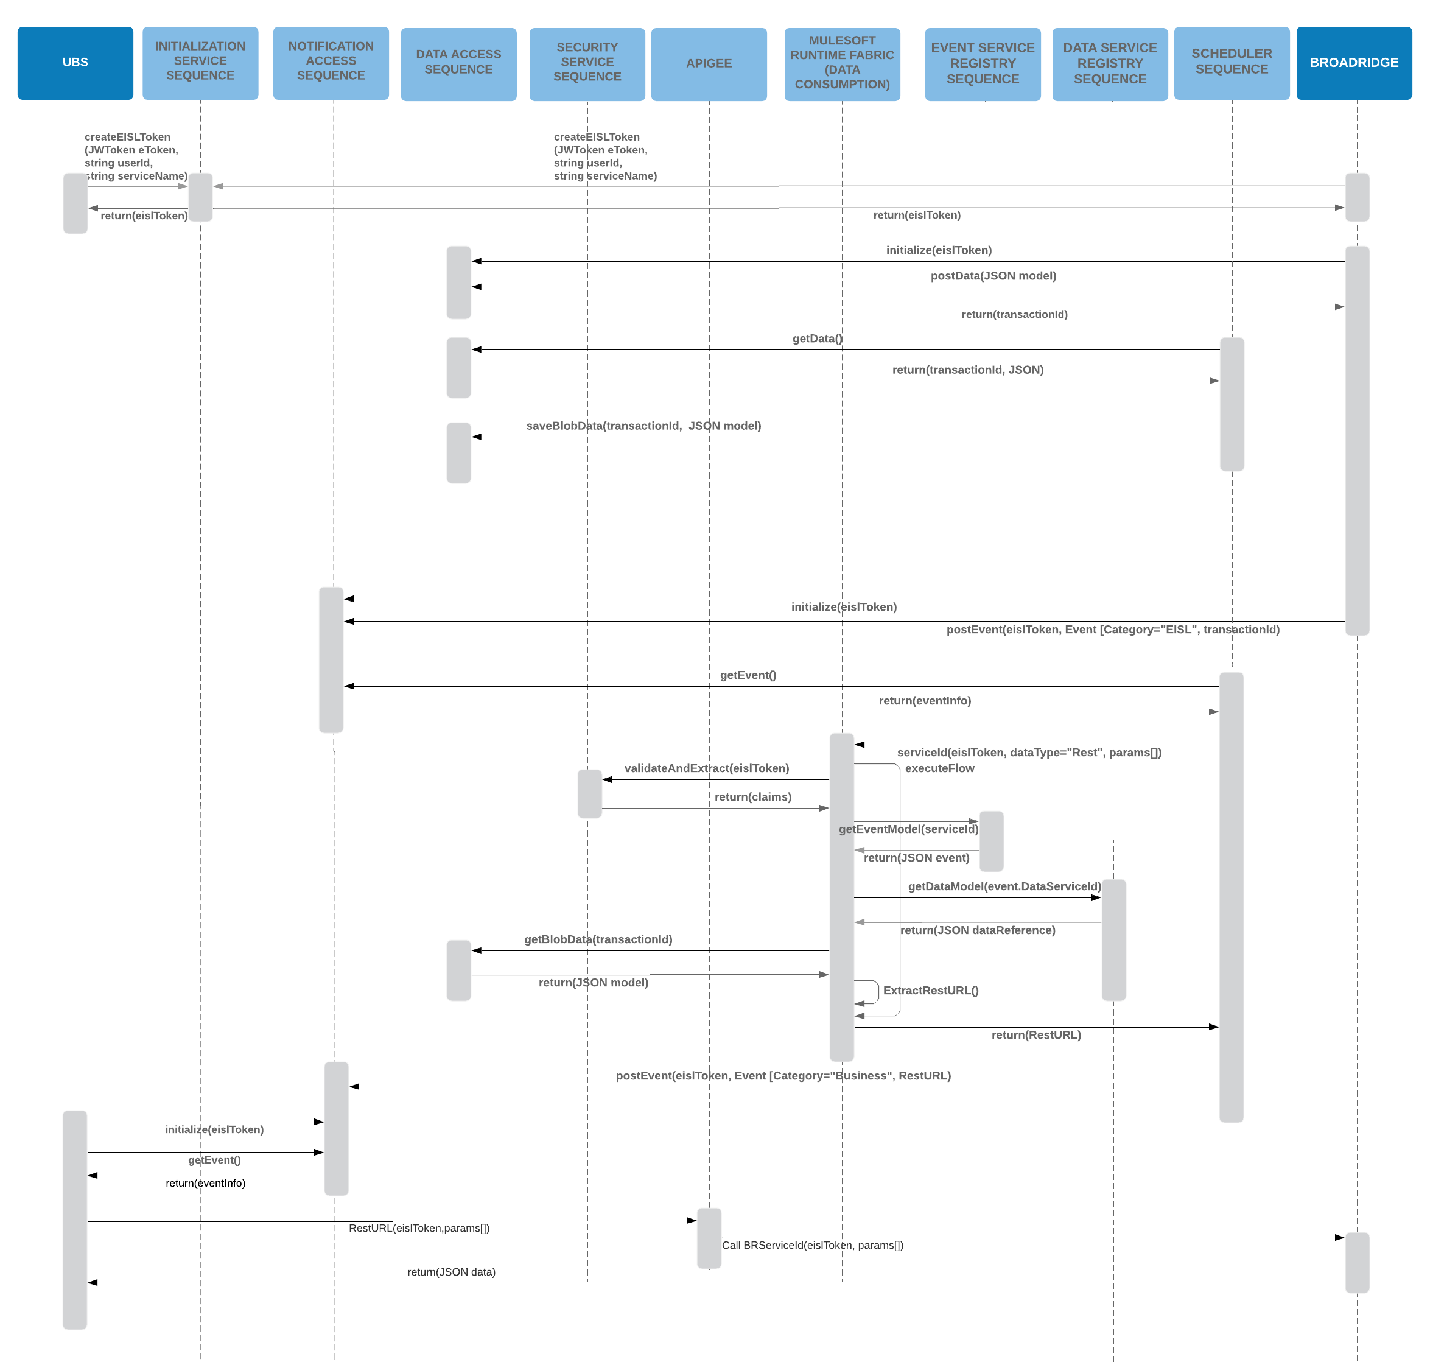

### Data Stream Sequence Diagram

This sequence diagram represents how data can be streamed between external entities. EISL plays the role of establishing the validity of the participants and then initializing the transport.

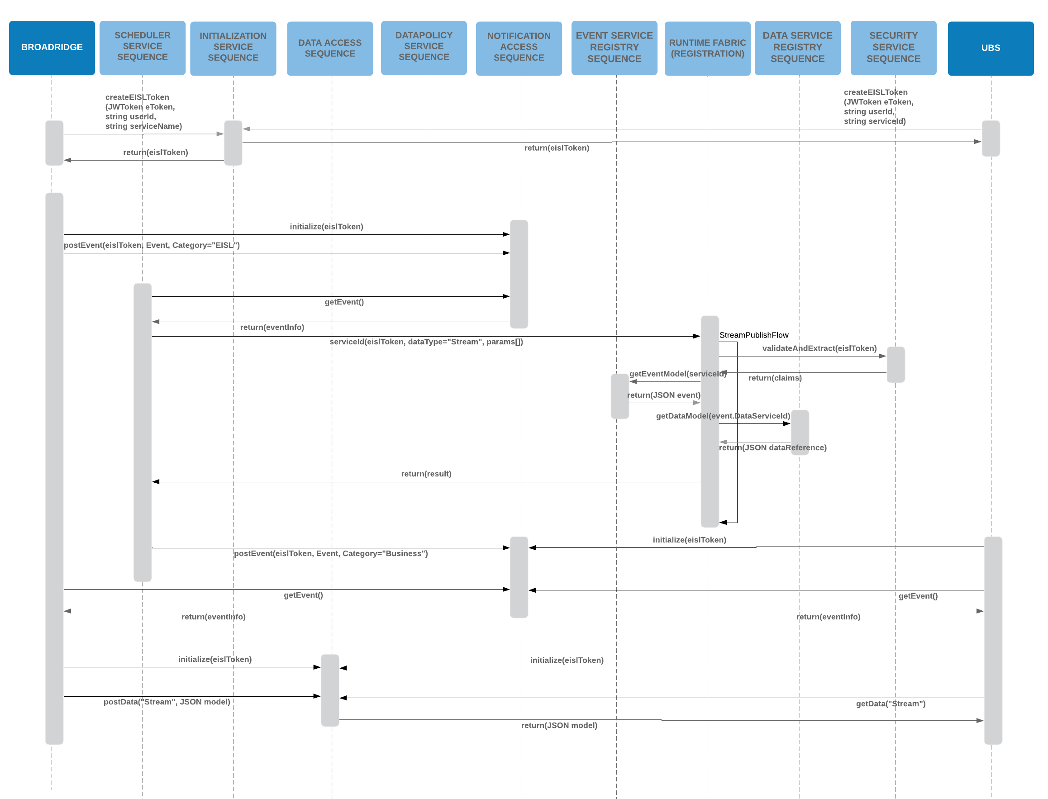

### Transform Cache Data Sequence Diagram

In addition, there is the option to trigger transformation of cached data.

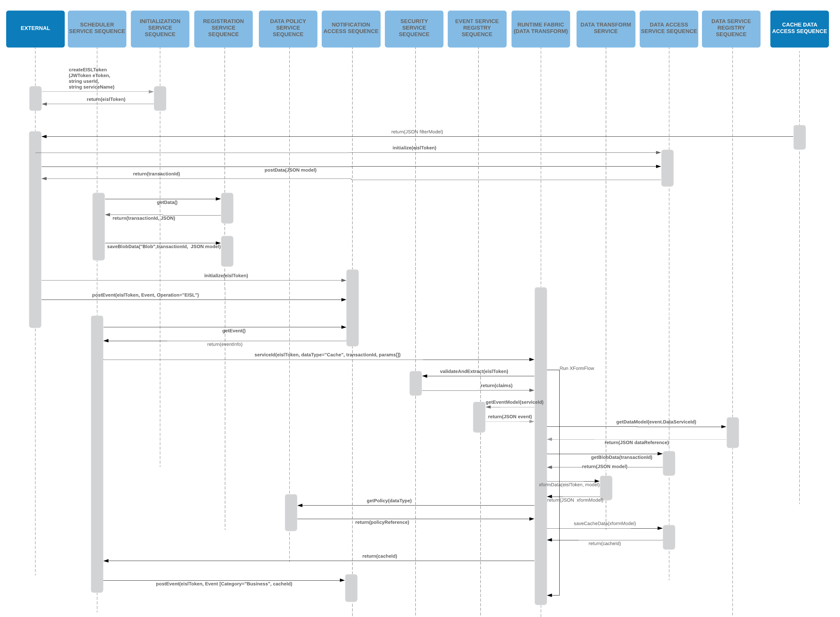

### Notification Hub Data

Within the Notification Hub there are 2 distinct forms:

1. Event Messages. Event messages have 3 categories of events:
   1. System Events – these are System level events created by EISL in order to manage system wide information.
   2. Operation Events – these are events created by external entities that request EISL to execute a process.
   3. Business Events – these events are generated by EISL as a result of an external entity interaction with EISL.
2. Data Messages. There are 2 types of data messages:
   1. EISL – these are data information messages, associated to an Operation Event, that allows external entities to “publish” data to EISL.
   2. Streaming – these data messages are similar to business events, in construct, but will include data streaming payloads.

**Event Message**

The following component shows the construct associated to both System and EISL events:

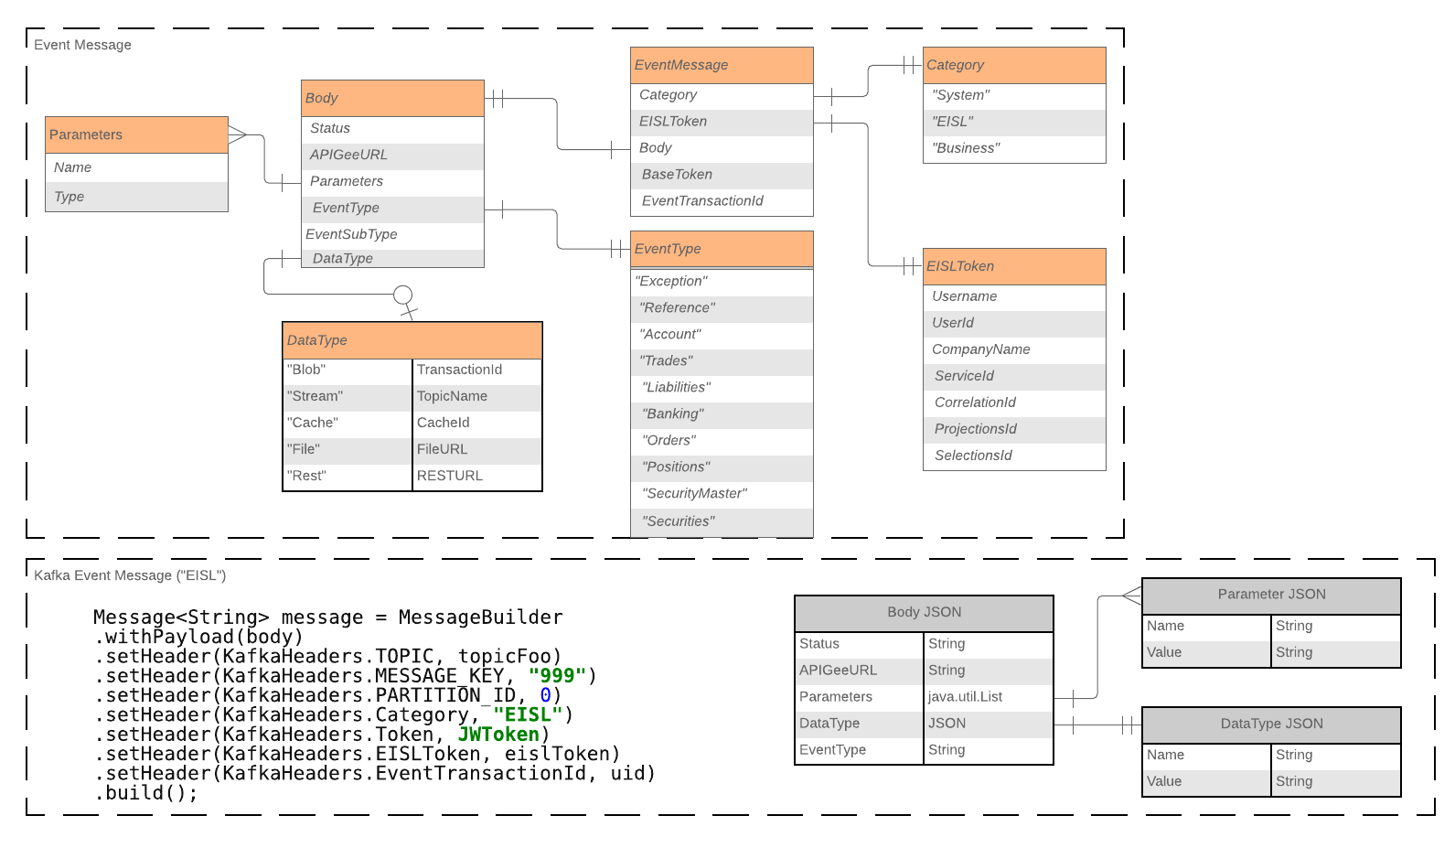

**Business Events**. This event must include sufficient information for any external entity to extract how to access data associated to this event.

**Operation Events**. These events include all information required for the EISL scheduler to execute and process the data.

**System Events**. These events allow the system to perform “master” type operations such as Start of Day or End of Day requests.

It is the Event Message that will contain all informational data associated to “stored” information, such as REST URLs, File Locations, Cache IDs, etc. This construct will allow external entities to simply process events in order to resolve data access.

**Data Messaging**

All data, including data associated to an event (EISL or System) will be passed through the data hub. In order to remove the need to handle synchronicity across 2 queue types, EISL will automatically process all data from the data hub and store in a blob storage. This also provides a foundation for auditing and high availability as EISL will always have the original data associated to any transaction.

The Data Message structure looks like:

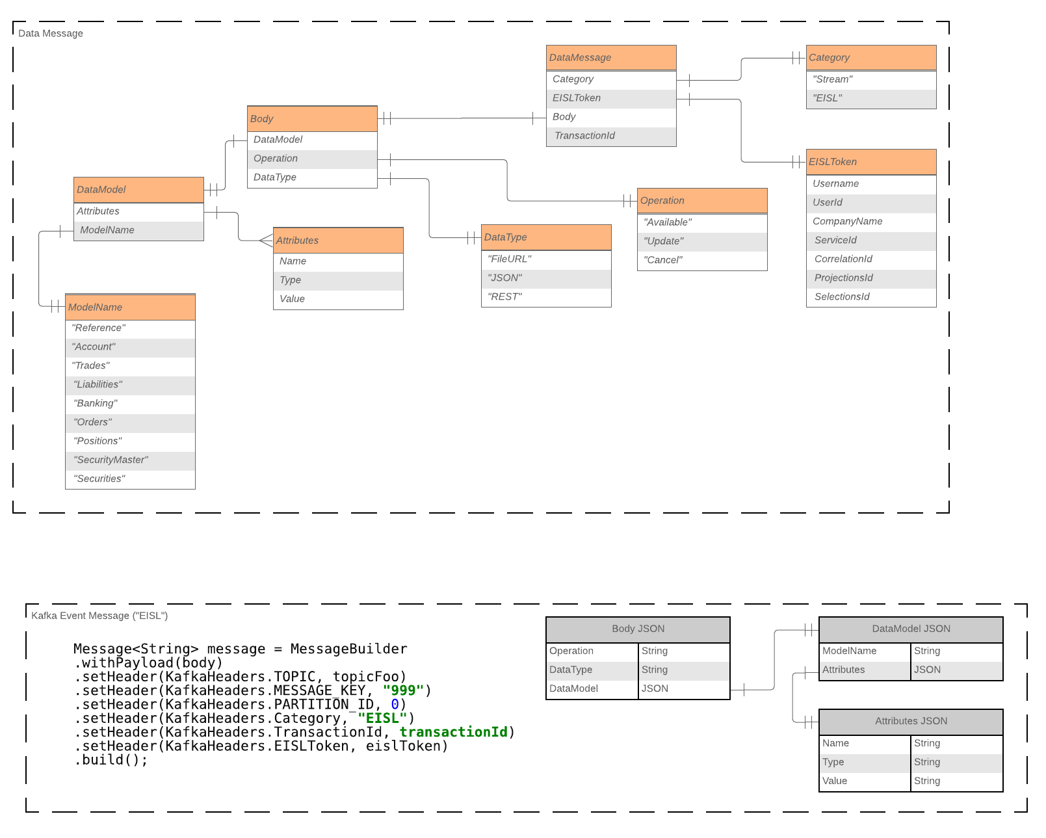

Data Messaging is used in 2 forms:

1. Identify input data associated to EISL requests.
2. Data Streaming associated to System Events that enable 2 or more external parties to stream data.

### Master Sequence Diagrams

#### End of Day

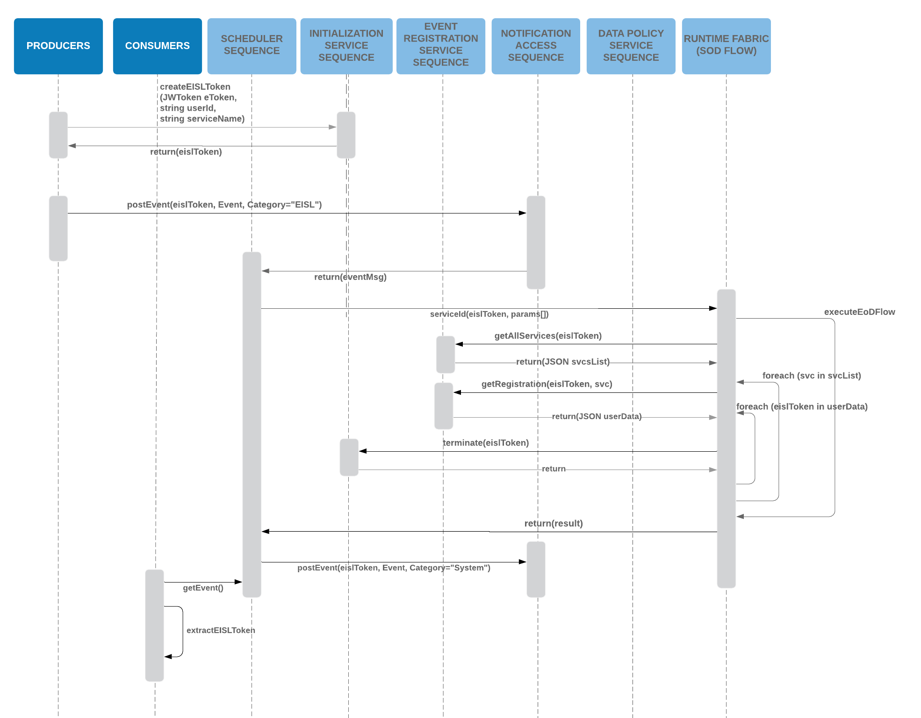

#### Start of Day

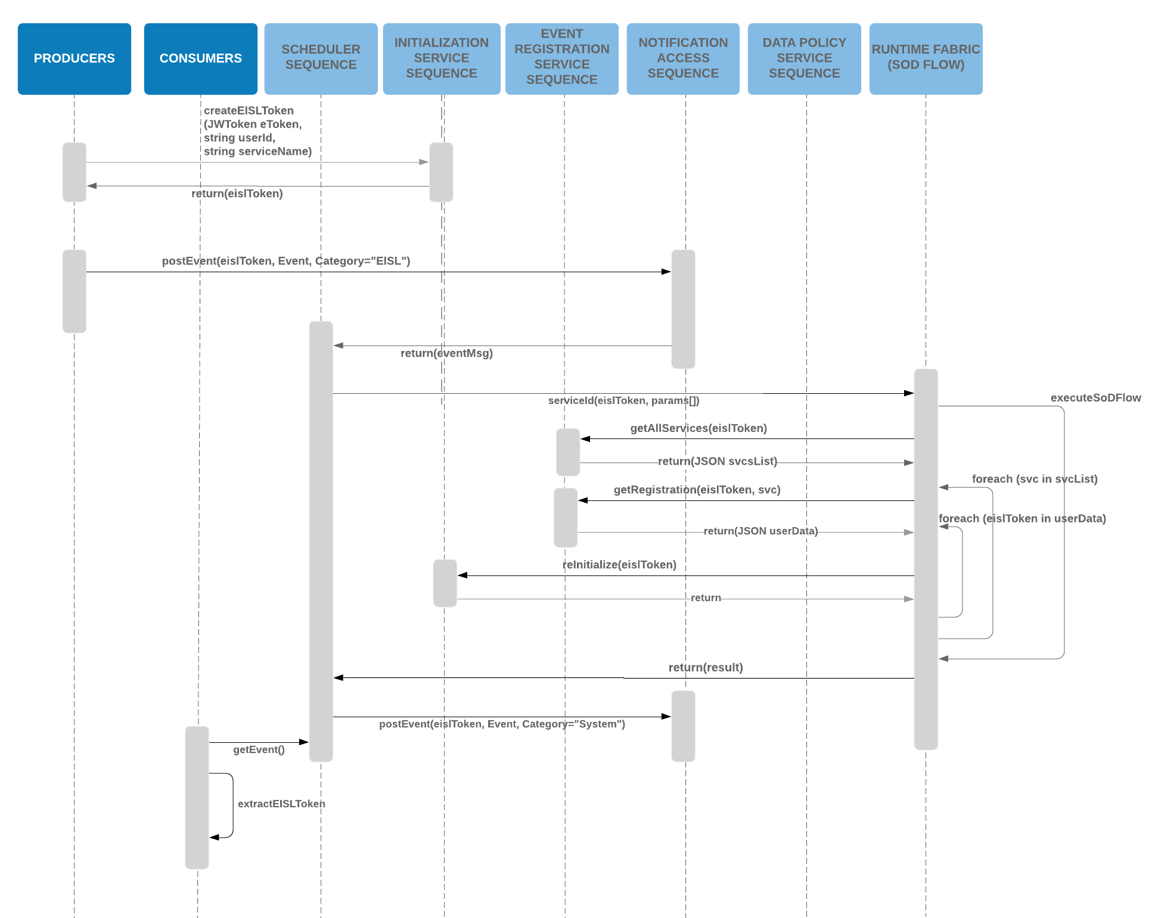

### Core Sequence Diagrams

The top-level sequence diagrams show that there are standard patterns associated to the underlying sequences/operations.

#### Initialization Sequence

Anyone or any application wishing to interact with EISL must perform a one-time initialization for each service. This performs two key operations:

* Create an EISLToken for that operation. The EISLToken fulfills several functions including the ability to authorize and entitle access to service and corresponding data. It also provides a secure approach to handling capabilities such as correlation ids and additional claims data associated to that service.
* Creates the registration for that operation, which defines what topics are used for messaging, data and exception handling.

The following sequence diagram shows this flow:



The initialization sequence is dependent on 2 core sequences

##### Security Sequence

It is this security that identifies the application’s (or user’s) authorization and entitlement for the requested service and data.

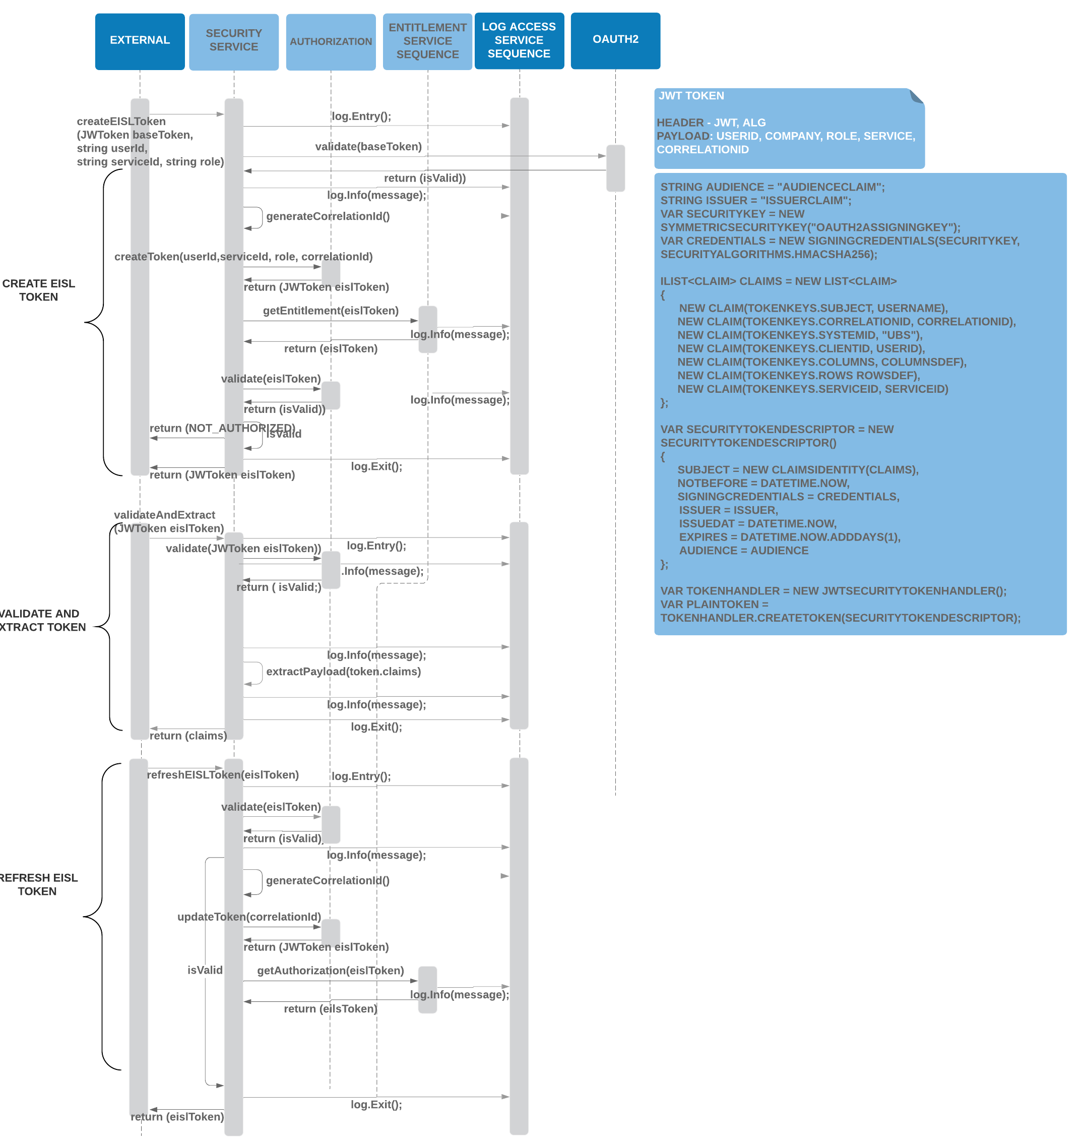

##### Entitlement Sequence

The Security Sequence is also dependent on the Entitlement Service that allows EISL to establish authorization and entitlements based on UBS MAC implementation:

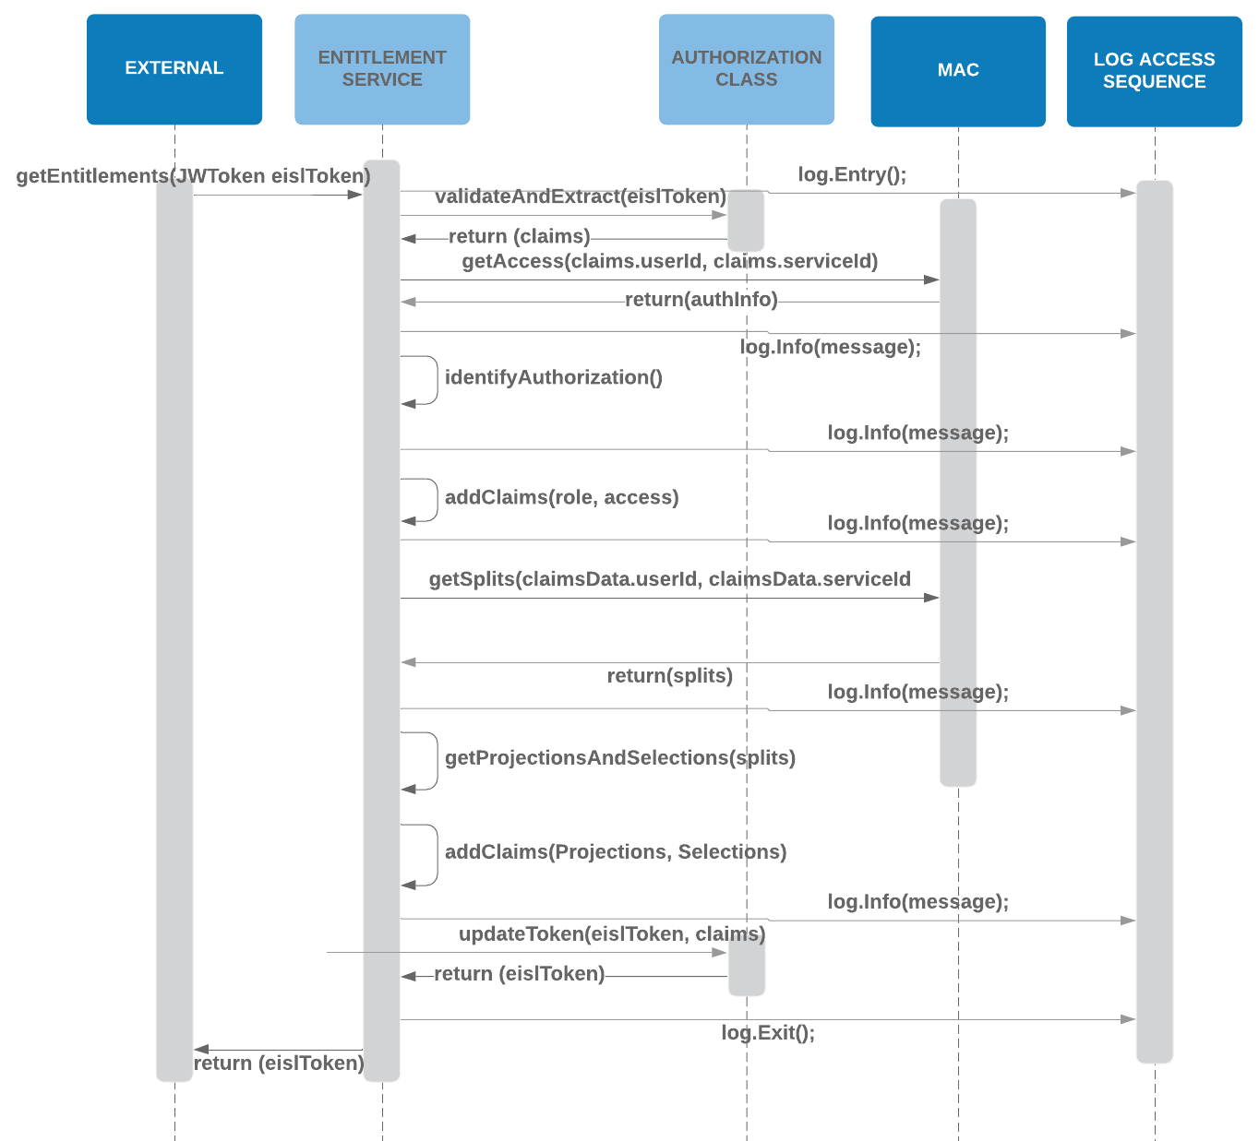

#### Static Information Management

The configuration of events, data and exceptions is the foundational core of EISL. These components define the communication information used to configure the external entity interactions with the system.

The structure of this information is based around the following:

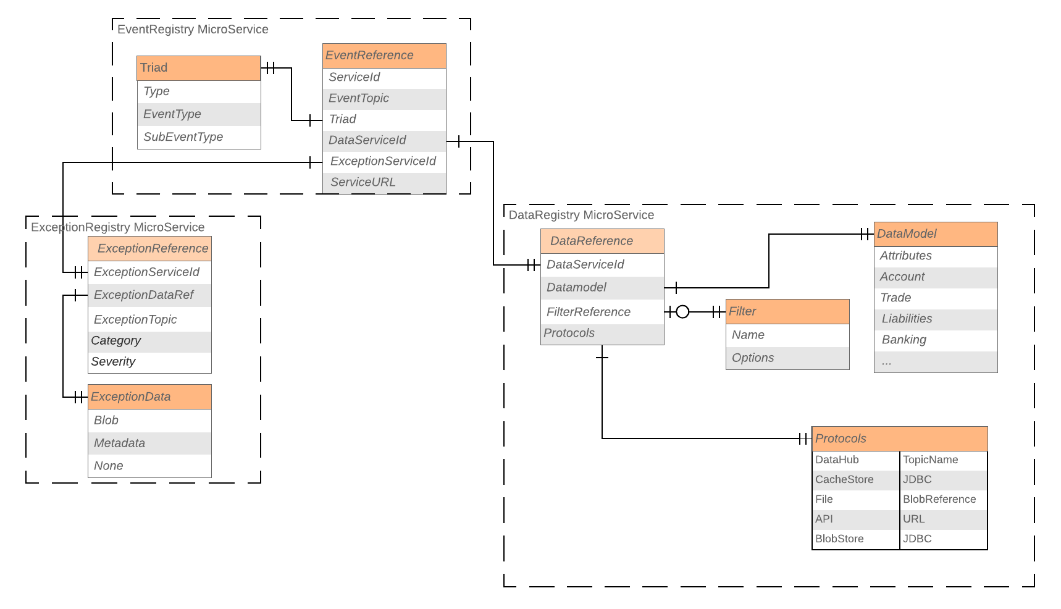

1. Event Registry

The Event Registry is used to define event configuration associated to one of the two following categories:

* 1. EISL events. This is used to define how external entities communicate with EISL
  2. System (Business) events. These are the events generated by EISL to notify external entities of events.

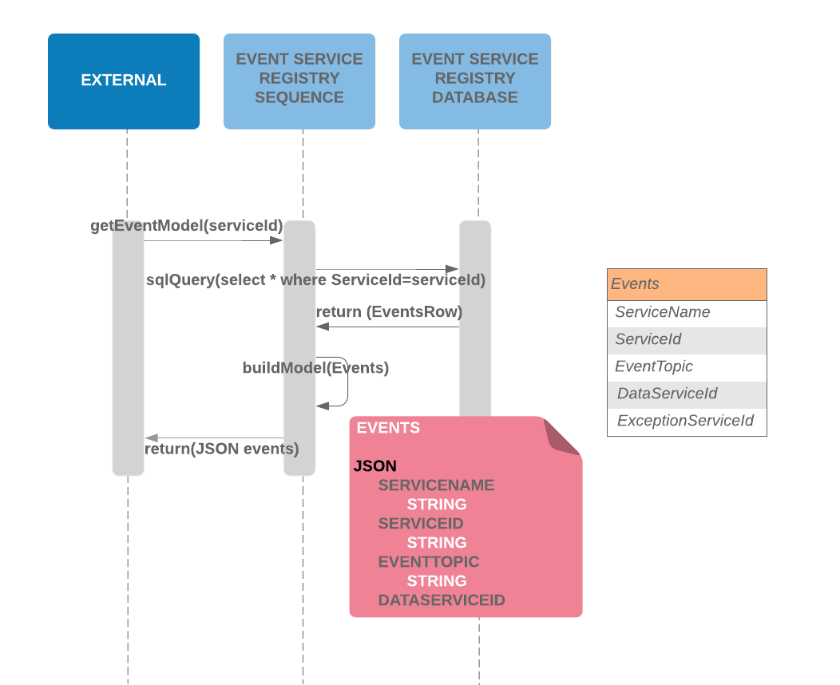

1. Data Registry

Associated to an event are a set of data components, which can be one or more of the following data types:

* 1. Stream
  2. File
  3. REST
  4. Cache
  5. Blob

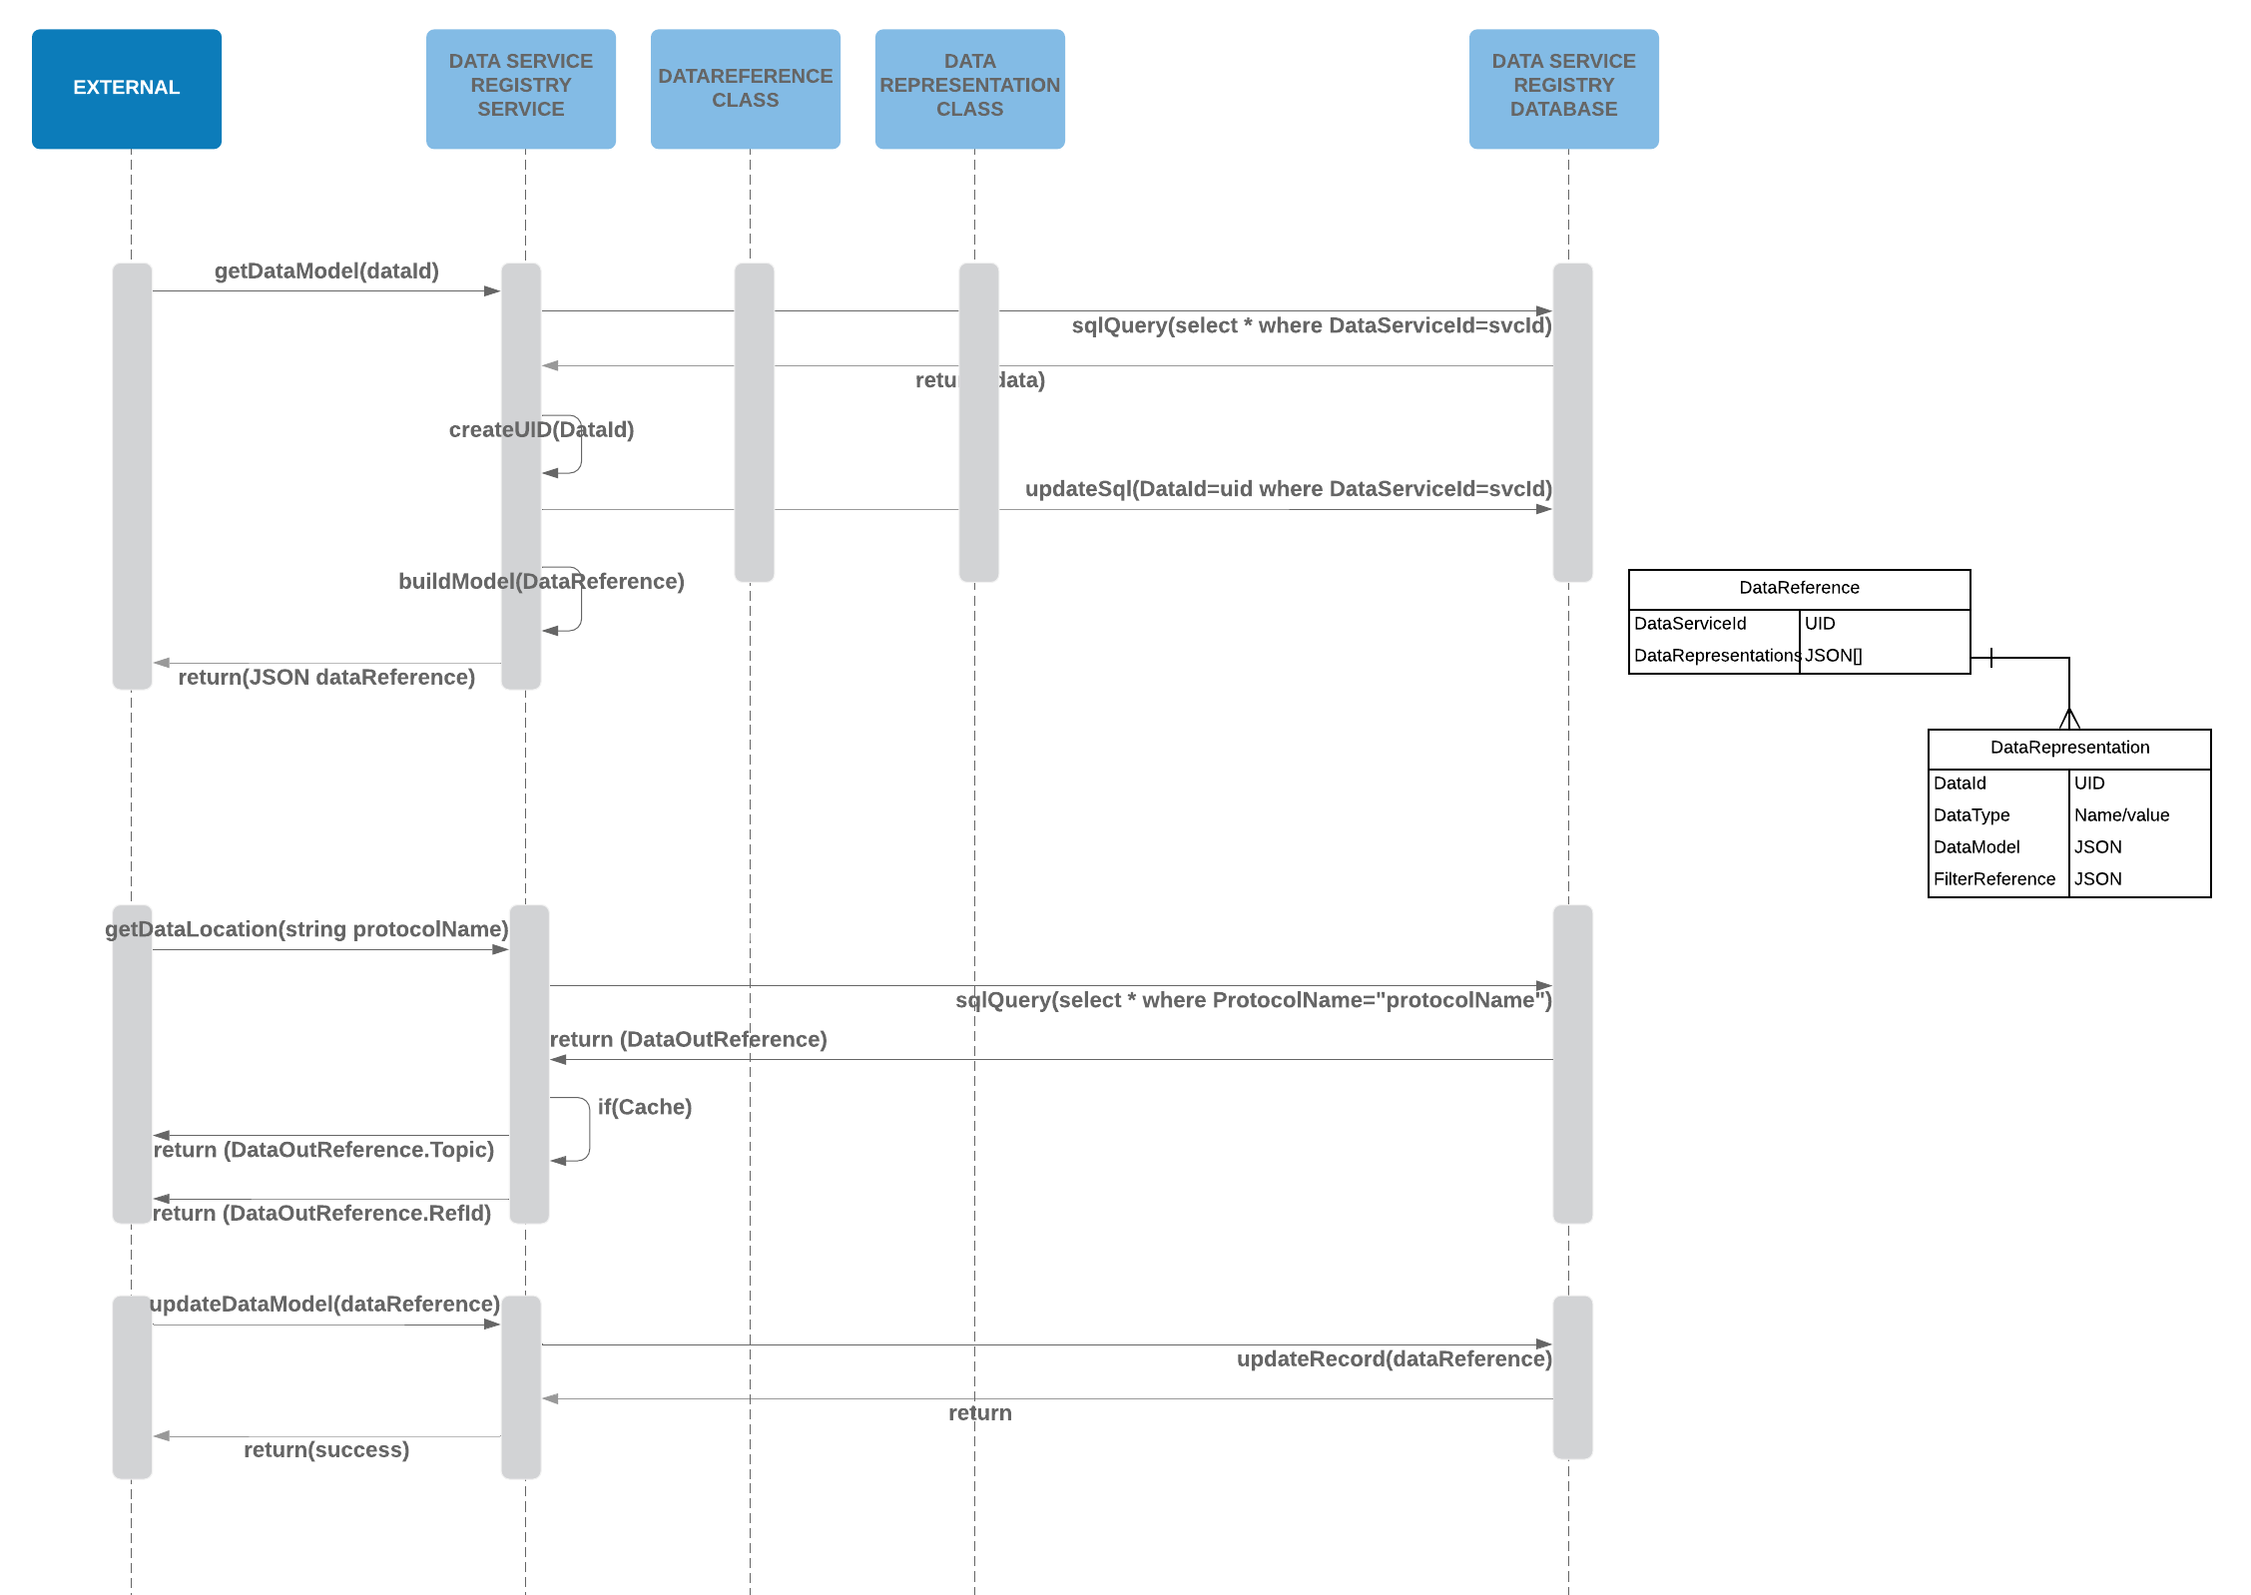

1. Exception Registry

Additionally, the system also manages the concept of reactive exception handling by defining exception messages associated to specific events. These exception messages are treated in the same way as data messages and can be used by external entities to resolve exceptions.

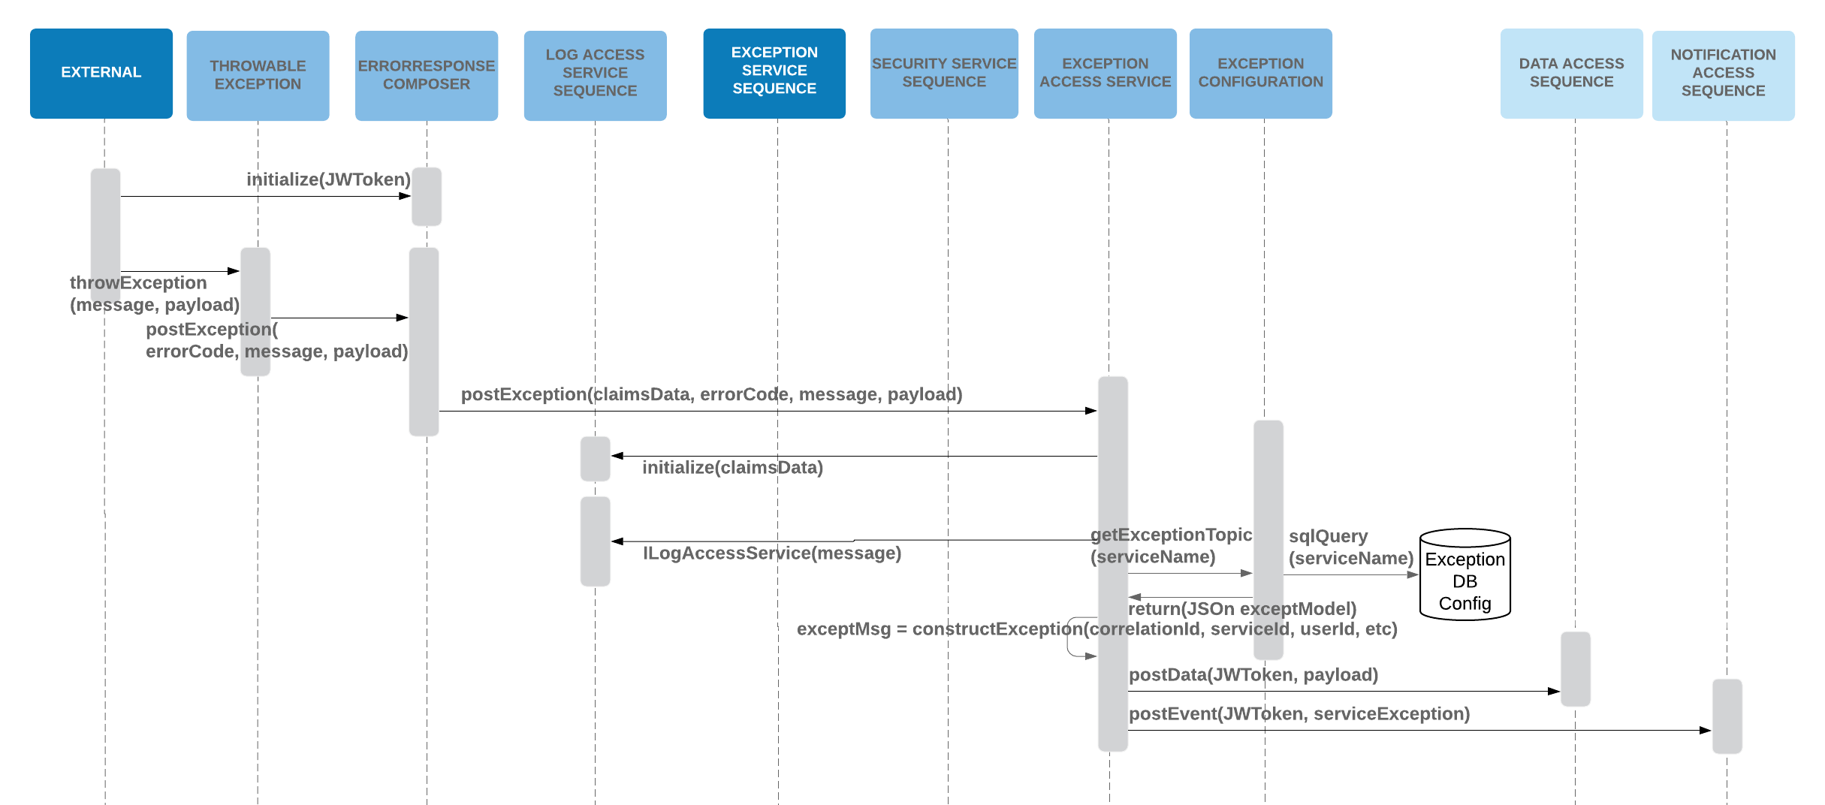

#### Registration Information Management

This is the core of EISL and allows EISL to manage all external entities as the register with EISL for business (event) notifications. As an external entity registers with EISL that information is stored in a Register Microservice. This database maintains a loose coupled interaction with the Event microservice enabling a cross correlation between the two services.

The underlying data model for the Registration Microservice is defined as:

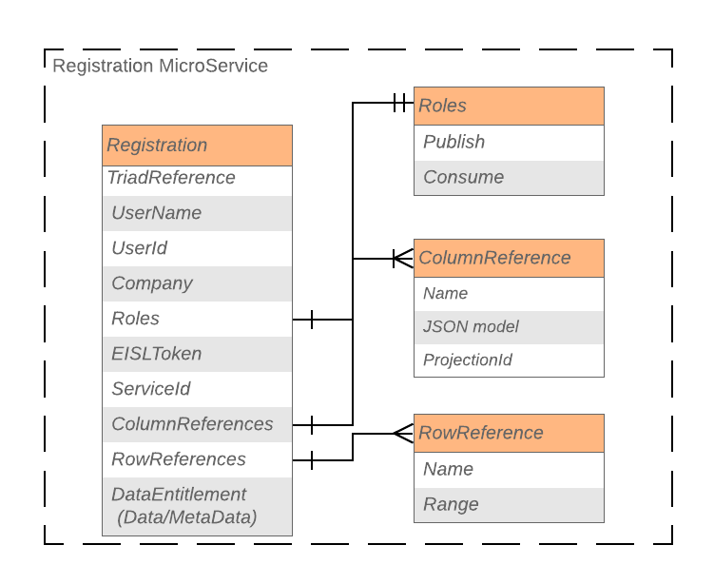

In order to support this, construct the Registration Microservice sequence is as follows:

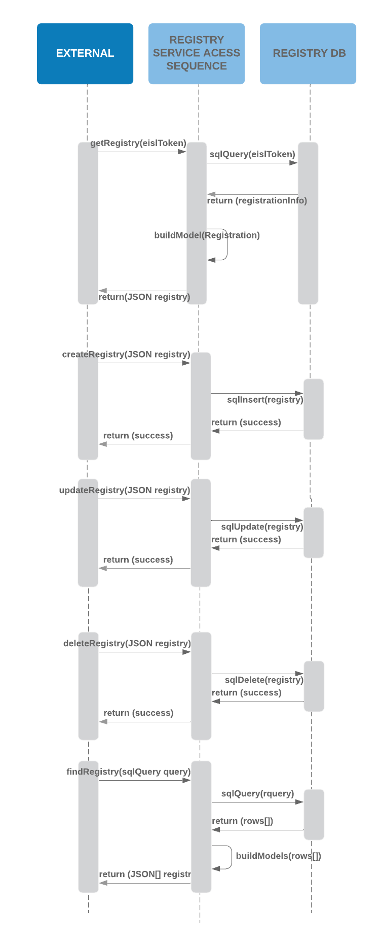

As Static and Registration Information are usually accessed at the same time there is an aggregating service (Registration Service) that provides the overarching access across these Microservices. The Registration Service allows the management and configuration of each of the aspects within EISL. Its role is to manage access to:

* Static Data
* Data References
* Application/User registration

It is these underlying, persistent, objects that enable EISL to identify communication topics for events, data and exceptions.

Below is the definition of the components managed by discrete micro services within the Registration Service that shows how the events and data are registered by EISL.

* Registration Service will be called by Initialization method using the EISL token
* Registration service will validate EISL token and extract claims using authorization class of security service
* Registration service will call registry access micro service with service id, user id, role to see existing registrations for the received claims are present or no. If present, it will receive the registration details in JSON. Based upon which, registration success status will be sent back
* If not present, it will call event registry service with EISL token, service id to get event registration details in JSON format with the attributes service name, service id, event topic, data service id and exception service id
* Using the data service id from event registration claims and EISL token, data registry service will be called to get data registration details
* Using the exception service id from event registration claims and EISL token, exception registry service will be called to get exception registration details
* After building the registration details using the claims from all the micro services, registry access service will be called with the claims and EISL token to add or modify/delete registrations

Registration service will get back the registration completion status as response and the same will be sent back to initialization method

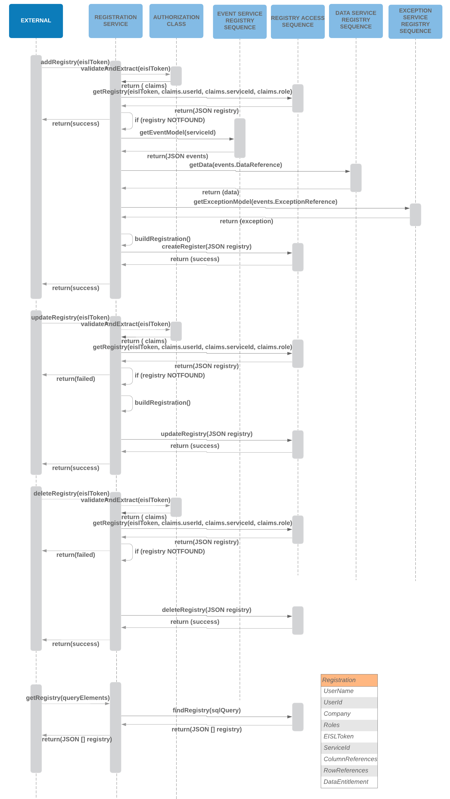

#### Broadridge Mapping and Correlation

The following shows the high degree of correlation between the Broadridge model and EISL.

Broadridge EISL and UBS EISL are the only components that interactions between the two systems:

1. UBS EISL is responsible for publishing and consuming all UBS External Entity requests and:
   1. Trying to resolve the request within UBS EISL
   2. If this cannot be done, then forward to Broadridge to resolve the request
2. Broadridge EISL is responsible for publishing and consuming all Broadridge Application requests and:
   1. Trying to resolve the request within UBS EISL
   2. If this cannot be done, then forward to Broadridge to resolve the request

In this context the only communication, and hence registration, between Broadridge and UBS are those between each EISL implementation.

The following shows how data is published from Broadridge and then consumed by UBS:

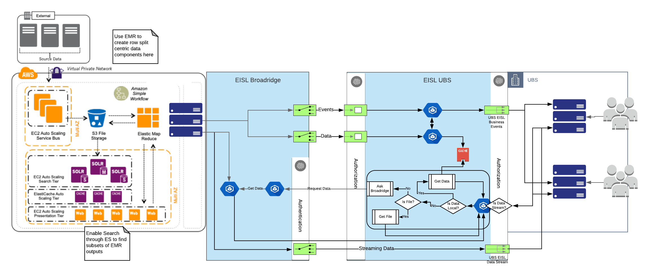

As with EISL, Broadridge, have a clear dependency around Registration and notifications (whether events or data) are triggered based on the underlying registration information.

There are actually 4 models identified by Broadridge

1. Register. This allows external entities to register with Broadridge for an Event, and like EISL, the event triad is based off category, domain event, sub domain event. The following sequence shows how this is implemented within Broadridge.

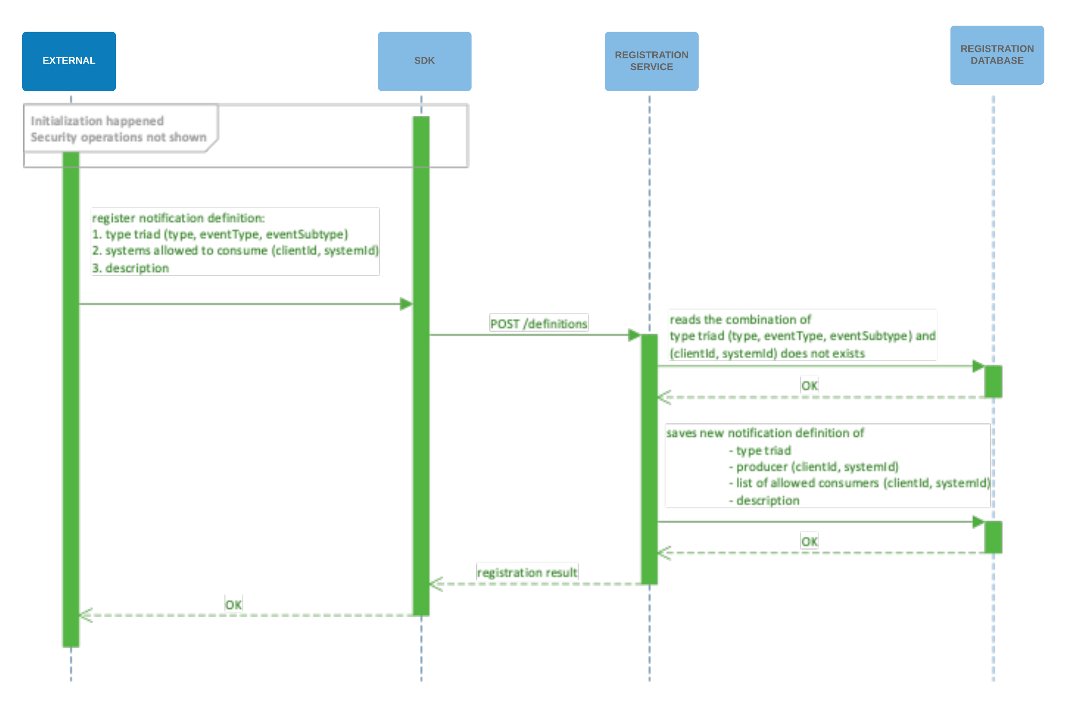

1. Publisher. The publisher model for Broadridge, accessed through a REST API, uses the underlying Registration Service to identify all registered consumers of that notification. This is then built into the notification event and posted to the Notification Hub.

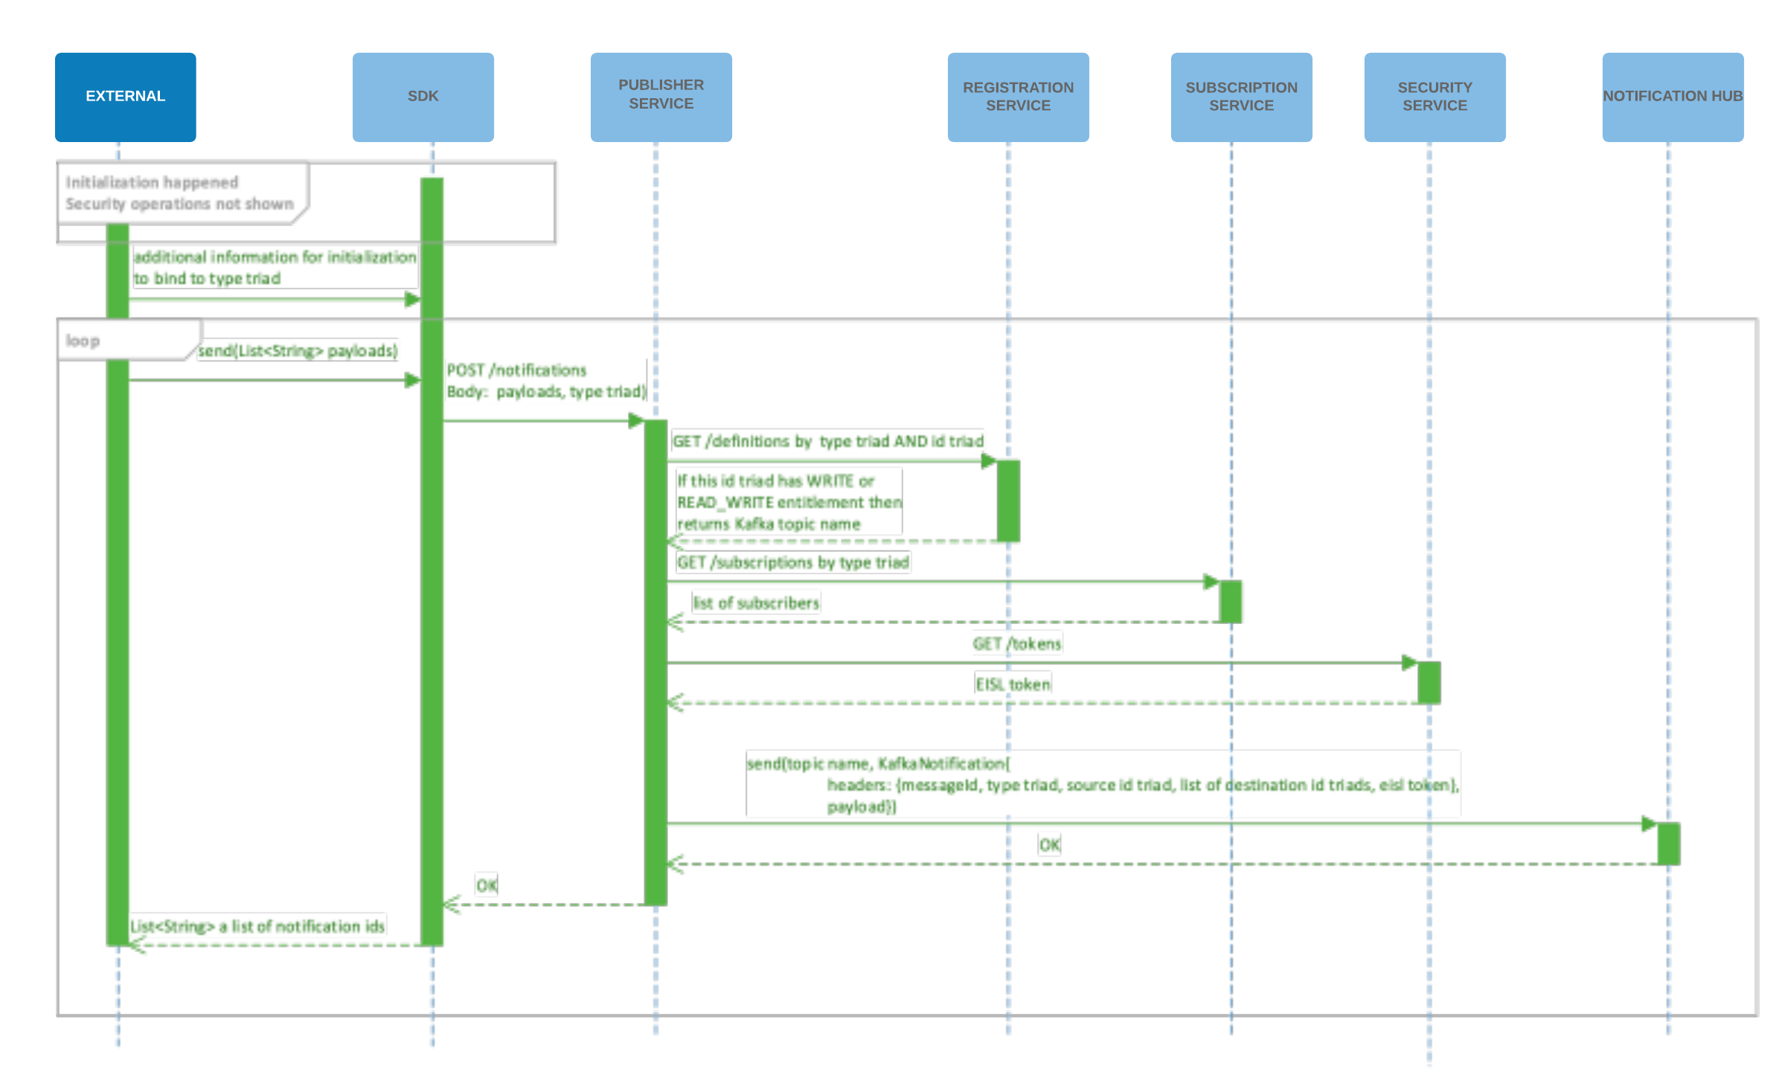

1. Consumer. Once an external entity is registered with Broadridge then notifications associated to a specific request (whether an event or data) will be consumable. The current proposed model in Broadridge is use polling, but the same result can be achieved by listening on the predefined topic. The following flow shows how a consumer flow in Broadridge works.

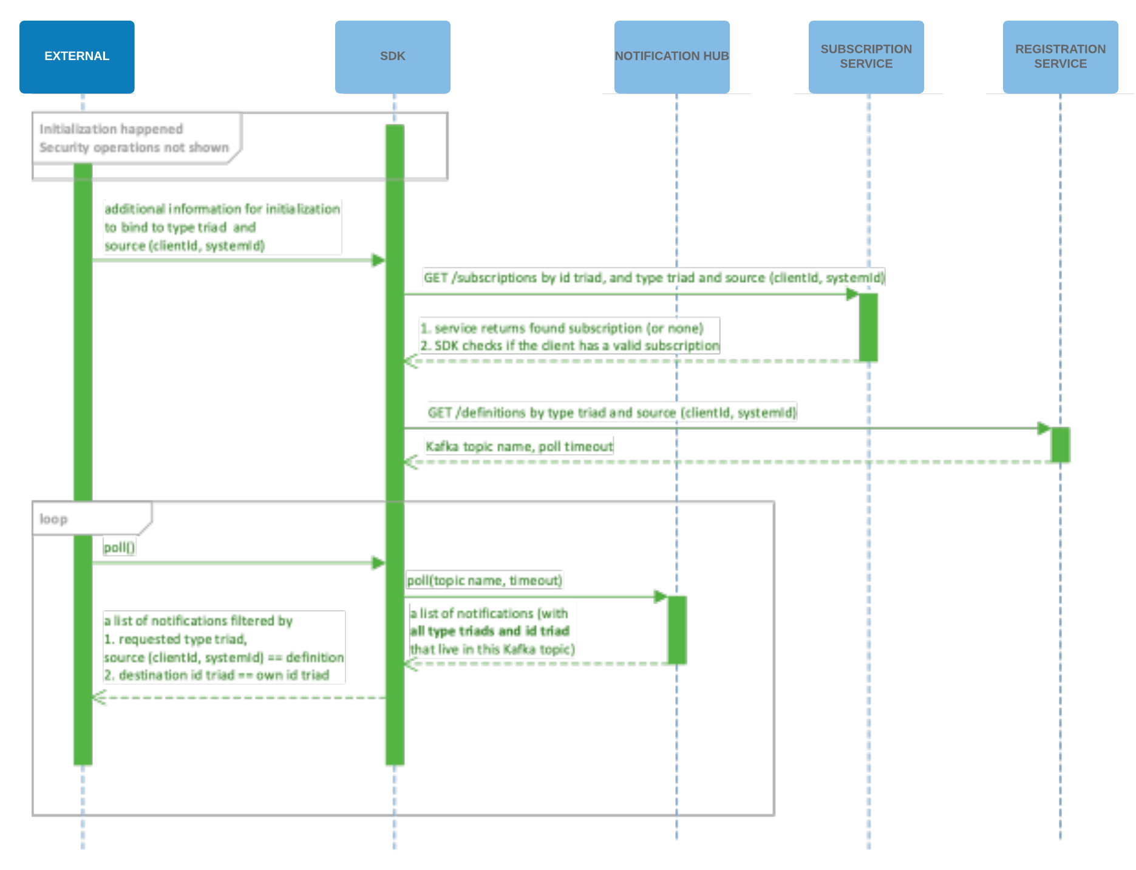

1. Subscriber. As with EISL there is a difference between a consumer and a subscriber. Consumer is associated to access notifications associated to near real time and batch operations, whether they are event or data based. A subscriber is an external entity that is accessing streaming data from Broadridge. As with EISL design both register for this type of notification and EISL then provides, via the subscription service (in the Broadridge model) the communication protocol for establishing the data stream.

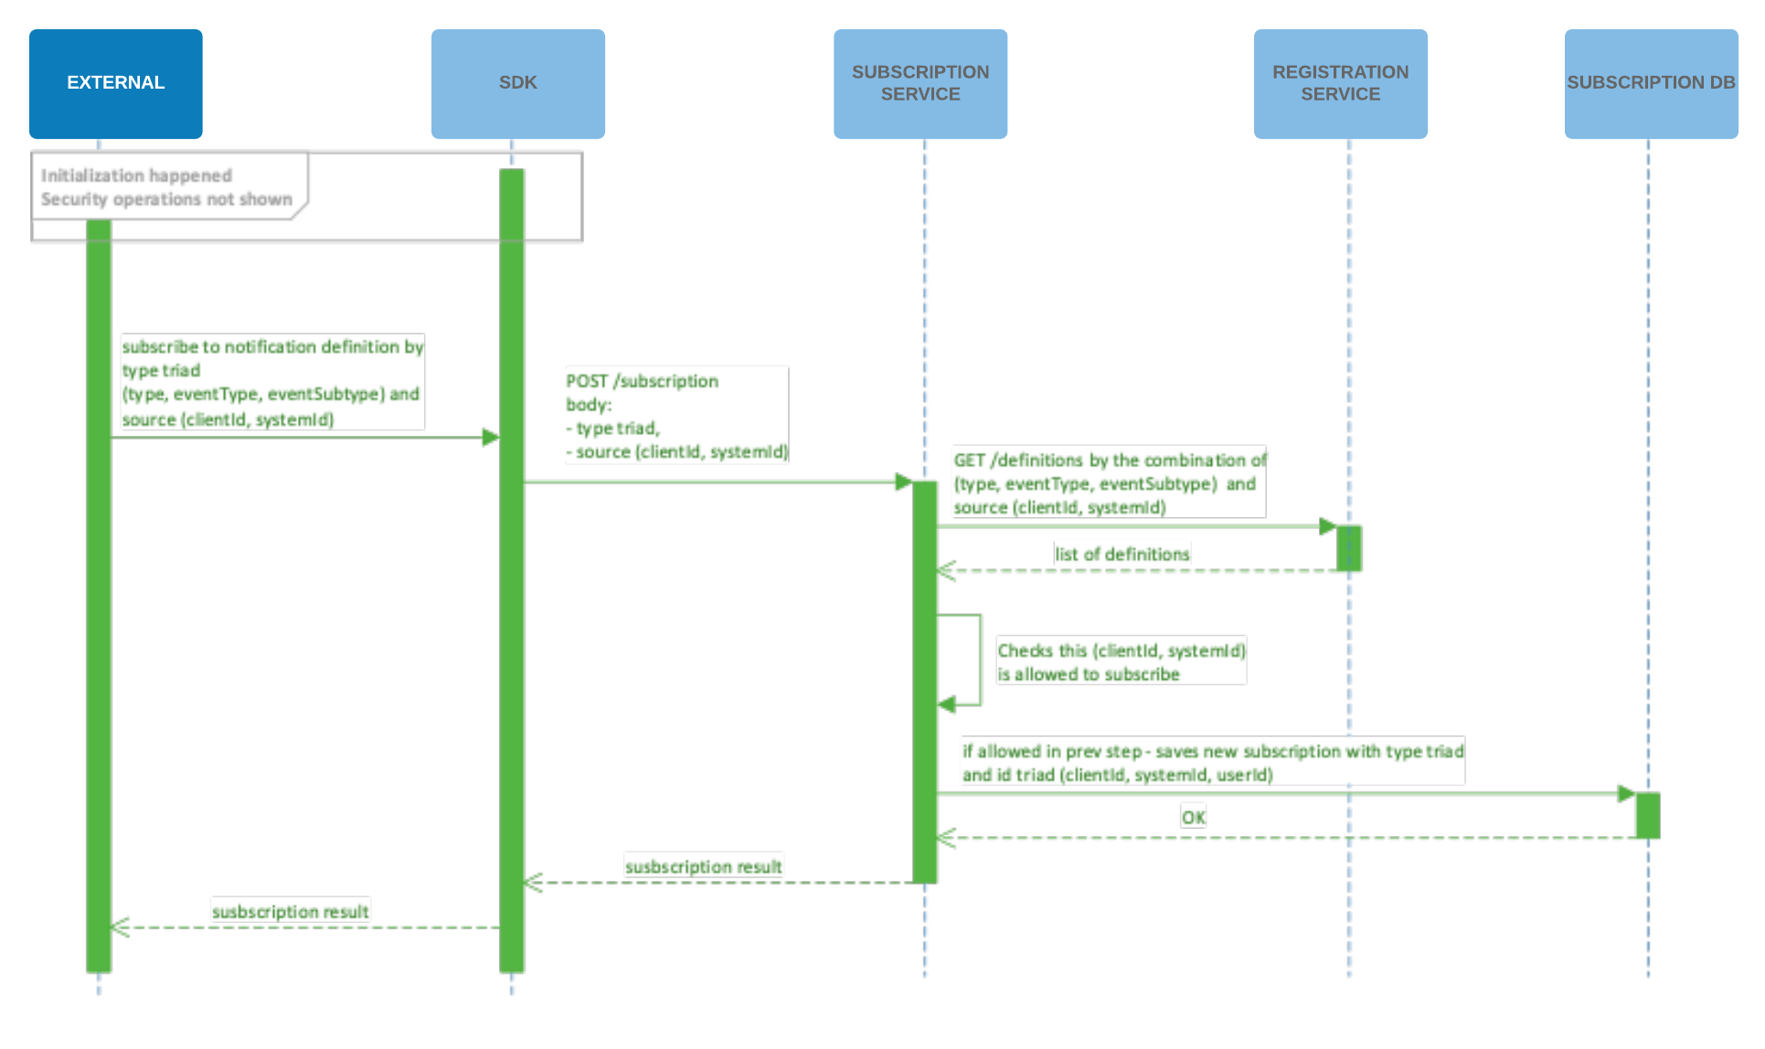

#### Scheduling Sequence

All ‘EISL’ events are processed through the scheduler along with associated Data Hub messages. This enables EISL to ‘execute’ services based on pre-determined messages (Category = “EISL”). Due to the underlying capability in Kafka of preserving messages it also enables EISL to provide the top level of fault tolerance, which means this acts as EISL’s stateful flow component, allowing EISL to re-execute complete requests if the underlying system fails.

Additionally, the scheduler executes all “EISL” events by invoking the APIGee façade that provides the abstraction level between the Notification Hub and the underlying REST services.

The sequence diagram is below:

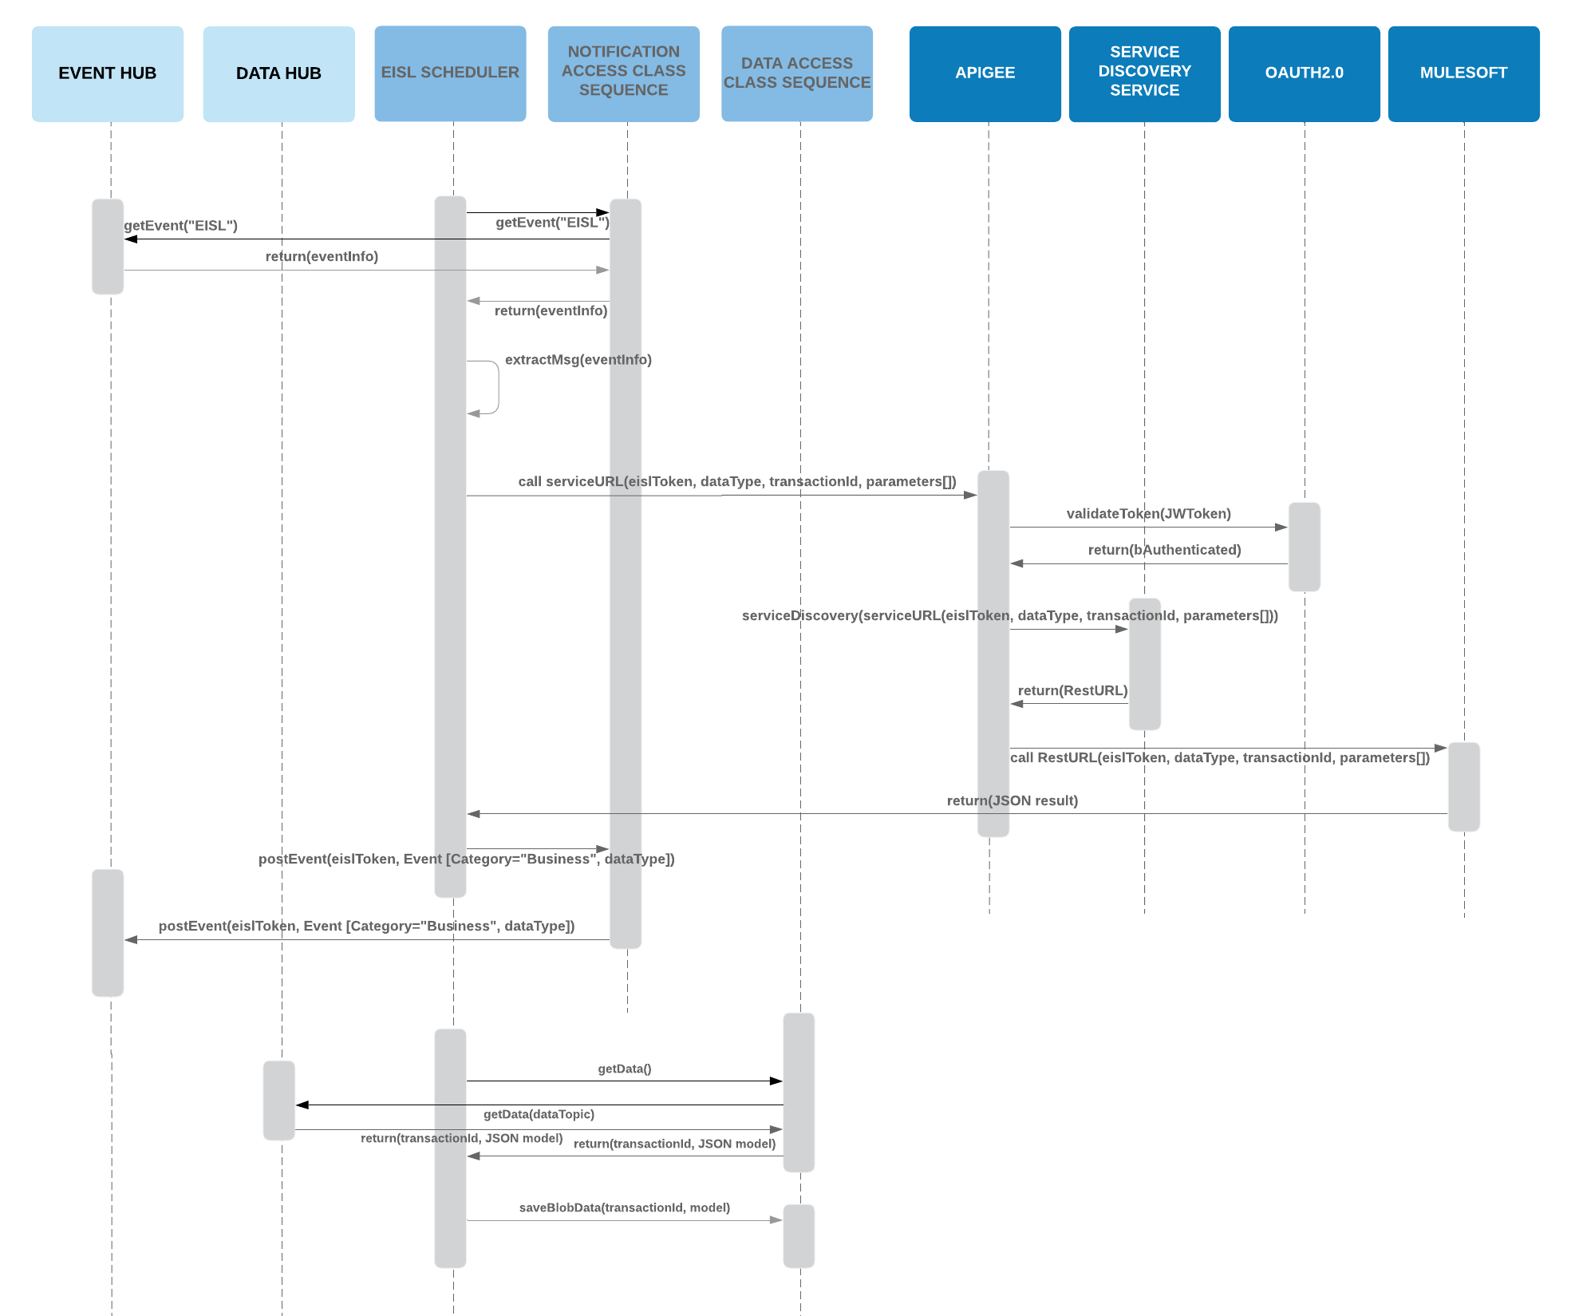

#### Notification Access Sequences

As already defined the Notification Hub is comprised of 2 components, however no external system directly interacts with the Data Hub, this is instead managed within EISL so that the various data types and access protocols are hidden from the external systems. There is one exception to this, which is the input of data.

##### Event Hub Sequence

The event hub itself has a standard ‘library’ class that abstracts the need to directly access and offers the following interfaces for external applications and users:

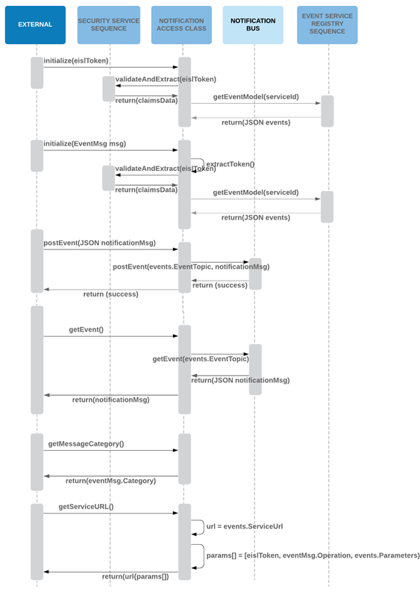

* For consumers, The EISL token received from external systems will be validated and claims would be extracted using the Authorization Helper class in Security and Entitlement Service. This would be done by calling the Security service from Notification Access Class
* For publishers, the event message that contains EISL token received from external systems will be validated and claims would be extracted using the Authorization Helper class in Security and Entitlement Service. This would be done by calling the Security service from Notification Access Class
* Using the Service ID extracted from the claims of EISL Token, Notification Access class would make a call to Event Service Registry Sequence to get the events details in JSON format
* The received JSON would provide notification access with Event Topic where message need to be posted, or from where message need to be received
* Posting Event: Notification Access Class would post the Notification message received from External system to Notification Bus on the Event topic received from Event Service Registry Sequence. Once successful, a success notification would be received from Notification Bus which would be returned back to External System
* Getting Event: Notification Access Class would request Notification Bus for the Notification message on the Event topic received from Event Service Registry Sequence. Notification Bus would return the notification Bus to Notification Access class which would be then returned to External System

##### Data Hub Sequences

The Data Hub would be used to post data required by EISL for processing associated events, in addition the Data Hub is also used for handling of streaming data between external entities. The data hub utilizes the data registry and registration access micro services to get the registration details needed in data access (publishing/consuming) and related entitlements.

Data Entitlement is the key aspect of the data access design, as EISL data access requirements need to support different set of data publishing/consuming that pertains to individual, or groups for the same domain.

1. Data Input to EISL
   1. In order to simplify the ingestion of data, whether that is a reference (REST URL, File URL) or a direct data object (data model) the JSON representing either of these is posted to the data hub and is associated to a transaction id.
   2. This information is automatically processed by the EISL scheduler and persisted in a blob store so that future Events can leverage the data using the same transaction id.
   3. This approach provides 2 major capabilities:
      1. Ensures that original input data is preserved even after processing by EISL.
      2. Removes any need for cross synchronization between the Event and Data hub topics.
2. Streaming Data
   1. A large proportion of the daily interactions between external entities through EISL will be based on data streaming that provide continuous updates to existing data models. In order to facilitate this EISL provides, and manages, the streaming of data on pre-defined topics.
   2. However, in order to effectively manage these topics and application (user) registration EISL requires external entities to register with EISL and EISL then provides the designated topic associated to the streaming activity.
   3. This means that the following logic must be applied to streamed data:
      1. The data configuration is setup using a domain.start event that creates the ‘System’ Event defining the topic. Registered applications (users) receive this event and subscribe to the topic.
      2. Publishers, who submitted the domain.start request also receive the same ‘System’ event and can start publishing to this topic.
      3. The stream will continue until a domain.end event is triggered. Registered applications (users) are then responsible for cleaning up and remaining subscriptions for this stream.
   4. It is expected that there will be ‘master’ events, such as Start of Day and End of Day that will also be linked to these ‘System’ events and that most of the daily domain.start and domain.end events will be automatically triggered through these operations.

The helper class Data Access provides two components associated to Data Hub access and the other two components are used for Data Storage.

Data Hub access helpers:

1. Data Streaming
2. Data Topic

Data Storage access helpers:

1. Data Blob Storage (used by EISL)
2. Data Cache Storage

All other components (Rest URL and File URL) and handled directly from the contents of the ‘System’ Event.

###### Data Streaming Access Sequence

Data streaming best suits in following cases:

1. Predetermined dataset that does not change frequently
2. Data set that has a short life cycle
3. New data set that completely replaces the previous one

Below listed are the cases where stream is not be suitable

1. Data access is controlled at the individual entitlements, which means that no one dataset can be provided to all consumers, but rather multiple variances are required
2. Data sets might not always be individual, repetitive, blocks of data, but continually changing aspects of data with varying number of rows, filters and customization
3. No current expectation to continuously deliver data streams in a sub second model

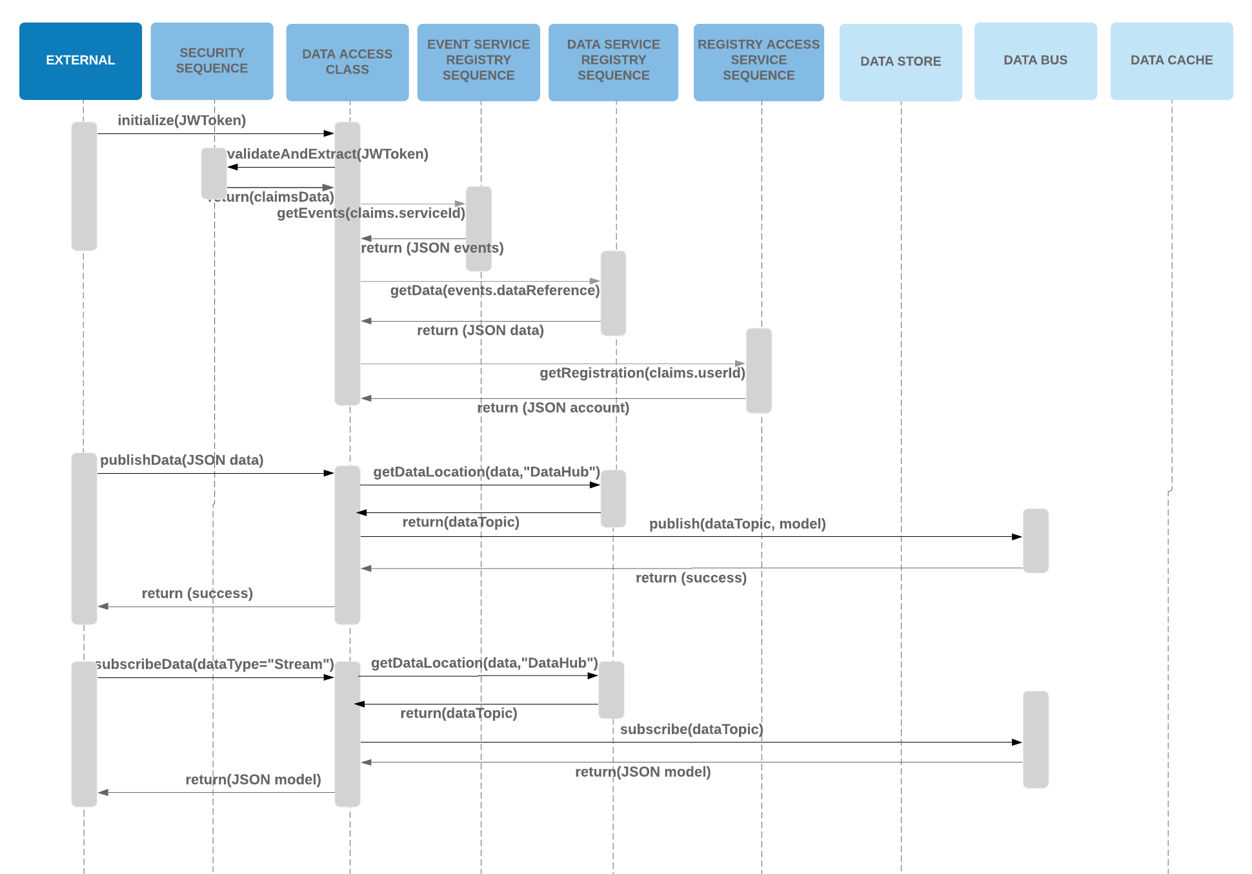

###### Data Topic Access Sequence

This is used by any producer to send data to EISL for processing as part of an EISL request.

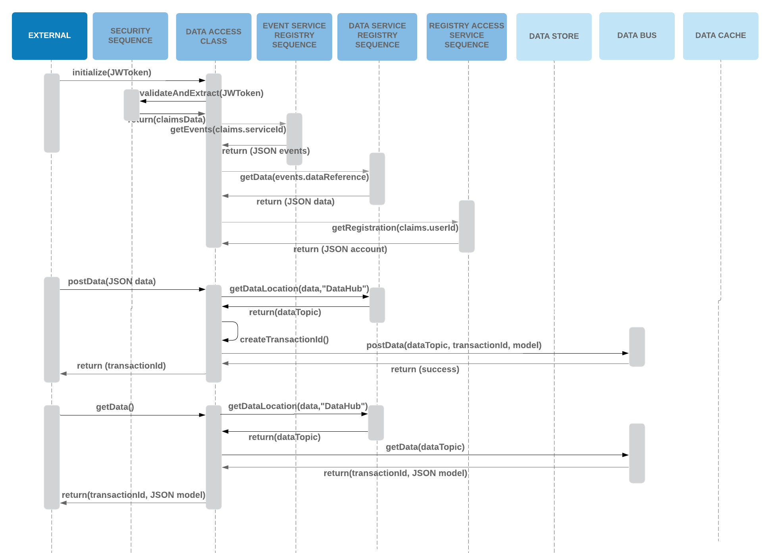

###### Cached Data Access Sequence

This helper class is a wrapper for getting and saving data in the EISL Cache repository. It is expected that the Cache repository is a key, value model and as such data stored there will be referenced through a unique identifier created in the helper class and returned for future access.

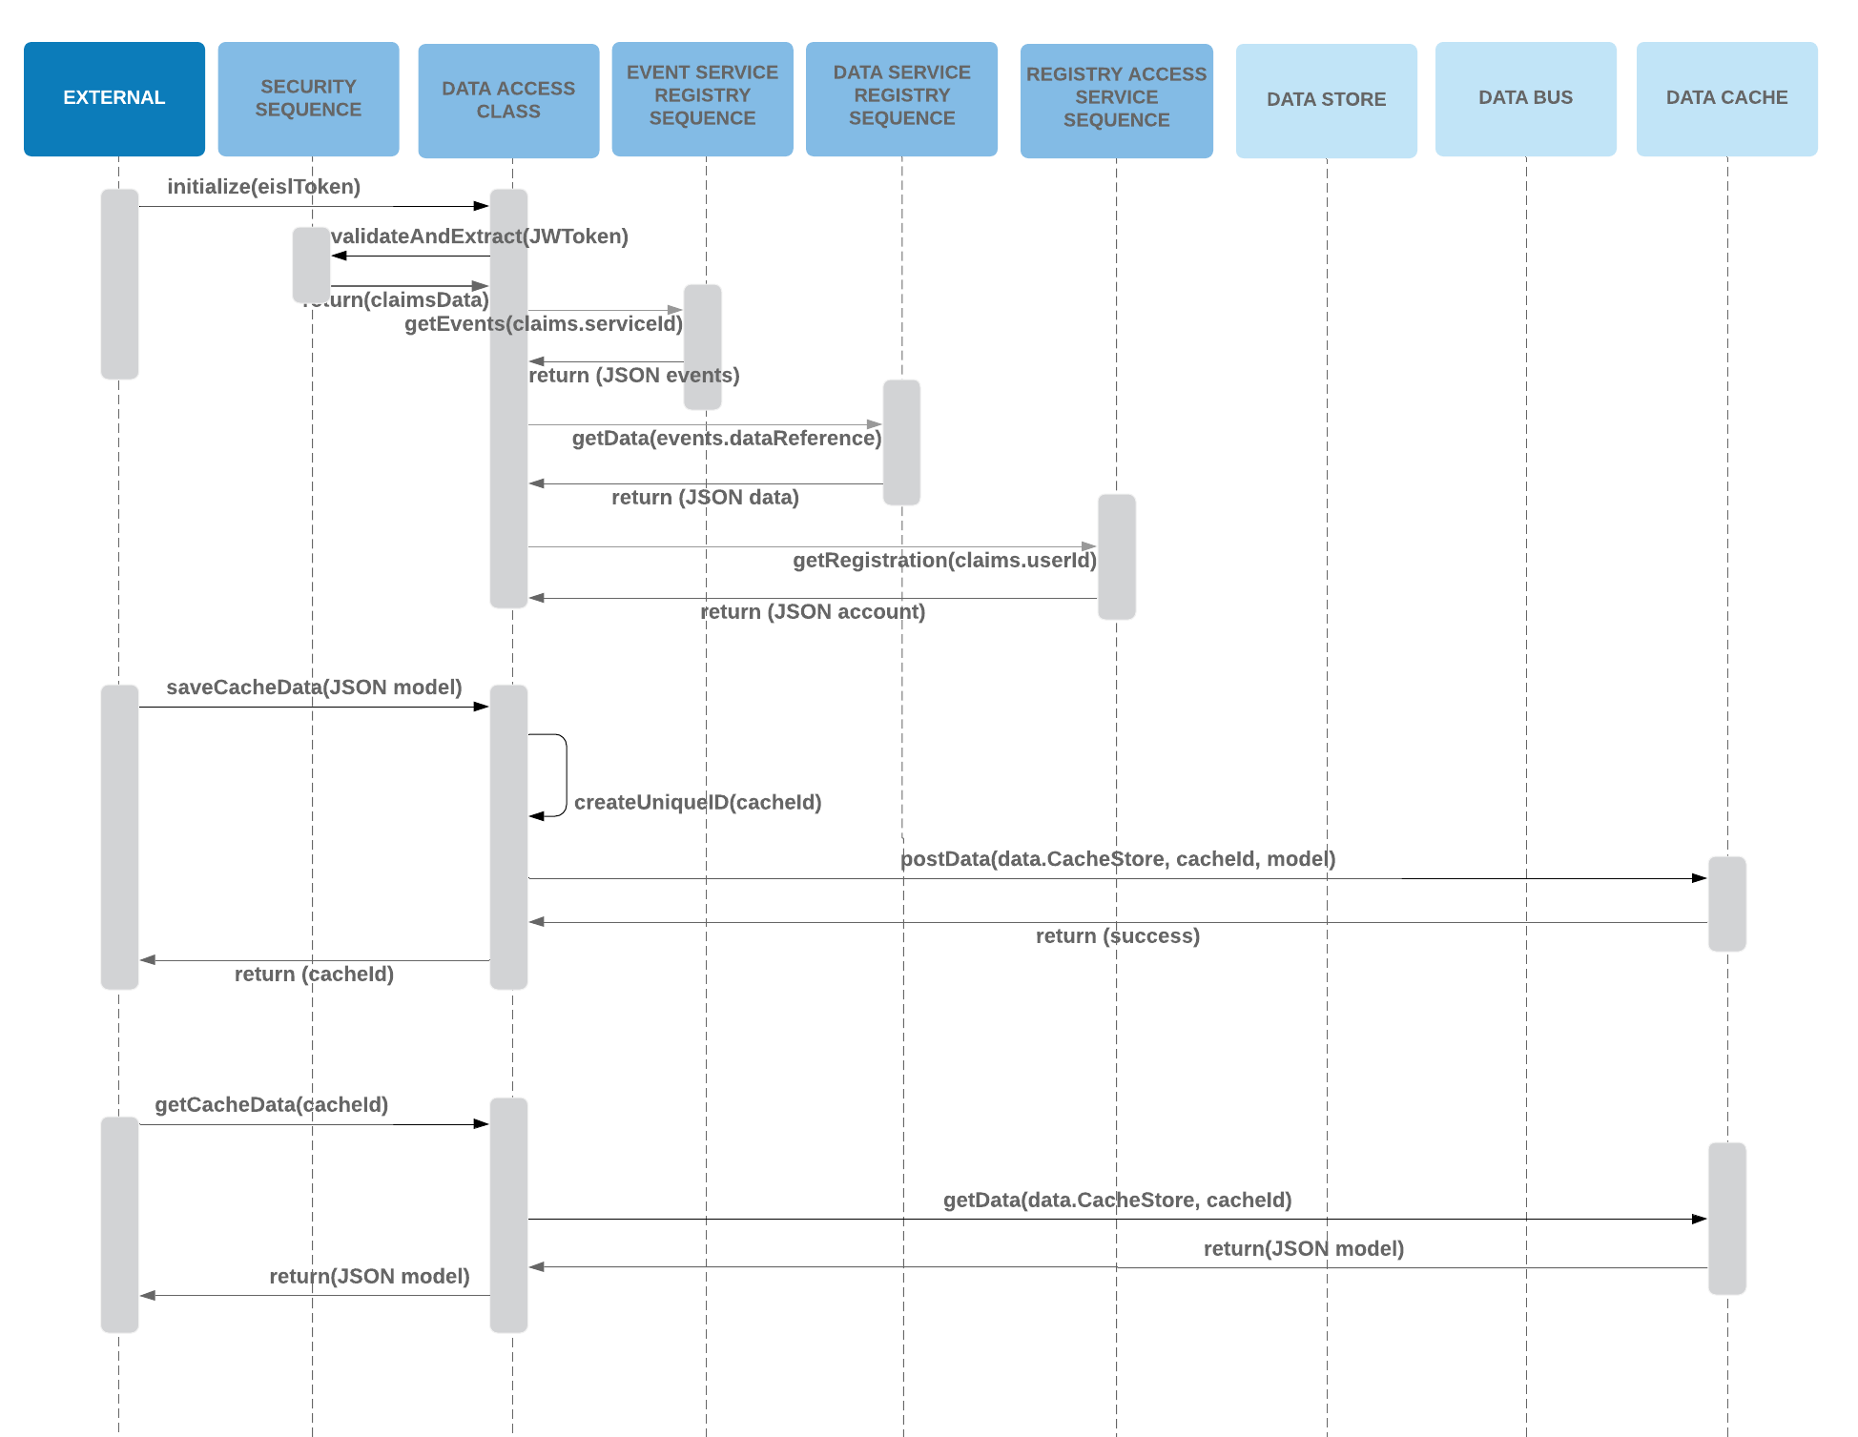

###### Data Blob Access Sequence

This repository is only used by EISL as a data store for caching data sent as part of an operation event. The data is saved and referenced through a transaction id that must also be stored in the associated operation event.

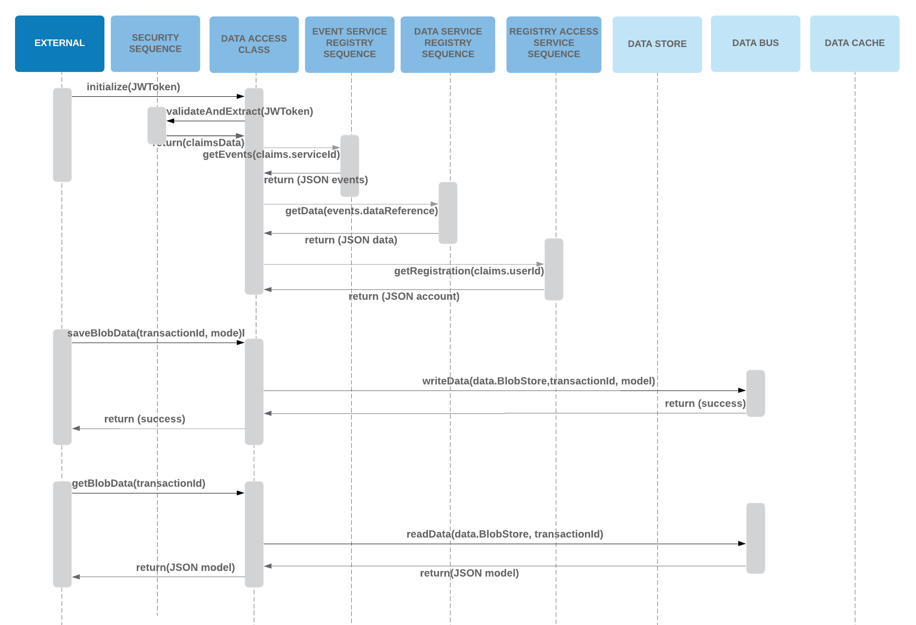

#### Logging

Log access service/class (SLF4J) should be used by all the EISL services to log any task being performed by the respective service with predefined attributes). Core logging service will be using the log access class to collect the log messages from message bus as per the configuration set up. These configurations will be predefined. Logging related services will also have the capabilities to consume any other static data wherever required

##### Logging Service

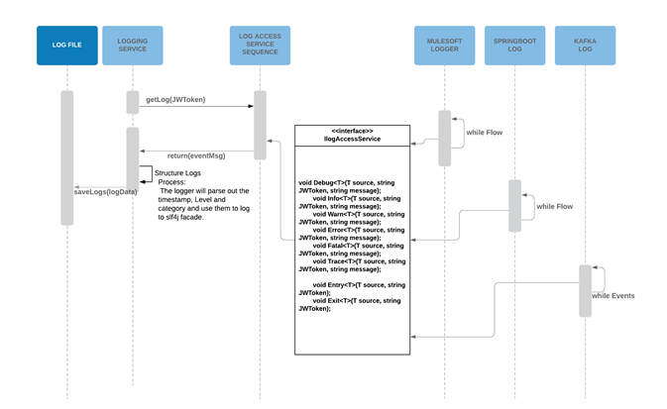

* Component level logging by each service/microservice involved in processing the domain service will be shared through the Log Access Service as and when an activity is performed
* Log Access Service will post these log messages to the message bus
* Log Access Service will also be utilized by the Core Log service in collecting the log messages for the given JWToken
* Core Log Service will consume all the messages from Log Access Service
* Core Log Service will send the recoverable task messages to scheduler again to rerun the service using rerun API
* Core Log Service will parse out the messages as per log structure defined
* Core Log Service will save the structured log messages onto a file locally saved

##### Log Access Service

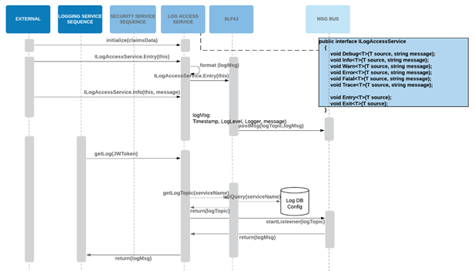

* Log Access Service receives the log messages from each service/microservice involved in processing the domain service along with JWToken
* Log Access Service will call log configuration service to get the message bus detail on which the log messages need to be posted and get the required response
* Log Access Service will post the messages to the identified message bus
* Core Log Service will call the Log Access Service along with the JWToken to get all the log messages
* Log Access Service will validate the token and call logging configuration service to identify the message bus where log messages are posted for the given domain service
* Log Configuration Service will connect with log data store config and receive the message bus details and send it back to Log Access Service
* Log Access Service will get all the log messages from the identified message bus and send it to Core Log Service as response

#### Exceptions

The core exception service should be used by all the domain/functional services to log the required attributes. (These exception-logging attributes need to be predefined). Core Exception service should be using the log access service to collect the log messages from message bus as per the configuration set up. These configurations and its values will be predefined that can be accessed by the configuration API. Core Exception Services should also be using Rerun API to connect scheduler and reprocess recoverable exceptions/tasks and Notification API should be used to send mail notifications for the irrecoverable exceptions. Exception related services will also the capabilities to configure and consume any other static data wherever required.

There are two types of possible errors, Infrastructure and logical:

* Infrastructure error is transient in nature and implies that retries are possible.
* Logical error implies that format/content of message is not valid, therefore, retries are not fruitful

All the exceptions will be logged, and certain exceptions will be available for audit purposes e.g. authentication and authorization related exceptions would be available for auditing

**Exception management for REST: Service Layer (Accepted/Rejected)**

* Any retry logic is up to the calling client. In case of failure or rejection, all the details of the error message will be returned to the client with appropriate http error codes.
* In case of Asynchronous processing on the back end any errors occurred in that process will be delivered to calling client by callback/messaging (error topic)

**Exception management for Streaming/Messaging**

Messages, where recoverability is important, should have correlation ID attached to them, so that any failure can be correlated to the original request.

Service will attempt to recover from transient errors by applying configurable retry logic. If retry fails, messages will be redirected to general Dead Letter Destination or REPLY-TO Destination.

**Exception management for File Transfer**

* Failure during transmission: Client is responsible for recovery/re-transmission
* Failure during processing of the file (structural failure): The recovery is on the Service Layer
* Failure during processing of the file (data): Messaging mechanism will be provided to notify the client of the failure. Client will be responsible for retrial

##### Exception Service

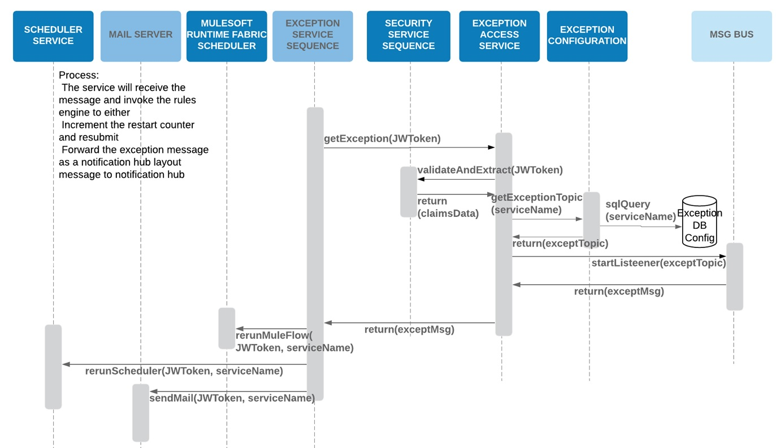

* Component level exceptions by each service/microservice involved in processing the domain service will be shared through the Exception Access Service
* Exception Access Service will post these exception messages to the message bus
* Exception Access Service will also be utilized by the Core Exception service in collecting the exception messages for the given JWToken
* Core Exception Service will consume all the messages from exception access service
* Core Exception Service will utilize the rules and identify the exception messages for which the rerun of service is possible (recoverable tasks)
* Core Exception Service will send the recoverable task messages to scheduler again to rerun the service using rerun API
* Core Exception Service will send all the non-recoverable task messages to the notification hub
* Core Exception Service will also send the notifications in mail for the non-recoverable task messages sent to notifications hub using notify Email API

##### Exception Access Service Sequence

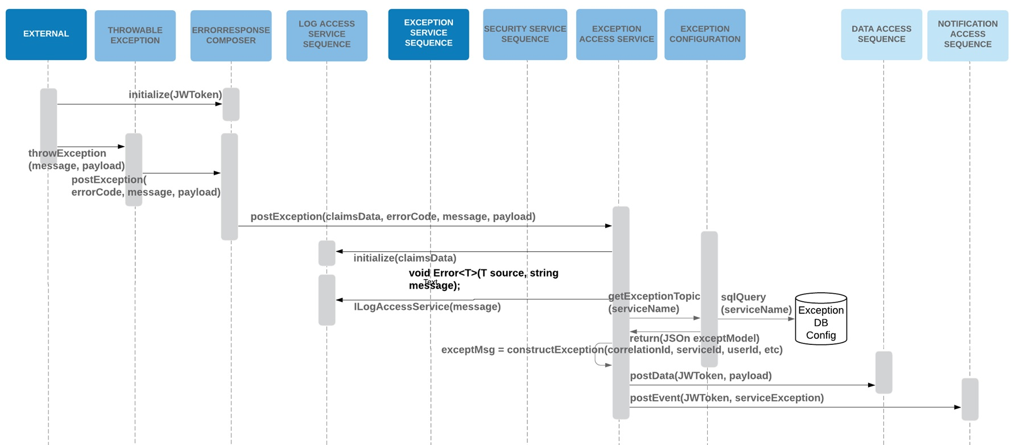

* Exception Access Service receives the exception messages each service/microservice involved in processing the domain service along with JWToken
* Exception Access Service will call exception configuration service to get the message bus detail on which the exception messages need to be posted and get the required response
* Exception Service will post the messages to the identified message bus
* Core Exception Service will call the exception access service along with the JWToken to get all the exception messages
* Exception Access Service will validate the token and call Exception configuration service to identify the message details where exception messages are posted for the given domain service
* Exception Configuration Service will connect with exceptions data store config and receive the message bus details and send it back to Exception Access Service
* Exception Access Service will get all the exception messages from the identified message bus and send it to Core Exception Service as response

##### NFR Exception Service Sequence

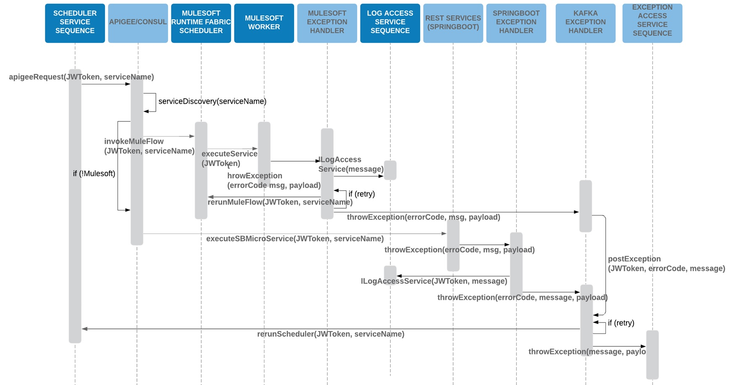

* Scheduler service will invoke APIGee using JWToken and ServiceId
* APIGee will identify the MuleSoft service where non-functional exception had occurred, using service discovery and invoke the applicable flow with JWToken, service name in MuleSoft runtime fabric scheduler, if the service is part of mule flow
  + MuleSoft worker will be triggered by scheduler that starts executing the identified service
  + Whenever, any non-functional exception is occurred, MuleSoft worker will trigger MuleSoft exception handler that will post the log messages for the exception (throw Exception, errorcode, msg, payload)
  + Exception handler will also call MuleSoft runtime fabric scheduler with the JWToken and service name to rerun the applicable mule flow and retry the process, if it's not successful in the previous attempt
  + MuleSoft exception handler will also throw the exceptions (errorcode, msg, payload) onto KAFKA exception handler
* If the identified service is a REST service that is not part of mule flow, then APIGee will call the respective REST service with the endpoint available to execute the microservice with the JWToken and service name
  + Microservice will call SpringBoot Exception handler that will first post the log message to log access class with JWToken and message
  + SpringBoot exception handler will also throw the exception message that includes errorcode, message, payload onto KAFKA exception handler
* KAFKA exception handler will access scheduler sequence to rerun the scheduler with JWToken and service name
* KAFKA exception handler will post the exception messages (message, payload) to the exception access class, if the service rerun cannot be initiated